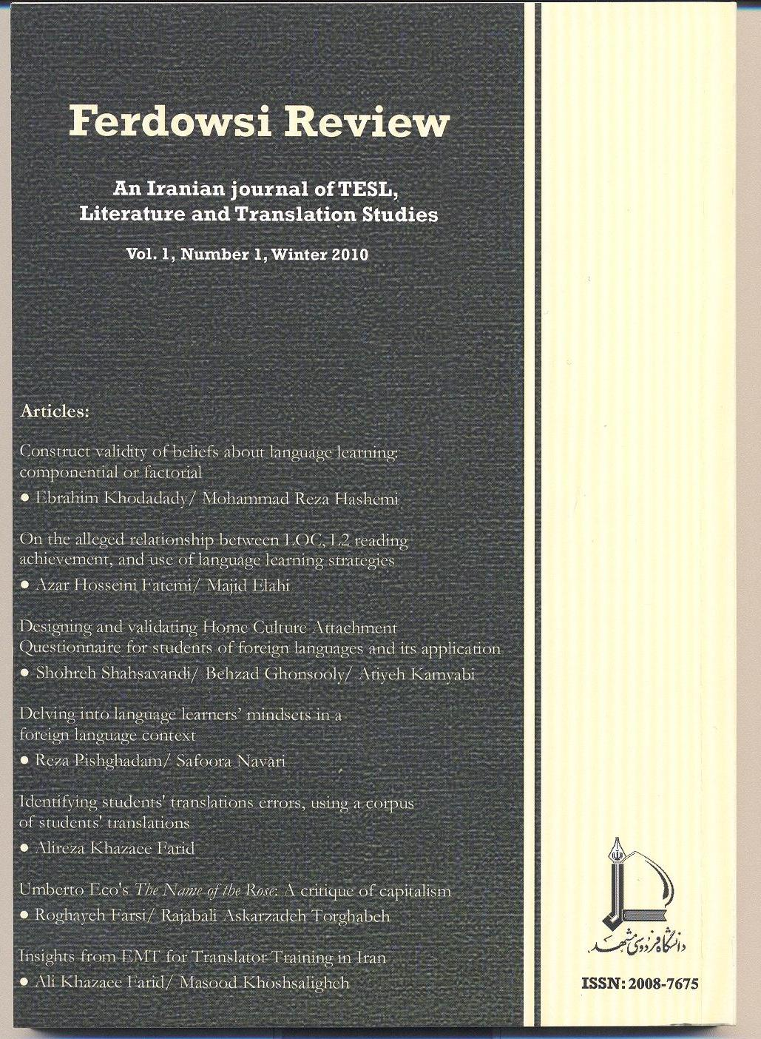
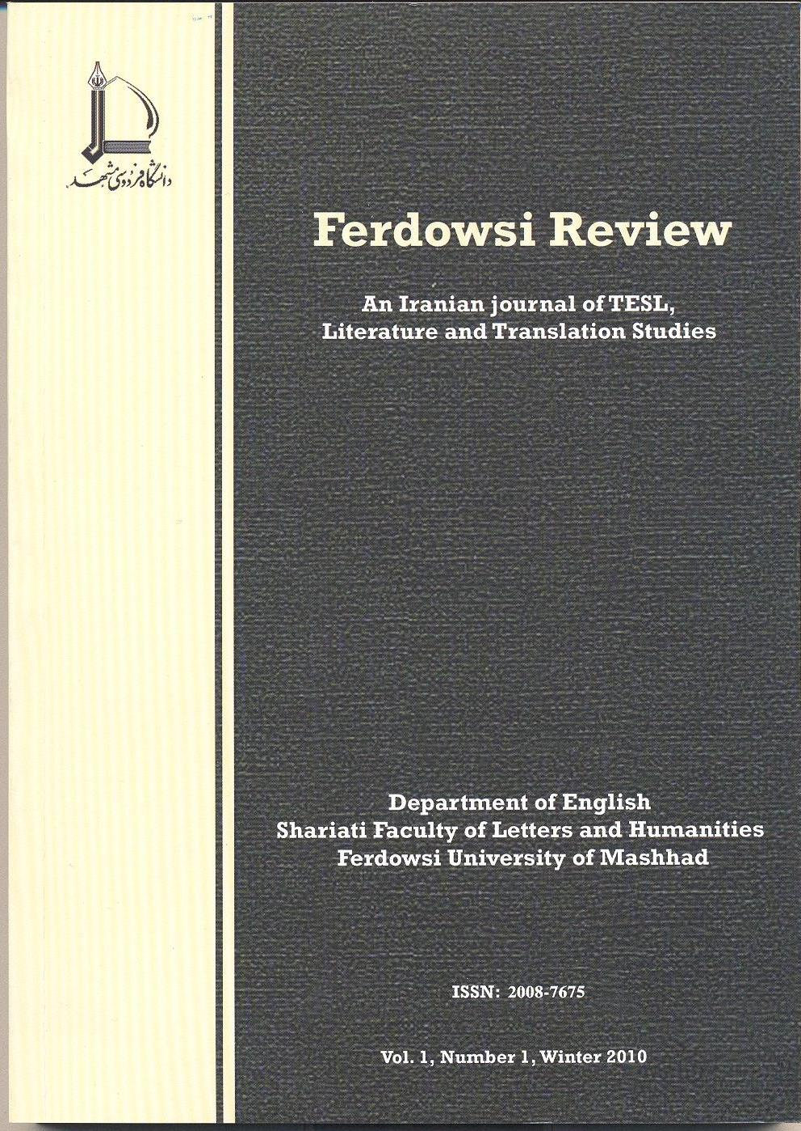

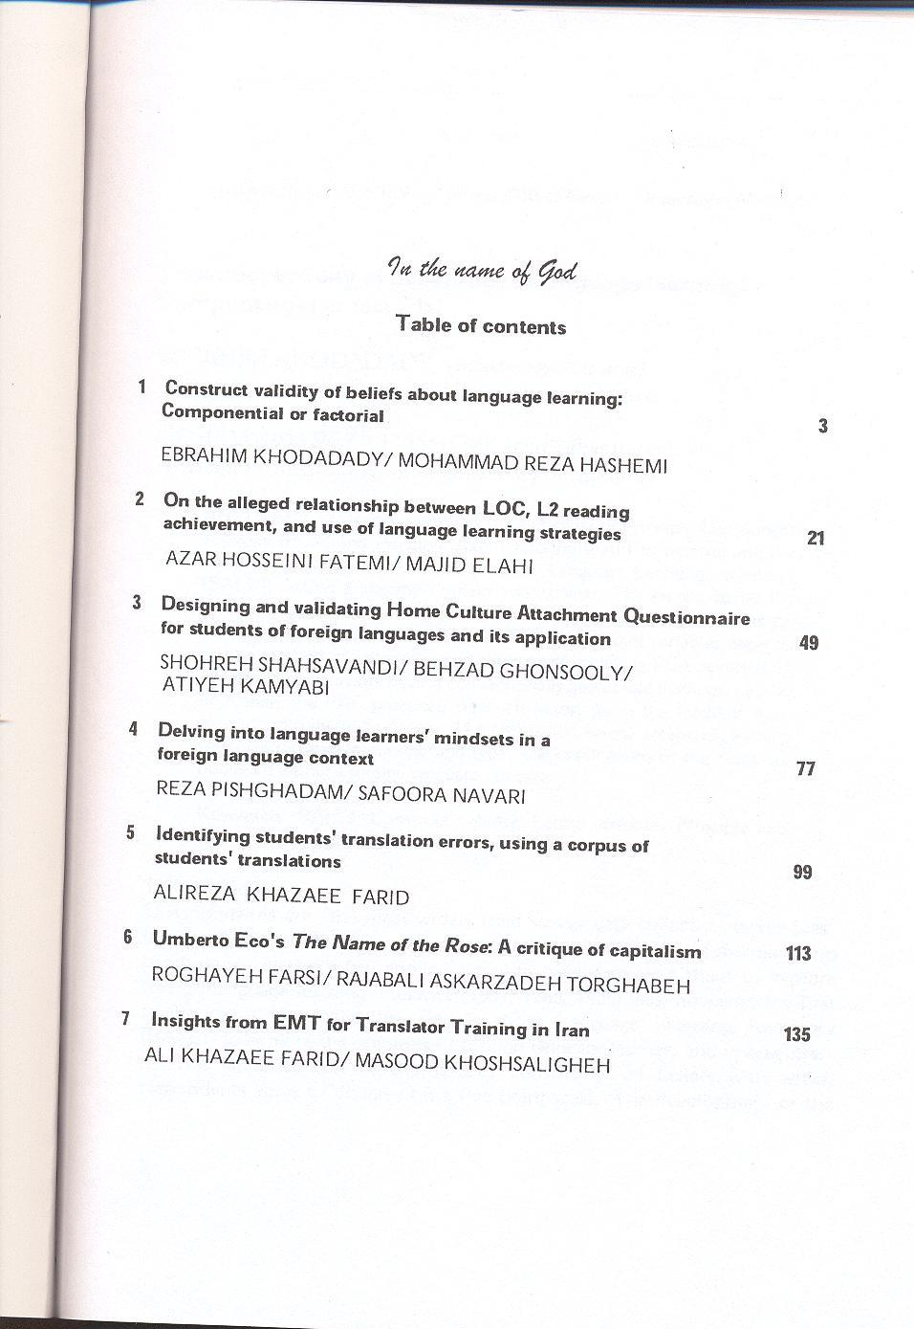
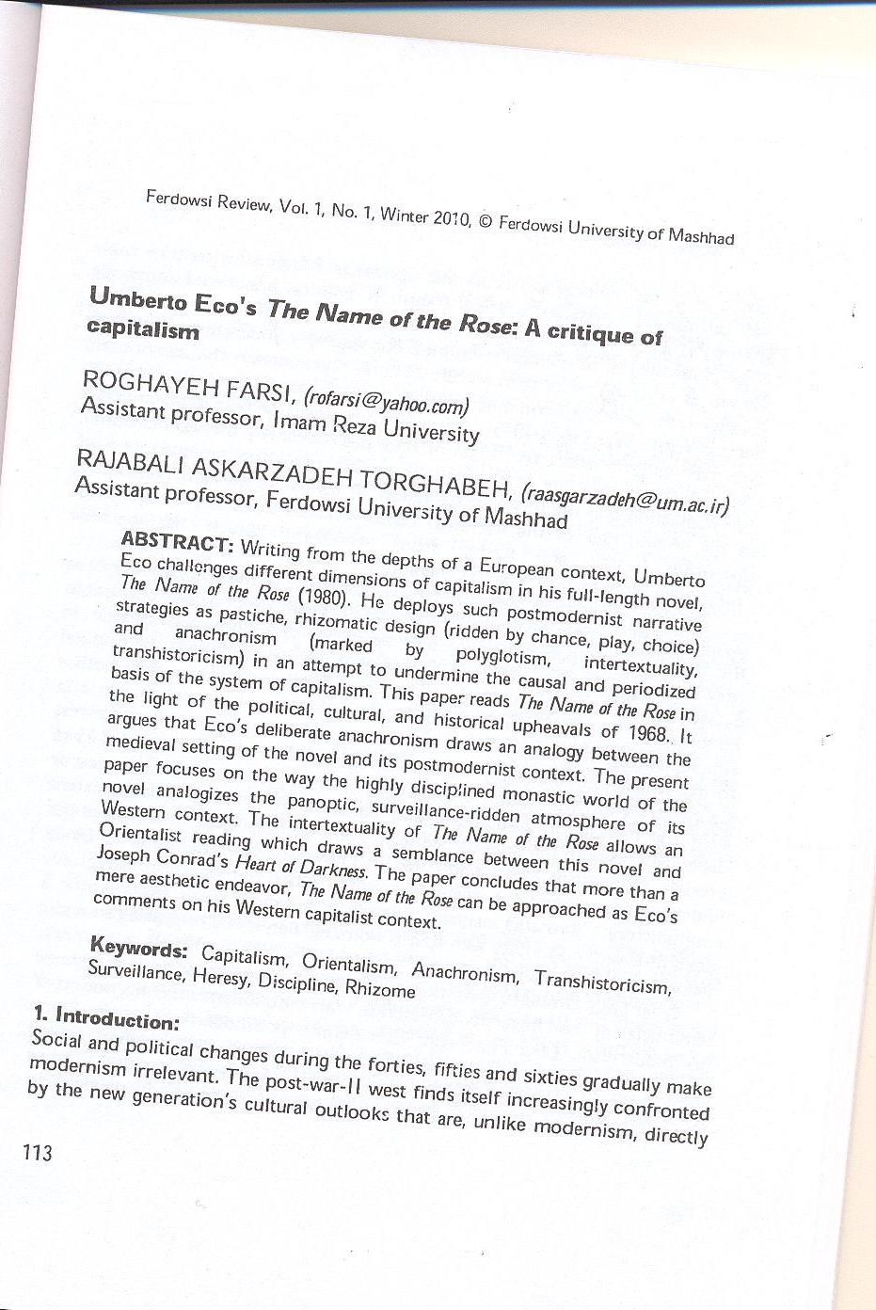
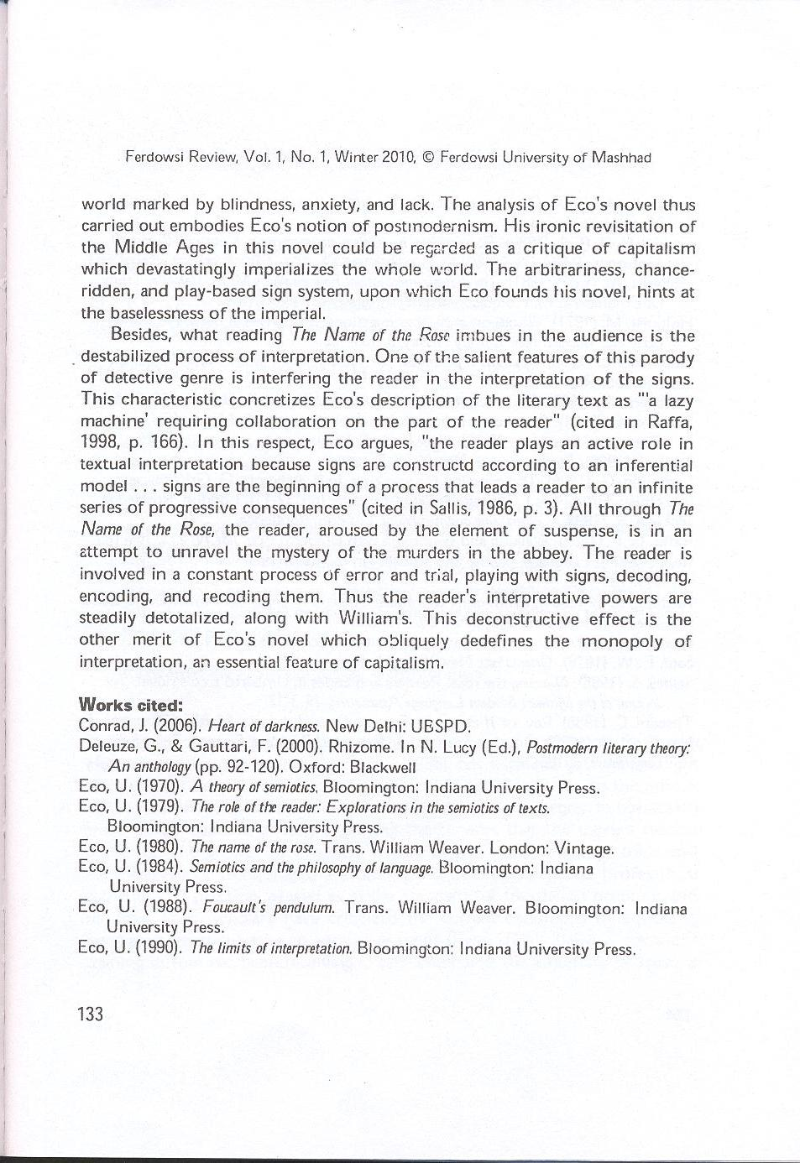
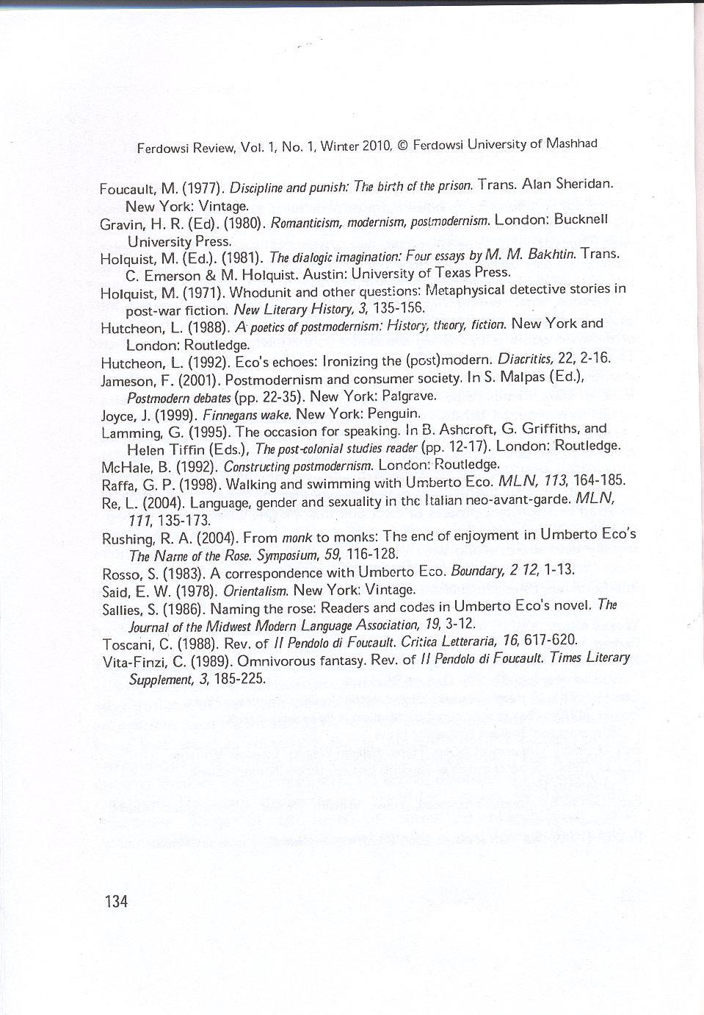

Umberto Eco’s The Name of the Rose:
A Critique of Capitalism

Dr. Roghayeh Farsi
Imam Reza University
Dr. Rajabali Askarzadeh Torghabeh
Ferdowsi University of Mashhad

Abstract
Writing from the depths of a European context, Umberto Eco challenges different dimensions of capitalism in his full-length novel, The Name of the Rose (1980). He deploys such postmodernist narrative strategies as pastiche, rhizomatic design (ridden by chance, play, choice) and anachronism (marked by polyglotism, intertextuality, transhistoricism) in an attempt to undermine the causal and periodized basis of the system of capitalism. This paper reads The Name of the Rose in the light of the political, cultural, and historical upheavals of 1968. It argues that Eco’s deliberate anachronism draws an analogy between the medieval setting of the novel and its postmodernist context. The present paper focuses on the way the highly disciplined monastic world of the novel analogizes the panoptic, surveillance-ridden of its Western context. The intertextuality of The Name of the Rose allows an Orientalist reading which draws a semblance between this novel and Joseph Conrad’s Heart of Darkness. The paper concludes that more than a mere aesthetic endeavor, The Name of the Rose can be approached as Eco’s comments on his Western capitalist context.

Keywords: Capitalism, Orientalism, anachronism, transhistoricism, surveillance, heresy, discipline, rhizome

Introduction:
Social and political changes during the forties, fifties and sixties gradually make modernism irrelevant. It finds itself increasingly confronted by the new generation’s cultural outlooks that are, unlike modernism, directly related to larger political and economic upheavals. Modernism remains quite well calculatedly unrelated to social transition, political praxis and economic alternation, because the artist’s rebelliousness is one of the mere formalities with no ideological or political overtones. Subsequently, modernism cannot be viewed as anything more than a mere cultural phenomenon that cannot run parallel to the political, economic and historical sea changes especially after the Second World War (1939-1945). The disastrous effects of Nazi totalitarianism and mass extermination, the threat of total destruction by the atomic bomb, the gradual devastation of the natural environment, the ominous fact of overpopulation and the threat of starvation, all constitute the dominant mood of the second half of the twentieth century. These traits are in charge of distancing further and further from modernism which has become “outmoded” for the post-War-II generation.
The resultant change in the Western epistemology of the second half of the century is called “postmodernism”, which has brought about drastic changes to the definition of being, identity and language. The dominant attitude in postmodernism is “disbelief”, which shares the same roots with the cultural catastrophe that has given rise to modernism. Postmodernism involves both a continuation of the counter-traditional experiments of modernism, and simultaneously, it involves diverse attempts to break away from modernist forms which had inevitably become, in their turn, conventional. In Mate Calinescu’s view, the notion of postmodernism suggests the obsolescence or even the demise of modernism, and concurrently, it is to a large extent dependent on both the time-consciousness and the deep sense of crisis that has brought modernism into being (qtd. in Gravin, 1980: 168). Therefore, as Linda Hutcheon has pointed out, postmodernism’s relation to modernism is typically contradictory: “it marks neither a simple and radical break from it nor a straightforward continuity with it: it is both/neither; it is a re-evaluation and a dialogue with the past in the light of the present " (1988: 19-20).
What links Umderto Eco, the Italian novelist, essayist, and the renowned semiotician at the University of Bolonga, with postmodernism is his notion of postmodernism. Like Hutcheon, Eco defines postmodernism as an ironic revisitation of the past. He concerns himself with theoretical positions which are in some way aligned with deconstruction. This concern is his focal point in most of his major studies in semiotics, language theory, and hermeneutics. His major works are La Struttura Assente (1968), A Theory of Semiotics (1970), Semiotics and the Philosophy of Language (1984), The Role of the Reader: Explorations in the Semiotics of Texts (1979), The Limits of Interpretation (1990), Interpretation and Overinterpretation (1992), and Six Walks in the Fictional Woods (1994). Besides these works, Eco has some best-selling novels, including The Name of the Rose (1980), Foucault's Pendulum (1988), L'isola del Giorno Prima (1994), and The Island of the Day Before (1995).
Umberto Eco’s novel, The Name of the Rose (1980), is a postmodernist aesthetic enterprise which targets the continuist, progressivist system of capitalism, thriving on discrimination, hierachization, normalization and surveillance. Having witnessed the political, social and cultural upheavals of 1968 and the subsequent failure of the protest against the monopoly of capitalism and the educational system, Eco holds a dialogue with the ancient past. In this revisitation, he endeavors to destabilize capitalism's despotically naturalized claims. His anarchronism thus accords him the status of a historian who, in Edward Said’s words, “deals with the human past from a vantage point in the present” (1978: 50). The Name of the Rose is the outcome of Eco’s critical outlooks which disrupt the postmodern political and ideological structure from within. Taking issue with his contemporary era, he adopts postmodern narrative strategies which drive at the very arbitrariness of his Eurocentric capitalist context. This paper attends to an analysis of these strategies. Besides, power relations, production and distribution of power in the form of investigation and surveillance (originated in the medieval inquisition) are the other characteristics of capitalism which underlie The Name of the Rose and which comprise part of the present paper.

Discussion:
Set in an early-fourteenth-century monastery, The Name of the Rose revolves around the events which happen in an unnamed abbey. The whole novel is framed by the contemporary author's opening description of a manuscript and Adso's end-of-the-century epilogue. Writing the story as an old Benedictine monk, Adso describes the events he witnessed in the abbey when he was a young novice. Adso accompanies William of Baskerville, a Franciscan, who is sent to various abbeys on official church business because of his shrewd observation of life. Upon arriving at the abbey, William is asked by the abbot to investigate the strange death of one of the monks. In the course of their stay in the abbey, few other monks are furtively murdered. The abbey has one of the greatest libraries in Europe and prides itself on the library's reputation. This library is a labyrinth to which only the abbey librarian and his assistant know the solution. All of the murdered monks have contact with the library and all the clues that William is about to deduce are somehow related to the library. William, with Adso's help, eventually discovers the murderer, who happens to be Jorge, the blind old monk and the guardian of the library. Jorge commits suicide when he is caught by Adso and William in the forbidden room of the library. Jorge's death leads to a fire, which burns down the great library. After the fire, Adso returns to his monastery at Melk to become a monk. Years later, his abbot sends him to Italy, where he cannot resist a visit to the abbey's ruins. He collects the scraps of books which he finds scattered about the ruins and collects them.
The Name of the Rose is centered on the monastery and hardly ever steps beyond that papist atmosphere. However, it is implicitly shown how heavily the survival of the abbey relies on the workforce of the villagers. It is the labor of the commonplace people or the simple which provides the monks' lives. This exploitative domination has culminated in the political dominance of the learned over the uneducated. Therefore, there is a strong power relation between the abbey and the village. In this relation, the simple are the producers on whose productive powers the monastery thrives. This resembles the ecclesiastic system to that of capitalism which, likewise, prospers on the labor of the other(s). This semblance encourages us to cast a critical light on the system of the abbey, taking it as an analogue for the West's capitalist system. The monastic power relation which segregates "us" from "them" is a point which will be further scrutinized with reference to Michel Foucault's theories.
The Name of the Rose cast in the generic framework of a detective story whose calculative base and causal rationality epitomizes the ratiocination of capitalism and fulfills its representationalist demands. Linda Hutcheon quotes Michael Holquist's argument in "Whodunit and Other Questions" that "the detective story is to postmodern as what myth and depth psychology were to modernism. In Eco's perverse version of the postmodern, however, the detective as the metaphor of order and logic is ironized by the decisive presence of chance accident (in The Name of the Rose) or by hyperbolic expansion and inversion (in Foucault's Pendulum)" (1992:1-2). Writing against the grain of conventional detective story, Eco problematizes the notions of order and logic through his ironical treatment of the genre itself. In the comparison that Brian McHale draws between William of Baskerville and other detectives like Sherlock Holmes, Hercule Poirot, and Miss Marple, he argues that the “element of irrationality’ in William’s detective work “undermines the basic assumption of the detective story . . . namely, the assumption of the adequacy of reason itself, of ratiocination” (1992: 150). Although McHale’s detailed analysis of The Name of the Rose locates it in the in-between space of modernism and postmodernism, he actually canonizes the novel by calling it, in agreement with William Spanos, an anti-detective story (Ibid, 150). Like such other modernist terms as anti-novel, anti-hero, the calcified notion of anti-detective implies a complete subversion of the conventional form which is typical of any avant-garde genre. However, Eco’s time has already witnessed the limitations of the metalanguage of the avant-garde, and therefore, craves for another reaction. Raising this issue in his correspondence with Stefano Rosso, he argues:
there comes a moment when the [historical] avant-garde can go no further. . . . At this point arises the reaction, which is never simply reversal. . . .
The postmodern response to the modern consists instead of recognizing that the past–since it may not be destroyed, for its destruction results in silence–must be revisited ironically, in a way which is not innocent. (1983: 2)
Accordingly, The Name of the Rose retains or deploys, unlike McHale’s coinage which signifies reversal, the basic potentials of the detective genre; its plot is woven out of the unraveling process of a chain of events and moves towards the identity of a mysterious murderer and subsequently ends up by discovering the motives of the crime. Thus one of the fundamental and unavoidable charms of the genre, which is suspense, is provided. The element of suspense entertains both the “ingenuous reader”–in Eco’s words (qtd. in McHale, 1992: 149)–and the experienced one aware of, although frustrated by, the ironical texture of the novel. More than an anti-detective story, The Name of the Rose ironizes the rationalization of the novelistic detectives who assume and impose a linear and causal pattern on the sequence of events. Replacing causality by casualty, Eco challenges the one-dimensionality of capitalist ratiocination and thereby unsettles its normalized claims. With an eye on Jameson’s critical view of postmodernism in his essay, "Postmodernism and Consumer Society", one can argue that The Name of the Rose is a pastiche of the detective genre, which in a Jamesonian terminology, blankly parodies the conventional genre. In this sense, it is more than “a pastiche of theological, political, aesthetic, and philosophical debates, historical references, moral reflections, private jokes with the reader, etc.”, as Rosso observes (1983: 6); rather Eco’s novel is generically a pastiche. Speaking of The Name of the Rose as a pastiche endows the work with an ambivalence which arises out of Eco’s belief that “‘the already-said’ [must] be not contradicted but reconsidered in an ironic way” (qtd. in Rosso, 1983: 5). It is this belief which has evoked Vita-Finzi to call Eco "an author who has irony in his soul" (1989: 618). By the same token, Claudio Toscani dubs Eco's work one of "irreverence and irony" (1988: 618). This irony-based trend is in charge of Eco's Hutcheonian strategy which “installs” then “subverts”, “uses” and “abuses” the “iron scaffolding”–Eco’s terms (qtd. in Rosso, 1983: 5-6)–of the detective genre. Through this subversive strategy, Eco pinpoints the limitations of the received notions of form.
Criticizing Jameson’s replacement of parody by pastiche defined as “the random cannibalization of all the styles of the past, the play of random stylistic allusion” (1988: 26-27), the Canadian postmodern theorist, Linda Hutcheon, renounces the element of randomness in the postmodernist text which recalls and re-examines the past parodically (Ibid, 27). However, a comparison between Eco and Joyce–on whom Eco has been working for a long time–would clarify the point that Jameson tries to accentuate by his predilection for pastiche. In Ulysses, Joyce “contemporizes”–in Mikhail Bakhtin’s terms (qtd. in Holquist, 1981: 21)–his mythical subtext, whereas Eco takes the other way around; he gothicizes his postmodern concerns and thus marks his text with a gloomy and severe mood which is characteristic of the Middle Ages. Accordingly, Joyce’s contemporization which evokes Bakhtinian sophisticated and “ambivalent laughter” renders Ulysses a parody of Homer’s epic, while Eco’s medievalism with its humorless world makes The Name of the Rose a blank parody, a pastiche. Whereas Joyce’s contemporization strategy postcolonializes his ideological stand as an Irish writer who writes back to the empire from the margins of his quasi-colonial context, Eco’s anachronism politicizes his aesthetic enterprise by undermining the monopoly of his postmodernist capitalist context from within.
Approaching Eco’s novel as a pastiche opens up the pertinent space to view it as a comment on the Western mode of thinking in his capitalist context. Speaking through the stylistic mask of the detective genre, Eco champions the linear rationality of capitalism by bringing to the fore issues of chance, play, choice and multiple possibilities, all of which unsettle the very base of rationality itself. Eco himself describes William as “reasonable” rather than “rational”, and concludes “[t]his is why he believes in no single truth” (qtd. in Rosso, 1983: 4). As the pastiche of a detective figure, William creates a labyrinth of hypotheses in which he drowns both the sidekick narrator and the reader along with himself. While Adso and the reader yearn for a pattern, a specific order, to follow up the sequence of events, William frustrates this expectation by giving the situation multiple other dimensions, each of which culminates in a different explanation. Therefore, instead of frustrating “the impulse to detect”, as McHale agrees with Spanos (1992: 150), The Name of the Rose intensifies the detective urges by giving it a much vaster and a more varied scope of possibilities. Like a conventional detective story, the mystery of the murders is solved by the end; but William manages to undo the knot through consistent misinterpretation of the evidence, in McHale’s words, “thanks to irrational associational leaps prompted by a dream and a grammatical error, both recounted by an adolescent novice!” (Ibid, 150). This is the point which perplexes Jorge in their vis-à-vis confrontation:
I cannot follow you. . . . You are proud to show me how, following the dictates of your reason, you arrived at me, and yet you have shown me you arrived here by following a false reasoning. What do you mean to say to me? (Eco, 1980: 471)
Disrupting the vertical course of conventional rationalization, William’s play with multiple possibilities adopts a horizontal plan which is open to many other possibilities, hence a rhizome. Unlike a conventional detective who heaps up a causal line at the pyramid of which lie the murderer and his motives, William follows a playful scheme, a network-like pattern, which can be cut, added, reversed, reformed, rejoined and subverted at any point. It is due to his rhizomatic reasonability that he becomes a pastiche of detective in whom both the sidekick narrator, Adso, and the reader lose confidence. Lacking center and periphery, having multiple exits and numerous entryways, a rhizome has the permanent potentiality of interconnectability and is always open (Deleuze and Guattari qtd. in Lucy, 2000: 96-103). This Deleuze-Guattarian characteristic renders William’s course of reasoning baseless and centerless; accordingly and justifiably enough, he appears in the novel as one who has quitted his position as an inquisitor, since he lacks the rooted criteria requisite to cast judgment on and discriminate the truth from the false. He denounces the causal sequence of events as a foolish attempt like “trying to build a tower that will touch the sky” (p. 30). In Adso’s opinion, William “was not at all interested in the truth. . . . On the contrary, he amused himself by imagining how many possibilities were possible” (p. 306). As a rhizomatic thinker, the detective ventures many hypotheses. Referring to the case of the horse Brunellus, he acknowledges that many of his hypotheses were complementary and many others contradictory:
I won, but I might also have lost. The others believed me wise because I won, but they didn’t know the many instances in which I have been foolish because I lost, and they didn’t know that a few seconds before winning I wasn’t sure I wouldn’t lose. (p. 305)
Eco’s detective is fully aware of the historicity and positionality of truth and therefore refrains from making any universal and stable law or developing confidence in any such law: “How can I discover the universal bond that orders all things if I cannot lift a finger without creating an infinity of new entities?” (pp. 206-207). Dislocated in the ecclesiastics-ridden setting of the Middle Ages and contra responsive to his context, William vouches for and revels at “variety in unity” (p. 16). This perspective makes him a self-reflexive and self-contradictory postmodern character whom Adso describes in a Lacanian key: “you act, and you know why you act, but you don’t know why you know that you know what you do” (p. 207). Accordingly, from the very outset of his narrative, the aged Adso acknowledges:
I did not then know what Brother William was seeking, and to tell the truth, I still do not know today, and I presume he himself did not know, moved as he was solely by the desire for truth, and by the suspicion–which I could see he always harbored–that the truth was not what was appearing to him at any given moment. (p. 14)
William’s rhizomatic mind which subjects everything to multiple possibilities without closing in on any specific hypothesis has the structure of a labyrinth which is based on chance and play and, which, lacking any center, is irresolvable. The labyrinthine structure of his mind contrasts with the labyrinth of the library which is, in Eco’s terms, mannersitic and solvable through a process of error and trial (qtd. in Rosso, 1983: 7); William’s mental labyrinth is “structurable but never definitely structured” (Ibid, 7).
The network-like reasonability of the detective William justifies his being an experimentalist, a scientist-like figure, who has educated in universities and has been taught the knowledge and secrets of the world. Eco’s anachronism has displaced William in the highly prejudiced monastic setting which looks at his machines with suspicion. He has the signs of technology with himself like the clock, the astrolabe, the magnet, and his lenses. His knowledge reveals hic transhistorical identity, a postmodern aesthetic attribute, which runs against the contemporaneity-orientation and periodic categorization of capitalism. William has educated in the University of Paris under the guidance of Roger Bacon whose name is reminiscent of the prophet of science, Francis Bacon. However, he steps beyond the sixteenth century, when he interprets Adso’s dream (p. 437) in the light of the theories of the twentieth-century psychoanalyst, Sigmund Freud. His application of the Freudian theories is also evinced in his psychoanalytic explanation of a man under torture, as in the case of the cellarer, Remigio of Varagine (p. 388; also 59), or of one stricken by a strong sense of guilt, like Adelmo who subsequently committed suicide because of his homoerotic relation–a sin highly condemned in Christianity (p. 117). A transhistorical figure, William knows about modern technology like ship, airplane, train, submarine, as well as “tiny instruments [which] will lift huge weights” (p. 17). His transhistoricism, an epitome of Eco’s anachronism, drives at the writer’s leveling of all the historical periodizations which have been hierarchized through such period terms as Middle (or Dark) Ages, Renaissance, or modernism.
One of the potentialities of anachronism upon which Eco draws to testify to his capitalist context is the analogizing procedure which enables him, in Hutcheon’s terms, to have “a dialogue with the past in the light of the present” (1988: 19). The embodiment of this analogue is the narrator himself. The name of the narrator, Adso, is an alteration of Adesso in Italian which means "now". It is Adso, whose name renders him the voice of "the present", who is narrating his experiences in the long-ago-burnt abbey. His narrative thus becomes the dialogic site where the past converses with the present. Therefore, in his narrative, Adso holds a dialogue with the past. Besides, by naming his narrator as such, Eco is deliberately deconstructing the reader's logic view of time. All through the novel, the reader is aware that the narrative is about the Middle Ages and Adso's "now" is to be realized in the line of that atmosphere. Yet Adso's presence and his part in the narrative constantly disrupt this illusion. The resultant disillusionment might be taken as a sign for the very artificiality of the novel form. It seems as if Eco is self-deconstructing not only his text but also the reader's perception of time. This self-reflexivity is another postmodern merit of The Name of the Rose. Moreover, Adso's act of remembering which, from a literary point is called flashback, accords the postmodern novelist the opportunity to revisit the past. However, the narrative texture of this revisitation always reminds the reader that this enterprise could be only narrative-based. This is the other postmodern feature which Eco's novel is marked with.
Eco defends his deliberate anachronism, “arguing that when one of his characters generates what appear to be “modern” ideas from medieval ones, he is only doing what his culture in fact did, as history confirms: the Middle Ages generated modernity” (qtd. in McHale, 1992: 152). Tracing back the roots of modernity and the ensuing postmodernity in the Middle Ages, Eco is actually giving his contemporary context and the predicaments of his present era a historical dimension. This process of (trans)historicization urges us more to approach his medieval setting as an analogy of his postmodern condition. Analogizing the medieval period and his post-War-II context, Eco’s anachronism politicizes his novelistic texture which challenges the fundamental base of capitalism.
Eco resorts to a medieval setting by writing against the contemporary neorealism. In Re's analysis, despite the neorealism's commitment “to themes of social change, and revolution and other explicit political contents–[it]remained complicitous with the dominant ideology” (2004: 148) of capitalism. This is the politico-social aversion that the anonymous narrator of the Borgesian frame story evokes by transcribing his text
with no concern for timeliness. In the years when I discovered that Abbe Vallet volume, there was a widespread conviction that one should write only out of a commitment to the present, in order to change the world. Now, after ten years or more, the man of letters . . . can happily write out of pure love of writing. (p. 5)
Accordingly, Eco deploys anachronism as a campaign against the demands of his capitalist context. The narrator ends his introduction to the supposedly found manuscript of The Name of the Rose, calling the novel “a tale of books, not of everyday worries"; he expresses his comfort at “finding it immeasurably remote in time . . . gloriously lacking in any relevance for our day, atemporally alien to our hopes and our certainties” (p. 5); yet Eco’s displacing strategy ironizes this atemporality. His ironic dialogue with the past, carried out through Adso's voice, is double-edged; he targets his problematizing irony to the past as well as the present, the medieval as well as the contemporary. In Hutcheon’s words, it is “a double-talking, a forked-tongued mode of address” (qtd. in Ashcroft et al., 1995: 133).
One of the sites of contest in The Name of the Rose is the question of power and power relations concretized in the medieval monastic microcosm of the nameless abbey. The highly systematized structure of the abbey exemplifies the way power works through discipline, normalization, and surveillance, which are the fundamental elements of the panoptic macrocosm in the postmodern era, hence a political analogy. The way Adso describes the disciplined system of the abbey reminds us of Foucault’s detailed analysis of discipline and disciplinary control in his Discipline and Punish: The Birth of the Prison (1977). For all the monks in the abbey, the day has been scheduled into eight categories of matins, lauds, prime, terce, sext, nones, vespers, and compline, during each of which the monks are required to do certain things. Describing the prescriptions of the Rule in the abbey to William and Adso, Severinus pinpoints, “you know how much our order has developed inquiry into divine and human affairs” (p. 68). It is through the Rule that those in charge, the abbot, come to know about what each monk does and how he spends his time, hence surveillance. Even the monks’ tables in the scriptorium are hierarchized; at meals, they are wholly dominated by the abbot’s table, “set perpendicularly to theirs on a broad dais” (p. 93). Moreover, since each monk has his own seat at the table, in the church and in the scriptorium, his presence and absence can be easily checked. For instance, Berengar’s absence in the choir at the compline, or the librarian’s empty seat a matins make Abo, William and others suspect of some disaster going on.
The Rule of the abbey monitors the monks through some prohibitions like silence during the meals, asking for only certain books, not entering the library, and avoiding carnal sins. Such constraints are reinforced through frightening images of punishment which inflict a strong sense of guilt on the consciousness of the monks. Thus in case of perpetration, they resort to confess their sins to those in charge who thereafter keep a vigilant eye on the sinner. Therefore, fear and dread are the key emotions through which the personal lives of the monks are kept in check. Adelmo’s suicidal case is a good example. His thirst for knowledge of the forbidden makes him yield to the whimsical desires of the lascivious library assistant, Berenegar. In a desperate state of redemption, Adelmo confesses to Jorge, whose words arouse a strong sense of guilt from which he tried to escape by committing suicide. This is the point with which William takes issue:
to stimulate piety and terror and fervor in the populace, and obedience to human and divine law, preachers have used distressing words, macabrethreats. Never before . . . has there been such insistence . . . on strengthening the faith of the simple through the depiction of infernal torments. (p. 118)
The other key means of keeping vigilance on the populace through fear are inquisition and different instruments of torture for the heretics. Adso’s narrative of the inquisition of the cellarer, Regimio, by Bernard Gui who sentences him to torture before death concretizes this fact. In Eco’s postmodern time, the means of torture have diminished behind the walls of the prison and no public execution is held; yet the police, the discourse and the institute of the prison evoke the same sense of fright and avoidance among people who thereby try to keep an eye on themselves. This signifies the transformation of monastic surveillance into self-surveillance of the panoptic society, which is more functional and more furtive.
The question of power and power relations is also evinced in The Name of the Rose through the religio-political debates over the issue of heresy and heretics which stand for the state of the marginalia. The competition of the pope and the emperor over authority and the subsequent marginalization of the simple can be taken as an analogy for the oppressive, exploitative and highly suppressive base of the Western capitalist system which subordinates the other in terms of class, race and gender. The medieval discourse and institute of inquisition finds its equivalent in the postmodern panoptic system which rules through self-surveillance. William’s convictions about the issues of power and resistance are another sign of his transhistoricism which shows his familiarity with Foucault’s theories. When he implicitly tells the abbot that the judges and inquisitors themselves often create heresy and heretics (p. 31), his speech strikes to the mind Michel Foucault’s analysis of the police system. In Discipline and Punish, Foucault discusses how the police system gives rise to delinquents and delinquency (1977: 257-292). William connects the discourse of heresy with the simple or the flock, which is the always-already marginalized side. To Adso, he clarifies that “[a]ctually, first comes the condition of being simple, then the heresy” (p. 200); these two conditions are inextricably interlocked, since the heresy is a sign to bring the marginalized simple to the center, a phenomenon which the dominant tries to avoid. The reason for the success of many heresies is their offer for “a different life” since the life of the simple is “haunted by illness and poverty, tongue-tied by ignorance. Joining a heretical group, for many of them, is often only another way of shouting their own despair” (p. 152). But the truth of the simple very shortly gets “transformed into the truth of the powerful” (p. 205) and becomes a weapon against the dominance of the other opponent. Therefore, the simple is again pushed to the margins. This is the reason for the failure of Francis’s attempt to
call the outcast . . . to be part of the people of God. . . . To recover the outcasts he had to act within the church, to act within the church he had to obtain the recognition of his rule, from which an order would emerge, and this order . . . would recompose the image of a circle, at whose margin the outcasts remain. (p. 202)
Thus the blind monk, Jorge, boasts of having reinscribed Francis and his followers in their order: “we have disciplined them. . . . They have rejoined our ranks, they no longer speak like the simple” (p. 478). In this sense, Francis’s failure can signify the failure of the political, social, and cultural revolution of 1968 which swept the Western Europe and ended in a total collapse, disillusioning the dissenters (students and workers) of their utopianism when confronted by institutionalized ideals.
William’s explanation of the margin is illuminative and can be easily applied to the exclusive system of capitalism. Adopting a Foucauldian gesture, he speaks of the lepers as the outcasts and generalizes their denigrated state to the simple which comprise the peasants and citizens, that is, the postmodern workforce and the ordinary populace (the rebels of 1968). Taking the lepers as “a sign of exclusion in general” (p. 202), William propounds: “in saying ‘lepers’ we would understand ‘outcast, poor, simple, excluded, uprooted from the countryside, humiliated in the cities’” (p. 203). Because of their marginalized state, they are ready to join any doctrine which would condemn the behavior of the dominant and
would promise their punishment one day. . . . And for their part, blinded by their exclusion, they were not really interested in any doctrine. This is the illusion of heresy. Everyone is heretical, everyone is orthodox. The faith a movement proclaims doesn’t count: what counts is the hope it offers. (p. 203)
William analyses that the powerful always realize this, since the centralization of the ex-centirc would deprive them of their privileges. In order to retain their centrality, the powerful have to oppress the simple; hence they raise the issue of heresy against them, taking them on stake as heretics, regardless of their doctrine. Envisaged as such, “[a]ll heresies are the banner of a reality, an exclusion. Scratch the heresy and you will find the leper. Every battle against heresy wants only this: to keep the leper as he is” (p. 203). Therefore, the simple remains the permanent victim in the contest over power. As William observes, “[t]he simple are meat for slaughter, to be used when they are useful in causing trouble for the opposing power, and to be sacrificed when they are no longer of use” (p. 152). This drastic discrimination between the simple (the commonplace) and the powerful (the important) helps the famous Ubertino escape from the abbey and save his life with the abbot’s arrangement; but it takes the village girl, who prostituted herself in return of food, on stake as a witch. The victimization of the girl disillusions Adso who thereby realizes the way the powerful takes advantage of the weak: ‘the simple folk always pay for all, even for those who speak in their favor, even for those like Ubertino and Michael, who with their words of penance have driven the simple to rebel!’ (p. 406). In Adso’s view, the peasant girl was “paying for something that did not concern her” (p. 406).
It is against the valorization of the simple over those in power that the blind monk, Jorge, a representative of the monastic authorial presence in the Middle Ages and a metaphor for the suppressive capitalist system, has taken pains to conceal Aristotle’s second book of Poetics. Jorge is more than a mere personality in the novel. Eco typifies him when he has Adso describing him as “the library’s memory and the soul of the scriptorium” (p. 130). This point is further corroborated when the plan of the famous library of the abbey “reproduces the map of the world” (p. 314). Therefore, Jorge is a principle which dominates the whole world; when he refers to himself and the church as “we” he is actually hierarchizing and privileging the “our” side over “their” side. This binary of we/they, us/them which has been accentuated in Edward Said’s seminal postcolonial study, Orientalism (1978), accords Jorge and the principle he represents an Orientalist angle–another essential feature of the imperialist capitalism in the postmodern era. Another instance of analogy between the medieval and the postmodern, Orientalism is voiced through the abbot’s belief that “the universal government, which at the beginning of the world was in the East, should gradually, as the time was nearing fulfillment, move westward to warn us that the end of the world is approaching, because the course of events has already reached the confines of the universe” (p. 36). Abo’s verticalizing notion that grants his order the status of the ‘universal government’ reminds us of Hegel’s Eurocentric notion of History which myopically locates the end of the world in the West: “The History of the World travels from East to West, for Europe is absolutely the end of History, Asia is the beginning” (Lamming qtd. in Ashcroft et al., 1995: 15). Due to this illusion, the abbot proclaims: “In this sunset we are still torches and light, high on the horizon” (p. 37).
The representative figure of the blind Jorge, holding the light and torches of his civilizing culture, resembles him to the sketch Mr. Kurtz has drawn in Joseph Conrad’s Heart of Darkness. On leaving the room of the manager’s agent, Marlow “noticed a small sketch in oils, on a panel, representing a woman, draped and blindfolded, carrying a lighted torch. The background was sombre–almost black. The movement of the woman was stately, and the effect of the torch-light on the face was sinister” (Conrad, 2006: 42). The semblance between Jorge and Kurtz’s drawing equates the European colonizing figure of Conrad’s novella with Eco’s medieval old monk.
Apart from this intertextual reading, Jorge’s Orientalism is also concretized in the arrangement of the books of the Oriental writers in the library; these books have been categorized as books of falsehood and of infidels and are therefore situated in Africa, which signifies for them nothing other than darkness. Entering the room called Leons: south, William and Adso find themselves in Africa in which many texts by infidel authors are kept. Upon encountering the Koran, Adso calls it “the Bible of the infidels, a perverse book . . .”, but William describes it as “[a] book containing a wisdom different from ours. But you understand why they put it here, where the lions, the monsters, are” (p. 315).
Aristotle’s book, which Jorge has tried to conceal by hook or by crook, revolves around comedy, “born from the Komai–that is, from the peasant villages” and tells not “of famous and powerful men, but of base and ridiculous creatures” (p. 472). Jorge’s objection is that Aristotle elevates laughter to the level of art and has thus reversed its function (p. 474). Jorge has tried to eliminate the book because it gives voice to the simple: “The simple must not speak. This book would have justified the idea that the tongue of the simple is the vehicle of wisdom. This had to be prevented, which I have done” (p. 478). Taking the simple as the marginalized in terms of class, gender, or race politicizes Jorge who longs to be always at the peak of authority. He argues that the church can deal with heresy, ignorance, lust, and violence, but not with laughter which neutralizes the power of dread and fear and valorizes the subordinate to feel like a master: “this book . . . would induce false scholars to try to redeem the lofty with a diabolical reversal: through the acceptance of the base. . . . But this is what we cannot and must not have” (p. 475). Jorge’s apprehension of the power of laughter hints at the very unstable and arbitrary base of his dominance as an authoritative principle. His anxiety can be analyzed from a Lacanian perspective as the effect of lack and difference; from a Bhabhalian postcolonial angle, this anxiety emanates from the ambivalence of the colonial encounter where the oppressor strives to fix his elusive authority in stereotypes. Aristotle’s book shows the illusive nature of the despotic principle Jorge represents and defends: “on the day when the Philosopher’s word would justify the marginal jests of the debauched imagination, or when what has been marginal would leap to the center, every trace of the center would be lost” (p. 475).
Although such a postcolonial approach reads well in the novel, it countersigns Eco’s Foucauldian characterization of Jorge, which does away with the notion of the subject and replaces it with subjectivity. The equivocal figure of Jorge embodies Eco’s view of postmodernism as “the orientation of anyone who has learned the lesson of Foucault, i.e., that power is not something unitary that exists outside of us” (Rosso, 1983: 4). Therefore, although Jorge has been the real master of the abbey (p. 464), he has not been the author of the iron rules of the library; rather he has observed the rules in order to safeguard the treasure of Christianity. From a Foucouldian perspective, Jorge is the construct and the agent of the dominant ecclesiastical discourse. This fact justifies his state of puzzlement when William accuses him of murder:
I have killed no one. Each died according to his destiny because of his sins. I was only an instrument. . . .
I accept the risk of damnation. The Lord will absolve me, because He knows I acted for His glory. My duty was to protect the library. (p. 471)
According to William’s rationalization, Jorge is a murderer, but Jorge’s belief in, and interpretation of, his own conduct gives the whole affair a different dimension. Viewing himself as the one called by Providence to find and hide the book, Jorge gives his role a divine aspect: “I know, I know as if I saw it written in adamantine letters. . . . I know that this was the will of the Lord, and I acted, interpreting it. In the name of the Father, of the Son, and of the Holy Ghost” (p. 479). Based on this belief, he rejects William’s notion that condemns him as the Devil: “I have been the hand of God” (p. 478). Such an incongruity between William’s and Jorge’s different views about the act of violence underscores the very arbitrariness of judgment itself.
In his renunciation of Aristotle’s ideas on comedy and laughter, Jorge warns against the moment art turns the weapon of rhetoric into the weapon of laughter “dismantling and upsetting . . . every holy and venerable image–oh, that day even you, William, and all your knowledge, would be swept away!” (p. 476). Such a prediction puts under question the status of William as a rhizomatic thinker whose democratic views smack of his naivety. The unbiased William adopts a deconstructive campaign against the suppressive Jorge and the religio-political pillar he defends; yet he proves to be far different from a Derridean deconstructionist, since he does not subvert the notion of authority itself. Robert A. Rushing rightly observes: “Certainly, William’s ‘stance’ in the novel functions as a completely nonironic center that endeavors to subvert the arrogant authority of the abbot or Jorge without actually putting into doubt the notion or necessity of authority itself (as William/Eco, the ideal philosopher-king, could attest)” (2005: 126). The raison d’etre for William’s, and thereby Eco’s, adherence of authority should be detected in the politico-historical context in which The Name of the Rose was published. The comparison that Lucia Re draws between the Italian neo-avant-garde and other avant-garde movements clarifies that
Demystification and demythification for the Italian neo-avant-garde did not imply the belief that one could somehow step outside of ideology in an absolute sense. . . . On the contrary, in a sort of Althusserian and Faucauldian perspective antelitteram, they saw ideology and power as all-pervasive and essentially inescapable . . . the overall philosophy of the Italian neo-avant-garde entailed learning to navigate and in some instances “sabotage” in various ways the institutions from within while simultaneously carrying out–whenever possible–reform. (2004: 141-142)
It is of this reformative spirit that William speaks in the novel. In the dispute over power, he vouches for the substitution of the ecclesiastics by science, of religion by technology. Galvanizing science and university in the face of religion and the abbeys, he can ambivalently represent capitalism and its twin brother, technology: “in the future the community of the learned will have to propose this new and humane theology which is natural philosophy and positive magic” (p. 206). Like the monitoring figures of Jorge and Abo, William believes in a binary which inevitably subordinates the simple, the ignorant, to the learned. William speaks of science as the divine magic which serves to transform nature and prolong man’s life (p. 87) and to “better the human race” (p. 63); accordingly, he believes that the secrets of nature should not be revealed to the simple, for they misinterpret the scientific achievements “as the power of the Devil” (p. 87). And not all the learned should have access to science, since some learned misuse the divine magic “to extend their earthly power and satisfy their craving for possession” (p. 88). This view not only justifies the exclusivity of technology but also founds a political ground to deprive the other nations, non-European or non-First-Worldists, from the right to benefit from scientific achievements and, at times, to attack them if they violate the restrictive norms–the traumatic event of Iraq is a telling example in this sense.
The Name of the Rose ends with the total destruction of the library and thereafter the abbey by the self-annihilative conduct of its faithful safekeeper, the blind Jorge. In a comparison between Eco’s novel and Miller’s A Canticle for Leibowitz, McHale argues:
Eco’s late-medieval apocalypse anticipates nuclear war while it recapitulates a different end of the world. For the burning of the abbey library literally destroys the ancient world all over again by destroying that world’s written remains, its archive. . . . Thus the destruction of the library is in this sense doubly apocalyptic, involving the (metonymic) destruction of the ancient world at the same time as the (metaphorical) destruction of our world, the postmodern world. (1992: 162)
Reading the end of the novel as such, McHale is in fact imposing an apocalyptic end on Adso’s narrative. McHale’s interpretation reiterates William’s error, who misguided by his interpretation of Alinardo’s quotations from the Apocalypse, followed the false pattern of an apocalyptic design. It seems as if through William and his acknowledgement that the apocalyptic plan was false (p. 470), Eco is obliquely warning us against falling in the same trap. It should be recalled that the nameless abbey and its textual treasure have been narrativized by the aged Adso, who writes in Latin and “thinks and writes like a monk who has remained impervious to the revolution of the vernacular, still bound to the pages housed in the library he tells about, educated on patristic-scholastic texts” (p. 4). Such characteristics attributed to the narrator put him on the side of the still dominant monopoly which the doomed abbey exemplifies. This survival is the point that McHale overlooks in his idealistic reading. For this critic, Adso’s collecting the debris of the burned library is the “final, memorable image of The Name of the Rose, an emblem of displaced apocalypse” (1992: 162). McHale locates Adso metafictionally at the beginning of a world, “for he is about to commence the project of world-making. From this debris Adso will compose, as he says, a cento, a book of remnants” (1992: 163). However, Adso’s new world, epitomized in the book we have before us, draws and draws upon the oppressive and suppressive system of the burned down abbey. The fact that his narrativized world is a patchwork of the library’s remnant and is thus highly intertextualized marks the continuation of the very old structure into the present one; hence postmodernity is the legacy of the medieval modernity just as capitalism deploys the medieval strategies of inquisition, marginalization, individualization, and prohibition. In this respect, one can argue that The Name of the Rose novelizes one of the multiple themes of Joyce’s Finnegans Wake whose cyclic pattern of history hints the fact that history repeats itself but with variation: “the seim anew” (Joyce, 1999: 214.23). This theme accounts for polyglotism and intertextuality which Eco’s novel shares with Joyce’s Wakean text. Latinating his language, Eco brings his narrative to a pause, defamiliarizes his diction in order to problematize the monoglot capitalist texture.

Conclusion:
In a Foucauldian and Althusserian spirit, which does not proffer any fulcrum other than that of the dominant capitalism and neo-imperialism, Eco entangles himself with the different aspects of his postmodernist condition in an attempt to, at least, show its arbitrary basis. He makes the novel a pastiche of the detective genre, de-structures the capitalist ratiocination by rhizomatizing his detective thinker, and intertextualizes his text to detotalize the monopoly of capitalism. These are the strategies which Eco adopts to disguise the exploitative visage of all kinds of normalized hierachization and individualization. The Name of the Rose digs into the void of the capitalist chaotic world marked by blindness, anxiety, and lack. The analysis of Eco's novel thus carried out embodies Eco's notion of postmodernism. His ironic revisitation of the Middle Ages in this novel could be regarded as a critique of capitalism which devastatingly imperializes the whole world. The arbitrariness, chance-ridden, and play-based sign system, upon which Eco founds his novel, hints at the baselessness of the imperial.
Besides, what reading The Name of the Rose imbues in the audience is the destabilized process of interpretation. One of the salient features of this parody of detective genre is interfering the reader in the interpretation of the signs. This characteristic concretizes Eco's description of the literary text as "'a lazy machine' requiring collaboration on the part of the reader" (qtd. in Raffa, 1998: 166). In this respect, Eco argues, "the reader plays an active role in textual interpretation because signs are constructd according to an inferential model . . . signs are the beginning of a process that leads a reader to an infinite series of progressive consequences" (qtd. in Sallis, 1986: 3). All through The Name of the Rose, the reader, aroused by the element of suspense, is in an attempt to unravel the mystery of the murders in the abbey. The reader is involved in a constant process of error and trial, playing with signs, decoding, encoding, and recoding them. Thus the reader's interpretative powers are steadily detotalized, along with William's. This deconstructive effect is the other merit of Eco's novel which obliquely dedefines the monopoly of interpretation, an essential feature of capitalism.
References:
Conrad, Joseph. (2006). Heart of Darkness. New Delhi: UBSPD.
Deleuze, Gilles, and Felix Gauttari. (2000). Rhizome. In: Niall Lucy (ed.) Postmodern Literary Theory: An Anthology. Oxford: Blackwell, pp. 92-120
Eco, Umberto. (1970). A Theory of Semiotics. Bloomington: Indiana University Press.
Eco, Umberto. (1979). The Role of the Reader: Explorations in the Semiotics of Texts.
Bloomington: Indiana University Press.
Eco, Umberto. (1980). The Name of the Rose. Trans. William Weaver. London: Vintage.
Eco, Umberto. (1984). Semiotics and the Philosophy of Language. Bloomington: Indiana
University Press.
Eco, Umberto. (1988). Foucault's Pendulum. Trans. William Weaver. Bloomington: Indiana University Press.
Eco, Umberto. (1990). The Limits of Interpretation. Bloomington: Indiana University Press.
Foucault, Michel. (1977). Discipline and Punish: The Birth of the Prison. Trans. Alan Sheridan.New York: Vintage.
Gravin, Harry R. ed. (1980). Romanticism, Modernism, Postmodernism. London: Bucknell
University Press. 168.
Holquist, Michael, ed. (1981). The Dialogic Imagination: Four Essays by M. M. Bakhtin. Trans.
Caryl Emerson and Michael Holquist. Austin: University of Texas Press.
Holquist, Michael. (1971). Whodunit and Other Questions: Metaphysical Detective Stories in
Post-War Fiction. New Literary History 3: 135-156.
Hutcheon, Linda. (1988). A Poetics of Postmodernism: History, Theory, Fiction. New York
and London: Routledge.
Hutcheon, Linda. (1992). Eco's Echoes: Ironizing the (Post)Modern. Diacritics 22 (1): 2-16.
Jameson, Fredric. (2001). Postmodernism and Consumer Society. In: Simon Malpas (ed)
Postmodern Debates. New York: Palgrave, pp. 22-35.
Joyce, James. (1999). Finnegans Wake. New York: Penguin.
Lamming, George. (1995). The Occasion for Speaking. In: Bill Ashcroft, Gareth Griffiths,and
Helen Tiffin (eds) The Post-colonial Studies Reader. London: Routledge, pp.12-17.
McHale, Brian. (1992). Constructing Postmodernism. London: Routledge.
Raffa, Guy P. (1998). Walking and Swimming with Umberto Eco. MLN 113 (1): 164-185.
Re, Lucia. (2004). Language, Gender and Sexuality in the Italian Neo-avant-garde. MLN
111: 135-173.
Rushing, Robert A. (2004). From Monk to Monks: The End of Enjoyment in Umberto Eco’s The
Name of the Rose. Symposium 59 (2): 116--128.
Rosso, Stefano. (1983). A Correspondence with Umberto Eco. Boundary 2 12 (1): 1-13.
Said, Edward W. (1978). Orientalism. New York: Vintage.
Sallies, Steven. (1986). Naming the Rose: Readers and Codes in Umberto Eco's Novel. The Journal of the Midwest Modern Language Association 19 (2): 3-12.
Toscani, Claudio. (1988). Rev. of II Pendolo di Foucault. Critica Letteraria 16. 617-620.
Vita-Finzi, Claudio. (1989). Omnivorous Fantasy. Rev. of II Pendolo di Foucault. Times Literary Supplement 3. 225.

All subsequent references to the novel are from the Vintage edition.

