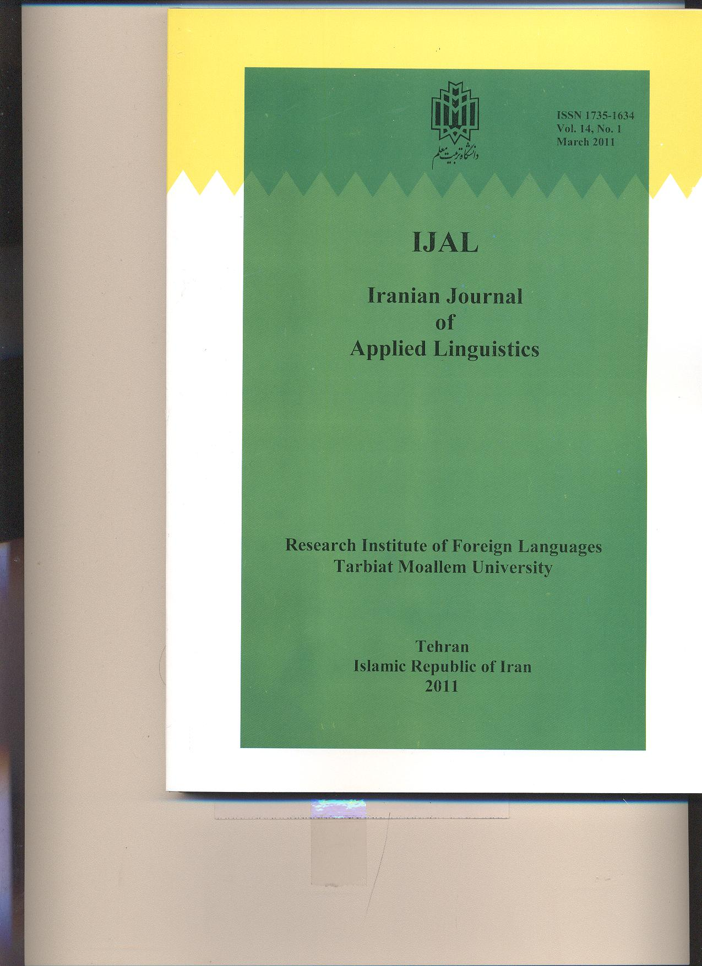
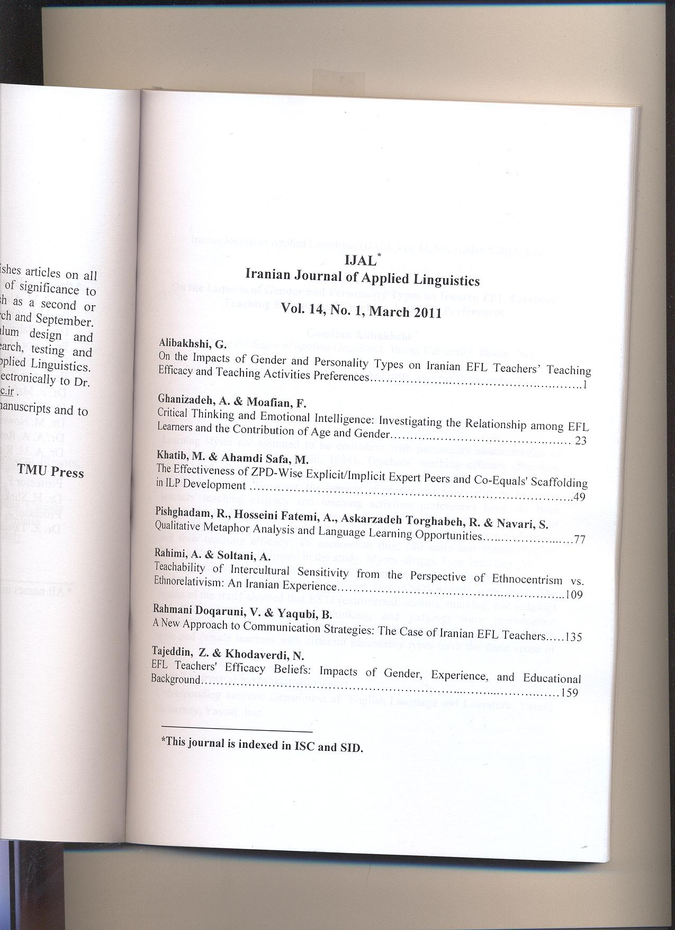
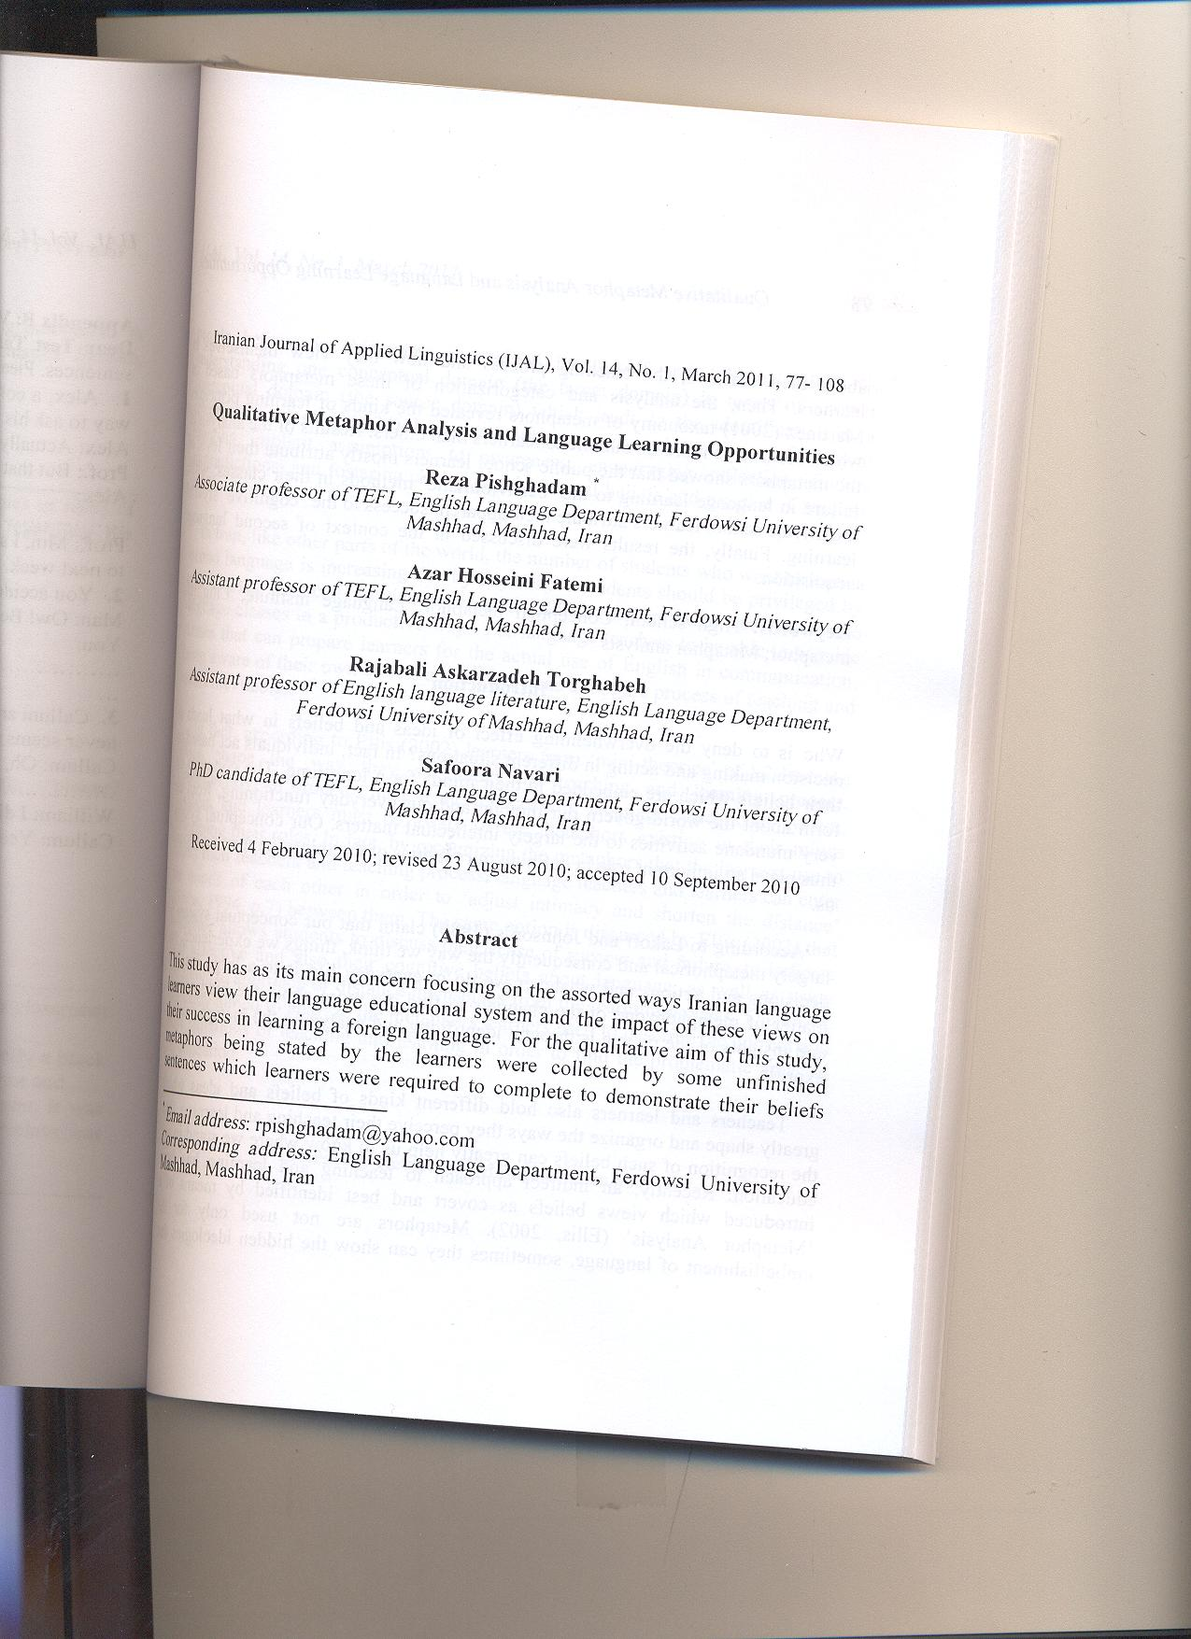

Qualitative Metaphor Analysis and Language Learning Opportunities

Reza Pishghadam
Associate professor of TEFL, Ferdowsi University of Mashhad, Mashhad, Iran

Azar Hosseini Fatemi
Assistant professor of TEFL, Ferdowsi University of Mashhad, Mashhad, Iran

Rajabali Askarzadeh Torghabeh
Assistant professor of English language literature, Ferdowsi University of Mashhad, Mashhad, Iran

Safoora Navari
PhD candidate of TEFL, Ferdowsi University of Mashhad, Mashhad, Iran

Abstract
This study has as its main concern focusing on the assorted ways Iranian language learners view their language educational system and the impact of these views on their success in learning a foreign language. For the qualitative aim of this study, metaphors being stated by the learners were collected by some unfinished sentences which learners were required to complete to demonstrate their beliefs about their teachers, the teaching process and how they view themselves as learners. Then, the analysis and categorization of these metaphors based on Martinez (2001) taxonomy of metaphors revealed the kinds of learning principles which seem to be more favourable to learners than others. Results of the analysis of the metaphors showed that the public school learners mostly attribute their level of failure in language learning to the ‘behaviouristic’ methods in their classes; while the private school learners attribute their apparent success to the ‘cognitive’ style of learning. Finally, the results were discussed in the context of second language acquisition.
Keywords: High School; Conceptual Metaphor; Language Institute; Linguistic Metaphor; Metaphor Analysis
Introduction
Who is to deny the overwhelming effect of ideas and beliefs in what leads to decision making and acting in different situations? In fact, individuals act based on their beliefs which are embedded in their minds for a long time. The concepts we form about the world govern our thought and our everyday functioning, from the very mundane activities to the largely intellectual matters. Our conceptual system thus plays an important role in defining our realities of the things happening around us.

According to Lakoff and Johnson’s (1980) claim that our conceptual system is largely metaphorical and consequently the way we think, things we experience, our decisions and actions and whatever we do in everyday life is to a large extent a matter of metaphor, one of the channels to find out more about the hidden ideas and insights of the people is through identifying and analyzing the metaphors they express.

Teachers and learners also hold different kinds of beliefs and ideas which greatly shape and organize the ways they perceive their teaching and learning, thus the recognition of such beliefs can greatly help us to know where we stand in our education: Recently, an indirect approach to teaching and learning has been introduced which views beliefs as covert and best identified by means of a ‘Metaphor Analysis’ (Ellis, 2002). Metaphors are not used only for the embellishment of language, sometimes they can show the hidden ideologies that people believe in. Metaphor as defined by Lakoff and Johnson (1980 “is understanding one conceptual domain (the target domain) in terms of another conceptual domain (the source domain) which leads to the identification of a conceptual metaphor”(p.34). In fact, metaphor as a research tool is a useful way of bringing implicit assumptions to awareness, encouraging reflection, finding contradictions, and fostering change in educational beliefs and practice (Cameron, 2003).

In Iran, like other parts of the world, the number of students who want to learn a second language is increasing day by day. Those students should be privileged by such classes that can provide them with skilful teachers who can handle the language classes in a productive way. For language teachers to be able to provide classes that can prepare learners for the actual use of English in communication, being aware of their own beliefs and conceptions about the process of teaching and seems inevitable.

In fact, according to Ellis (2002) learners form ‘mini theories’ of L2 learning which shape the way they set about the teaching and learning process. Consequently, in order to have a more successful language educational system, teachers and learners must be aware of the metaphors existing in their minds describing their roles. In fact, by recognizing the metaphors that the learners use to depict their teachers and teaching process, language teachers and learners can enter the minds of each other in order to ‘adjust intimacy and shorten the distance’ (Gibbs, 1994, p.7) between them. The same notion is discussed by Ellis (2002) that metaphor allows students to discuss their sense of success and failure, to indicate their affective and also their cognitive beliefs about language, as well as using metaphor to approach or distance themselves from the learning process. Therefore, this study aimed to analyze the metaphors learners used to describe the current and ideal situations of teaching and learning in order to find the problematic areas in our education.

Metaphor Analysis
While in the traditional theories, metaphor was just a matter of language, contemporary theory of metaphor puts emphasis on the fact that, metaphorical expressions are the matter of thought and are understood in the mind by mapping across domains in the mind. The proponents of the contemporary theory of metaphor hold that metaphors are ubiquitous and are used unconsciously and automatically in our everyday speech, shaping our thoughts and actions (Lakoff & Turner, 1989; Lakoff & Johnson, 1980; Lakoff, 1993). One of the unique features of the contemporary theory of metaphor is the distinction it makes between ‘conceptual metaphors’ or metaphorical concepts the one hand, and ‘linguistic metaphors’ or metaphorical expressions on the other hand (Lakoff & Johnson, 1980). In this distinction, conceptual metaphors refer to those abstract notions such as ARGUMENT IS WAR and LOVE IS A JOURNEY while linguistic metaphors are the actual linguistic phrases that realize or instantiate those notions in different ways. According to the convention of cognitive linguistics (Kovecses, 2002), conceptual metaphors are presented in upper case and linguistic metaphors in italics. In everyday speech, we use metaphorical linguistic expressions (MLEs) in order to make ourselves more understandable by others and these metaphorical expressions are based on the source domain, while the conceptual metaphors can be taken from these MLE.

As it was mentioned, learners bring with them a myriad of experiences, beliefs, assumptions and ideas about teaching and learning into language learning system. These beliefs can be explicit or implicit for learners; they may keep learning and dealing with teacher and other students based on them for years without knowing that most of their own success or failure somehow or other depend on these beliefs. Actually, as Williams and Burden (1997) suggest, the learners’ self-concept can have a huge impact on how they learn a language. A student who feels so low of himself, has a negative self-concept as a language learner no matter how much the teacher tries to help him by providing suitable situation, he will probably still have a sense of embarrassment, not being such a risk-taker to get involved in classroom activities or conversations.

Conversely, if a student has a positive self-concept of himself as a language learner, he will be able to set more optimistic roles to learn second language, he may participate more in classroom activities and take more risks since he is much more motivated than the rest. So, for a learner to make best use of the language learning situation it’s a must to be aware of his ideas and beliefs about his capabilities which is shaped in his mind as his self-concept and he may not be fully aware of it. These ideas may have various attributes as Ellis (2002) identified some of learners’ attributes about language learning and their ability to learn a second language. Such attributes may include: the language they want to learn, the best way for learning that, the importance of learning English in their specific culture, and the extent to which they expect to be successful.

The implicit ideas of learners which characterize the approach they favour to learn a language may be at variance with that of the teacher and also of the aims of the language course they are doing (Stern, 1992). Considering that there may be a mismatch between language learning and teaching in our education, one can conclude that language teachers and learners by not being aware of each others’ beliefs’, sometimes are not on the same wavelength and that they are exploring distinctive avenues to achieve their goals.

As Lakoff and Johnson (1980) surely stated, metaphors are unconsciously and pervasively used in our everyday talk and they are central to our conceptual system in terms of the ways we act and think, and are rooted in our physical and cultural experience (Gibbs, 2005), therefore the analysis of the metaphors people use can provide a novel way to studying the underlying beliefs and ideas which people hold and causes them to enjoy specific ways of thinking and behaviour (Schmitt, 2005). So, the use of metaphors to find out about the learners’ implicit ideas which may be as the result of their past experiences of learning a language, or their cultural background, or their personality traits like their self-image and self-efficacy, seems to be an effective, promising tool. Metaphor as a multifaceted device can be both utilized as a window to view the belief system of students and also as a consciousness-raising approach to promote learning and teaching achievements in the classroom.

Dórnyei (2005) emphasises the importance of doing researches to identify the learners’ belief system about language learning and its contribution to our understanding of SLA. He believes that by identifying the realistic learner beliefs and offering it to them to reflect on, we can create a kind of motivational strategy by raising the learners’ awareness of their current beliefs and letting them know that if they be able to change their negative ideas they are going to be more successful in learning a language. In addition, metaphor analysis enjoys the privilege of considering the cognitive and affective aspects of people’s beliefs which have been neglected in traditional methods such as the closed-item belief questionnaire (BALLI) by Horwitz (1987) which was designed to let the learners become more aware of their ideas by checking those statements in the questionnaire that were true for them (cited in Stern, 1992).

Several studies have investigated the metaphors SLA researchers use to discuss L2 acquisition. Kramsch (1995) refers to the ‘input-black box-output’ metaphor which is dominant in SLA and makes it easier for researchers to talk about teaching and learning process. Ellis (2001) analyses some articles written by several SLA researchers to identify the metaphors they use such as ‘learner as machine’ metaphor which is widely used by researchers. Oxford (2001) used some personal narratives kept by language learners to identify the metaphors by which they characterize three teaching approaches (cited in Ellis & Barkhuizen, 2005).

Oxford et al. (1998) gathered the metaphors used by learners to talk about their concept of teacher. These metaphors were then organized under four philosophical perspectives of education to provide a typology for the language teaching field. Actually, in education research, metaphor analysis has often been used as a cognitive tool to raise awareness about assumptions and beliefs held by teachers and learners alike (Bullough, 1991; Marchant, 1992; Marshall, 1990; Munby, 1987; Strickland & Iran-nejad, 1994) (cited in de Guerrero & Villamil, 2002).

Ellis (2002) examined the metaphors in diaries of some beginner learners of L2 to find out what their belief system reveal about the language they are learning, their teacher and themselves. Nikitina and Furuoka (2008), using the context of Malaysian education, gathered some metaphors from language learners in perception of their language teachers, then categorized and analyzed these metaphors based on the typology of metaphors on education developed by Oxford et al., 1998. While most of the studies deal with the learners’ attitudes toward their teachers, Swales (1994) conducted a study on the learners’ perceptions of language learning. In this study, the learners were asked to describe their perception of learning a foreign language by drawing cartoons, the results of which were closely related to the learners’ social and political experiences in the countries they came from (cited in Nikitina & Furuoka, 2008).

In a recent study, Pishghadam (2008) reported that learning English at institutes is seen to yield more promising results comparing with learning English in the formal context (schools) in Iran and the learners seem to gain more rewarding outcomes. Due to probable existence of problems between L2 learning and teaching at schools and language institutes in our education, in the present study, in addition to analysis of metaphors, a comparison is also made between the school and language institute learners’ use of metaphors. To categorize the metaphors and thus draw a systematic comparison among them in the present study, a metaphoric model whose guidelines were taken from a study by Martinez, Sauleda, and Huber (2001) was used in which the metaphors were categorized into three main dimensions of the learning space: behavioristic/empiricist, cognitive/constructive and situative/socio-historic perspective.

In the behaviourist/empiricist view, knowledge is interpreted as accumulation of associations which are resulted from experience and process of learning as generating new (S-R) connections between the units of “sensory impressions” and “individual response”. Thus the metaphors falling into this category reflect the learners as passive recipients, teachers as transmitters of knowledge, and learning as a process of individual growth by the acquisition of knowledge in the form of new associations. The second perspective, the cognitivist/constructivist, includes the metaphors which view knowledge as consisting of interrelated schemata that are actively and individually constructed by transferring old schemata into new ones or by inductively developing new schemata from a series of different experiences. The mind here is pro-active, problem-oriented, and interpretative, teacher is considered as a facilitator and a coach and the learner as an active re-constructor of knowledge who constantly organizes and elaborates knowledge with an active role in restructuring the experiences and achieving conceptual coherence (Martinez, Sauleda, & Huber, 2001).

In the third category that deals with the situative view of learning (Greeno, Collins, & Resnick, 1996) the dominant belief is that learners should become able to interact with the physical world. Metaphors arising from a situative or socio-historical perspective reflect the view that learning is situated in the context in which it is used. In this category teacher can be seen as the North Star guiding the explorer (learners) to find their way during the journey of learning. Teacher and learners can perform a joint job like ants, working collaboratively to get a result or like a tourist guide negotiating a route with the tourists.

Purpose of the Study
The major aim of this study is to put language learners in situations to provide metaphors expressing their hidden beliefs and ideas about teaching and learning and analyzing those metaphors to trace the roots of disapprovals in Iranian formal and informal contexts of English language education. Therefore, the present study addresses the following questions:
Q1: What are the metaphors provided by school learners about teaching and learning in the current and ideal situations?
Q2: What are the metaphors provided by language institute learners about teaching and learning in the current and ideal situations?
Methodology
Participants and Setting
To carry out the comparison between two contexts of L2 education, a group of 50 language learners at high schools (Hoda, Fateh, and Zahraye Marzie High schools) and another group of 50 learners from some language institutes in Mashhad (Kish and Danesh Language Institutes) were selected to participate in this study. The school students were studying in the third grade of high school and the language learners at the institutes had different educational background but both groups were truly eager in taking part in the study.

The average age of the students at the schools was 16 with little or none .experience of studying English at private institutes but having studied English at schools for almost 6 years, while the average age of the students at the language institutes was 18 who had several years of studying English at different institutes. Before asking the learners to take part in the study in order to ensure the homogeneity of the groups with respect to the language proficiency, Nelson’s intermediate test was utilized.

Instrumentation
In order to address the research questions, two instruments were utilized in this study. First, in order to measure and determine the learners’ level of general English language proficiency and ensure their homogeneity, the learners at the schools and institutes were required to do the Nelson’s intermediate level test. Thus, test 200 D of Nelson test battery was used as the language proficiency test in this study.

Each of the 40 tests in this battery consists of 50 items in the form of multiple choice questions and students are supposed to choose the correct answer from among the alternatives. The required time to complete the test is 50 minutes. At each level the passing score is intended to be 30 (60%).
As for the second instrument, the participants were asked to take part in discussion groups which were held by the researcher both in the schools and language institutes separately. The topics of the discussion groups were about learners` attitudes towards real and ideal teaching and learning situations in both formal and informal contexts of education. These discussions aimed at extracting as many metaphors as possible about the teachers in both contexts. Having discussed the issues, the participants filled out the forms, which were comprised of four sections with the prompts: “I think a teacher is like a...”, “I think a teacher should be like a...”, I think a learner is like a...” and “I think a learner should be like a...”. The raison d’être of such prompting was to gain the attitudes of learners for their teachers about the status quo as well as the ideal situations, that `s why is and should were employed in the prompts. The participants were asked to complete the sentences with as many (omit) metaphors they want to mention describing the teachers and/or learners. In this stage, they were also provided by a blank piece of paper to write down the metaphors about teachers and learners in any other forms they might prefer (see Appendix A).

The learners were free to express their ideas in both English and Persian since it was difficult for some of them to come up with the English equivalents and the purpose of the study was mainly to collect their ideas. As a matter of fact, the learners were so willing to put down lots of metaphors in one session that the researchers had to confide themselves to that very session.

Data Collection and Analysis
In October (2008) the process of data collection was commenced and continued until December (2008) so that all the data was gathered in high schools and language institutes. Since in this study a qualitative approach was employed, a metaphor-elicitation instrument was utilized which consisted of a form with an instruction and a prompt: “I think a language teacher/learner is like a...” that required the subjects to express their ideas about what they usually believe about the language teacher and learner; also were required to complete this sentence “I think a language teacher/learner should be like a...” so that the subjects were able to provide some insights about their ideal teacher and learner. In this phase, the subjects were asked to write down as many metaphors as they pleased to express their views of their teachers and learners and also to provide an explanation or entailment for the given metaphor to make it easier for analyzing and categorization.

The data collected by the use of prompts displayed the learners’ beliefs and views about the current and ideal situation of English teachers and learners in some formal and informal contexts of language education in Iran. According to Moser (2000), Metaphor Analysis is essentially a qualitative research methodology which allows the researcher to identify, explore, categorize, and discuss the hidden beliefs and ideas behind each metaphorical concept. Thus, the forms that subjects had filled with their metaphors about teachers and learners were analyzed based on the guidelines suggested by de Guerrero and Villamil (2002) and confirmed by Ellis and Barkhuizen (2005).

As for the first step, analyzing the data started with organizing the metaphors generated by the subjects so that they were listed verbatim alongside with their entailments. Next, the data was scrutinized to identify the metaphors that actually were related to the subject of the study and could clarify some hidden concepts about English educational process. In this stage 136 collected metaphors (76 about teachers, 41 about learners, 19 as self referential) were codified according to the typology of metaphors developed by Martinez, Sauleda, and Huber (2001) into one of the three categorizations of learning: behaviourist/empiricist, cognitivist/constructivist, situative or socio-historical perspectives. At last, each metaphorical group was coded and categorized by the researcher first individually and then in a discussion with one expert so that the final categorizations were approved by the researchers.

Any kind of Metaphor Analysis requires the researcher to select some certain framework into which he can fit the collected metaphors. Our study was not an exception to that. Actually, it is the very nature of metaphor that exerts a kind of subjectivity on the researcher (Ellis & Barkhuizen, 2005). For the above mentioned reasons, in the present study the attempt was to categorize as many metaphors as possible into the categories and the rest which due to their entailments could escape the purpose filter of our study were introduced as self-referential.

Results
The comparison between the metaphors selected at schools and institutes provided some illuminating results. All the metaphors produced by the participants that could fit into the framework introduced by Martinez (2001) along with their entailments are presented in appendix B. Some other metaphors that did not include any entailments and could not be classified into our categories are not mentioned in these tables and were exclusively classified as ‘self-referential’.

Schools
Metaphors for Teachers
Table 1
The frequency and percentage of school learners’ metaphor for teachers in the current situation
(Note: In the following tables, the notions Behaviourism, frequency, percentage, Cognitivism, and Situative learning are abbreviated due to the shortage of space.)
BEH. | f/p | COG. | f/p | SIT. |  | f/p | SELF |  | f/p
watch | 1,0.73% | father | 1, 0.73% | policeman | 1,0.73% |  | pen |  | 1,0.73%
Robot | 39,28.46% | mother | 12, 8.75% | moon | 2,1.45% |  | clown |  | 2,1.45%
bomb | 1,0.73% | player | 4, 2.91% | vehicle | 1,0.73% |  | evil |  | 1,0.73%
military officer | 3,2.18% | team coach | 1, 0.73% | airplane | 3,2.18%
monster | 3,2.18% | guide | 2, 1.45% | boat | 1,0.73%
employer | 1,0.73% | true friend | 15,10.94% | traffic light | 1,0.73%
Narcissus | 3,2.18% | aunt | 1, 0.73% | referee | 1,0.73%
bad chef | 1,0.73% | granny | 3, 2.18% | farmer | 1,0.73%
factory manager | 4, 2.91% | CD player | 2, 1.45%
Boss | 2, 1.45% | artist | 1, 0.73
Book | 4, 2.91% | tree | 2, 1.45%
recorded CD | 2, 1.45%
carpenter | 2, 1.45%
computer | 2, 1.45%
Idol | 1, 0.73%
Wall | 1, 0.73%
Total | 78, 56.94% | total | 44,32.12% | total |  | 11,8.03% |  | total | 4,2.91%

You may have the right to be puzzled since as we mentioned before the nature of metaphor and the subjective burden it puts on the shoulders of the researcher, provide such confusion. It is worth mentioning that as there are different entailments for any given metaphor in the mind of speaker, the interpretation of us which have been done based on such entailment that the learners provided for us may differ with that of yours with other entailments.

As evident in Table 1, the dominant numbers of metaphors for the school learners are located in the behaviorist category (p=56.94%). This means that the school learners consider their language teachers as following the principles of the behaviorist perspective. They apparently enjoy little participation in the learning process and are supposed to be passive and to obey the teacher in his authoritative procedures.
Table 2
The frequency and percentage of school learners’ metaphors for teachers in the ideal situation
BEH. | f/p | COG. | f/p | SIT. |  | f/p | SELF | f/p
Lion | 2, 1.09% | sister | 5, 2.74% | caterer | 1, 0.54% |  | flower | 1, 0.54%
Boss | 1, 0.54% | mother | 30, 16.48% | sun | 1, 0.54% |  | candy | 1, 0.54%
strict manager | 1, 0.54% | close friend | 35, 19.23% | tour guide | 3, 1.64% |  | pure water | 1, 0.54%
 |  | artist | 9, 4.94% | consultant | 7, 3.84%
 |  | player | 6, 3.29% | moon | 3, 1.64%
 |  | group leader | 24, 13.18% | fast train | 2, 1.09%
 |  | beekeeper | 3, 0.64% | star | 4, 2.19%
 |  | guide | 2, 1.09% | host | 9, 4.94%
 |  | comedian | 3, 1.64% | sky | 1, 0.54%
 |  |  |  | airplane | 2, 1.09%
 |  |  |  | life guard | 13, 7.14%
 |  |  |  | nurse | 12, 6.59%
Total | 4, 2.17% | total | 117, 64.35% | total | 58, 31.90% |  | total | 3, 1.64%

Table 2 reports that the school learners would prefer their teachers to be mostly classified under the category of cognitive/constructive metaphors (p=64.35%). This implies that the school learners no longer like to be under the umbrella of behaviorism (p=2.19%), instead they would rather have a facilitator teacher in the class who provides a friendly atmosphere for them to learn meaningfully.

Metaphors for Learners
Table 3
The frequency and percentage of school learners’ metaphors for learners in the current situation
BEH. | f/p | COG. | f/p | SIT. | f/p | SELF | f/p
sheep | 4,13.33% | child | 3,10% | flower | 2,6.66% | river | 1.3.34%
goat | 1,3.34% | friend | 1,3.34% | thirsty | 1,3.34% | sugar cube | 1,3.34%
exile | 1,3.34%
empty glass | 1,3.34%
stone | 2,6.66%
statue | 2,6.66%
recorder | 4,13.33%
sponge | 2,6.66%
recipient | 4,13.33%
total | 21,70.14% | total | 4,13.36% | total | 3,10.02% | total | 2,6.66%

According to Table 3, the most occurring metaphors in the school learners’ metaphors for learners belong to the behaviorist domain (p=70.14%). These learners also considered their teachers to be most of a behaviorist one who looks at them as passive participants in the class, empty containers waiting to be filled by the teacher’s knowledge. This implies the conceptualization of the learner as a dependent creature who is not able to make any decisions in his learning process.

Table 4
The frequency and percentage of school learners’ metaphors for learners in the ideal
situation
BEH. | f/p | COG. | f/p | SIT. | f/p | SELF | f/p
CD | 4,7.54% | friend | 14,26.41% | tourist | 8,15.09% | star | 1,1.89%
computer | 1,1.89% | good company | 2,3.77% | inventor | 4,7.54% | pencil | 2,3.77%
vacuum cleaner | 1,1.89% | player | 1,1.89%
cards | 2,3.77% | sister | 1,1.89%
 |  | spouse | 1,1.89%
 |  | child | 3,5.66%
 |  | team member | 8,15.09%
total | 8,15.09% | total | 30,56.7% | total | 12,22.68% | total | 3,5.66%

Interestingly, as it is presented in Table 4, the school learners provided most metaphors in the cognitive/constructive category of learning (p=56.7%). Such metaphors reveal the learners preference of being an active person in class whose values are respected, his learning styles are magnified, and is encouraged to construct his knowledge individually. There is no doubt that the learners can fulfil their potentials and develop their skills following the dynamics of cognitive/constructive view of learning.

Language Institutes
Metaphors for Teachers
Table 5
The frequency and percentage of institute learners’ metaphors for teachers in the current situation
BEH. | f/p | COG. | f/p | SIT. | f/p | SELF | f/p
dictionary | 3, 3.44% | close friend | 18, 20.68% | moon | 2, 2.29% | canary | 1. 1.15%
machine | 1, 1.15% | engine | 3, 3.44% | sun | 1, 1.15% | spring cloud | 1, 1.15%
master | 1, 1.15% | coach | 2, 2.29% | starry night | 1, 1.15%
robot | 2, 2.29% | group leader | 1, 1.15% | psychologist | 10, 11.49%
Fire alarm | 1, 1.15% | sister | 1, 1.15% | driver | 1, 1.15%
radio | 1, 1.15% | mother | 2, 2.29% | shepherd | 5, 5.74%
book | 5, 5.74% | guide | 10, 11.49% | make-up artist trainer | 1, 1.15%
leader | 1, 1.15% | player | 14, 16.09% | architect | 1, 1.15%
boss | 1, 1.15% | father | 3, 3.44%
strict judge | 1, 1.15%
monster | 1, 1.15%
good speaker | 1, 1.15%
speaking bird | 1, 1.15%
total | 20, 22.9% | total | 43,49.45% | total | 22, 25.3% | total | 2, 2.29%

Table 5 exhibits that the maximum of metaphors produced by the institute learners about their teachers is classified in the cognitive/constructive mode of learning (p=49.45%). That means that they view their teachers as close friends (p=20.68%) with whom they can share a lot in the process and learning, who kindly promotes his development in constructing his knowledge of English.

Table 6
The frequency and percentage of institute learners’ metaphors for teachers in the ideal situation
BEH. | f/p | COG. | f/p | SIT. | f/p | SELF | f/p
dictionary | 2,2.29% | father | 3,3.44% | researcher | 3,3.44% | apple | 1,1.15
machine | 1,1.15% | close friend | 10,11.49% | road sign | 2,2.29% | magnetic | 1,1.15
manager | 1,1.15% | sister | 1,1.15% | moon | 2,2.29% | eraser | 1,1.15
strict professor | 1,1.15% | brother | 2,2.29% | sky | 1,1.15%
master | 1,1.15% | colleague | 4,4.59% | host | 1,1.15%
 |  | classmate | 3,3.44% | sun shine | 1,1.15%
 |  | engine | 1,1.15% | tour guide | 9,10.34%
 |  | player | 3,3.44% | ladder | 3,3.44%
 |  | guide | 3,3.44% | waiter | 2,2.29%
 |  | artist | 2,2.29% | mechanic | 5,5.74%
 |  | comedian | 4,4.59% | host | 8,9.19%
 |  |  |  | nurse | 4,4.59%
 |  |  |  | referee | 2,2.29%
total | 6,6.9% | total | 35,40.25% | total | 43,49.45% | total | 3,3.44

As it is presented in Table 6, the language institute learners have formulated 49.45% situative metaphors about their ideal teacher. Thus, these learners would prefer to have a teacher who pays considerable attention to the context and the activities employed in the learning process. The notion of their ideal teacher is the one who lets the learner create knowledge which is the by-product of the activity in which the learners and the teacher are involved.

Metaphors for Learners
Table 7
The frequency and percentage of institute learners’ metaphors for learners in the
current situation
BEH. | f/p | COG. | f/p | SIT. | f/p | SELF | f/p
desert | 1,2.33% | friend | 8,18.60% | lawyer client | 2,4.65% | parrot | 1,2.33%
Doll | 2,4.65% | sister | 3,6.97% | builder | 4,9.30% | Davincie code | 1,2.33%
Eye | 1,2.33% | baby | 4,9.30%
Toy | 2,4.65% | player | 4,9.39%
piano | 1,2.33% | doctor assistant | 4,9.30%
recipient | 1,2.33%
copy- machine | 4,9.30%
total | 12,27.96% | total | 23,53.59% | total | 6,13.98% | total | 2,4.65%

Based on Table 7, the institute learners hold the view that the learners in some of the language institutes are mostly following the cognitive/constructive domain of learning (p=53.59%). Evidently, these learners consider themselves as being involved in classroom activities, making decisions for the changes in their learning process and evidently being able to construct their knowledge of English in a friendly, cooperative connection with teacher and other learners.

Table 8
The frequency and percentage of institute learners’ metaphors for learners in the ideal situation
BEH. | f/p | COG. | f/p | SIT. | f/p | SELF | f/p
sponge | 1,2.05% | team  member | 4,8.16% | plant | 10,20.4% | carpet | 1,2.05%
memory card | 1,2.05% | sister | 1,2.05% | car-  passenger | 2,4.08% | movie | 1,2.05%
suitcase | 1,2.05% | friend | 8,16.32% | TV-show-contestant | 4,8.16%
mirror | 1,2.05% | amateur  swimmer | 2,4.08% | patient | 4,8.16%
 |  | child | 3,6.12% | customer | 5,10.2%
 |  | basketball  player | 2,4.08%
total | 4,8.16% | total | 20,41% | total | 23,47.15% | total | 2,4.08%

And finally, Table 8 demonstrates the institute learners’ metaphors for how they believe a successful learner should be. The examination of their metaphors shows that the situative metaphors (p=47.15%) are more prevalent in this group. The institute learners seem to prefer a learning situation in which they can learn their best in special activities and contexts where they can construct the meaning socially and practice the use of language in true to life contexts.

We again are obliged to repeat ourselves that any type of analysis dealing with metaphors, their identification, interpretations, analyses and even categorizations are quite subjective and the researchers in this study tried hard to observe the requirements of fitting the metaphors in the categories outlined by Martinez, Sauleda and Huber (2001).

Conclusion
According to Cameron and Low (1999), metaphor analysis involves “collecting samples of linguistic metaphors used to talk about the topic...generalizing from them the conceptual metaphors they exemplify, and using the results to suggest understandings or thought patterns which construct or constrain people’s beliefs and actions” (cited in Ellis & Barkhuizen, 2005, p.317). This study gained metaphors about teachers and the attempt was done to categorize them according to the guidelines offered by Martinez, Sauleda and Huber (2001) into behaviorist, cognitive and situative learning types of metaphors and the rest were introduced as self-referential.

As the results of this study demonstrate, by organizing the metaphors on teachers and learners around the three perspectives of behaviorist, cognitive and situative learning, some noteworthy and significant points about the present and ideal situations of language teachers and learners in Iran`s English education were gained. According to Martinez, Sauleda and Huber (2001) by disclosing the metaphorical base of thinking about teaching and learning, researchers can assist learners to bridge the gap between their implicit and explicit knowledge. Therefore, analysis of the data clarified that the school learners think of themselves and their current teachers as those with behaviourist characteristics, where teacher has the of classical roles of leader (boss, military officer, manager), provider of knowledge (book, dictionary, recoded CD), agent of change (captain, animal trainer, carpenter), agent of control (strict judge, factory manager, traffic warden) with the conceptual metaphor of TEACHER AS CONDUIT which represent his role as holder, provider and transmitter of knowledge. Such roles do not seem to consider any feelings for the teacher to share with her learners instead they represent just a kind of mission she has to accomplish. Consequently, the metaphors like empty glass, sponge, vacuum cleaner and recorder about language learners, emphasizes the conceptual metaphor of LEARNER AS RECIPIENT which does not leave much space for the activity of the leaner in the process of learning. These findings somehow reveal the maintenance of the behaviouristic guidelines in language schools are compatible with those of Pishghadam and Mirzaee (2008) which asserted that Iran’s educational system is still under the influence of modernist, behaviourist and positivist views of learning.

On the other hand, these learners at schools expressed their preference for a greater involvement and a more intense interaction with the teacher. Thus, these learners are aimed at strengthening their connection with the teacher, to get more involved in learning activities and construct their own meaning of English. Their friend, parent, guide, group leader and colleague metaphors for ideal teachers with theme of TEACHER AS FACILITATOR and child, player, baby and cooking trainee for the ideal learners conveying the conceptual metaphor of LEARNER AS DEVELOPING ORGANISM, reflects those learners’ bold decision in promoting to a cognitive/constructivist class which reveals their understanding of their teachers’ dysfunction in getting fruitful results from their present classes and the fact that they have faced a neglect of their needs.

Besides, the institute learners considering themselves as cognitive/constructive English learners illustrated their opting for learning English in situative or socio-historical mode of learning. In fact, producing metaphors like caterer, tour guide, host, policeman, ladder and mechanic for their ideal teachers with the conceptual metaphor of TEACHER AS SCAFFOLDER who stays in the activity of the group, providing support and guidance; and metaphors like tourist, inventor, patient and builder for the ideal learners reinforcing the theme of LEARNER AS INTERACTOR whose interaction in situated collaborative activities get him to enjoy much social support and stimulation for better learning, draws more attention to learners’ will to learn English in social processes and joint activities where knowledge is seen as situated, by-product of the activity, context and the culture in which it is developed and used.

Being interested in learning L2 in an appropriate context confirms this idea of Brown, Collins and Duguid (1989) that acquiring the de-contextualized knowledge is not helping to the present language learners to use their language in a real life situation. Thus, the institute learners’ choice of situative as their best way of learning implies a further step they take in learning another language in comparison with the school learners who still long for a cognitive/constructive teaching situation.
Clearly, finding out these hidden beliefs and views, turning implicit insights into explicit ones for teachers to reflect on, is one of the many contributions to the myriad of problems in the English language education in Iran. So trying to get into the depth of teachers belief system, exploring the parts which affect teaching, presenting the hidden ideas to the teachers and asking teachers to reflect on them to make probable changes or modifications seem to be an inevitable need in Iranian contexts of English education. Accordingly, another remarkable advantage of knowing someone’s beliefs can be revealed in the factors which are actually promoting or hindering learning for learners at schools or institutes since learners as well as teachers hold some views about teaching and learning which will consequently affect the way and styles they apply in the classroom.

This research also contained some limitations. As the proponents of scientific research claim, nothing can be self evident unless verified by observation or experimentation. To do any type of observation or experiment, one may face with some limitations and problems. This study could have come to somewhat more different results than it did, if it were not confronted with the following limitations. First, this study was conducted in some schools and language institutes in Mashhad while more research can take place in universities or in other cities of Iran to compare the results. The second limitation of this research was that sex and major of the participants in both contexts were not controlled. Finally, students in institutes are generally students in schools which can affect their conceptualizations of teachers and learners.

References
Brown, J. S, Collins, A., & Duguid, P. (1989). Situated cognition and the culture of learning. Journal of Educational Researcher, 18(1), 32-42.

Bullough, R.V. (1991). Exploring personal teaching metaphors in pr-eservice teacher education. Journal of Teacher Education, 42, 43-51.

Cameron, L., & Low, G. (1999). Metaphor. Language Teaching, 32, 77-96.

Cameron, L. (2003). Metaphor in educational discourse. London: Continuum.
de Guerrero, M., & Villamil, S. (2002). Metaphorical conceptualizations of ESL teaching and learning. Language Teaching Research, 6, 95-120.

Dornyei, Z. (2005). The psychology of the language learner: Individual differences in second language acquisition. New Jersey: Lawrence Erlbaum Associates.

Ellis, R. (2002). A metaphorical analysis of learner beliefs. Asian EFL journal. Retrieved from: http://asian-efl-journal.com/Learner-Beliefs-&-Language Learning.ppt.

Ellis, R., & Barkhizen, G. (2005). Analyzing learner language. Oxford: Oxford University Press.

Fowler, W. S., & Norman, C. (1976). Nelson English language tests. Middlesex: Thomas Nelson.

Gibbs, Jr. R.W. (1994). Figurative thought and figurative language. In M. A. Gernsbacher (Ed.), Handbook of psycholinguistics (pp. 411-446). San Diego, CA: Academic Press.

Greeno, J. G., Collins, A., & Rensik, L. B. (1996). Cognition and learning. In D. C. Berliner & R. C. Calfee (Eds.), Handbook of educational psychology (pp.16-46). New York: Simon & Shuster Macmillian.

Horwitz, E. K. (1987). ‘Surveying students’ beliefs about language learning’. In A.Wendon & J. Rubin (Eds.), Learner strategies in language learning (p. 268). London: Prentice Hall.

Kovecses, Z. (2002). Metaphor: A practical introduction. Oxford: Oxford University Press.

Krasmsch, C. (1995). The applied linguist and the foreign language teacher: Can they talk to each other? Australian Review of Applied Linguistics, 18, 1-16.
Lakoff, G., & Johnson, M. (1980). Metaphors we live by. Chicago: University of Chicago Press.

Lakoff, G., & Turner, M. (1989). More than cool reason. Chicago: University of Chicago Press.

Lakoff, G. (1993). The contemporary theory of metaphor. In A. Ortony (Ed.), Metaphor and thought (pp. 4-50). Cambridge: Cambridge University Press.

Marchant, G. J. (1992). A teacher is like a...: Using simile lists to explore personal metaphors. Language and Education, 6, 33-45.

Marshall, H. H. (1990). Metaphor as an instructional tool in encouraging student teacher reflection. Theory into Practice, 29, 128-132.

Martinez, M. A., Sauleda, N., & Huber, G. L. (2001). Metaphors as blueprints of thinking about teaching and learning. Journal of Teaching and Teacher Education, 17, 965-977.

Moser, K. S. (2000). Metaphor analysis in psychology: Method, theory, and fields of application. Forum: Qualitative Social Research. Retrieved from: http://qualitative-research.nrt.fqs.

Munby, H. (1987). Metaphor and teachers’ knowledge. Research in the teaching of English, 27, 377-397.

Nikitina, L., & Furuoka, F. (2008). ‘A language teacher is like...’: Examining Malaysian students’ perspective of language teachers through metaphor analysis. Electronic Journal of Foreign Language Teaching, 5, 192-205.

Oxford, R. L., Tomlinson, S., Barcelos, A., Harrington, C., Lavine, R. Z., Aaleh, A., & Longhini, A. (1998). Clashing metaphors about classroom teachers: toward a systematic typology for the language teaching field. System, 26, 3-50.

Oxford, R. L. (2001). ‘The bleached bones of a story’: Learners’ constructions of language teaching. In M. Breen (Ed.). Learner contribution to language learning. London: Longman.

Pishghadam, R. (2008). The content analysis of the books for English language learning in Iran’s formal and informal contexts of language education in light of MI, EI and mediation theory. Paper presented in the first conference on formal education, Ferdowsi University, Mashhad, Iran.

Pishghadam, R., & Mirzaee, A. (2008). English language teaching in postmodern era. TELL, 2, 89-109.

Schmitt, R. (2005). Systematic metaphor analysis as a method of qualitative research. The qualitative report, 10, 358-379.

Stern, H. H. (1992). Issues and options in language teaching. Oxford: Oxford University Press.

Strickland, C. R., & Iran-Nejad, A. (1994). The metaphoric nature of teaching and learning and the role of personal teaching metaphors. Paper presented in the Annual Meeting of the Mid-South Educational Research Association, Nashville.

Swales, S. (1994). From metaphor to meta-language. English Teaching Forum online, 32, 8-11.
Retrieved from: http:/exchanges.state.gov/forum/vols/vol32/no3/p8.htm.

Williams, M., & Burden, R. L. (1997). Psychology for language teachers. A social constructivist approach. Cambridge: Cambridge University Press.

Appendices
Appendix A

What is your idea of a language teacher?
Try to complete the following sentence in as many ways to reflect your ideas of a language teacher.
☺ A language teacher is like...
- ................................
- ................................
- .................................
- .................................
- .................................
- .................................
- .................................

What is your idea of an ideal language teacher?
Try to complete the following sentence in as many ways to reflect your ideas of an ideal language teacher.
☺ An ideal language teacher should be like...
- .....................................
- .....................................
- .....................................
- .....................................
- .....................................
- .....................................
- ....................................

What is your idea of a language learner?
Try to complete the following sentence in as many ways to reflect your ideas of a language learner.
☺ A language learner is like...
- ................................
- ................................
- .................................
- .................................
- .................................
- .................................
- .................................

What is your idea of an ideal language learner?
Try to complete the following sentence in as many ways to reflect your ideas of an ideal language learner.
☺ A good language learner should be like...
- .....................................
- .....................................
- .....................................
- .....................................
- .....................................
- .....................................
- .....................................

Appendix B
Table 1: Metaphors about teachers
behaviourist | cognitive/constructive | situative/socio-historic
Lion(the king of the class) | friend(helping you in any situation) | caterer(provide you with needed service in an occasion)
strict manager(everybody should follow his rules) | sister(caring, helps you anytime) | sun(provides light in when you are lost in learning)
boss(he decides for everything in class) | mother(kind, helping and supporting, believing in you) | tour guide(when on travel, guides you to best places)
watch(he is set to work carefully, the same everyday) | father(you can count on him in any situation) | consultant(helps you out in problems)
robot(emotionless, pre-programmed) | team coach(guides the players how to learn and win) | moon(provides light when you are lost in learning)
bomb(he is set to work based on a program, no feelings) | player(you are in one team cooperating to win) | fast train(carries you to destination when you are in hurry)
monster(terrifies, so strong) | group leader(he decides with others for the group) | star(shows you the way when dark in learning)
military officer(forcing others to obey him, strict) | beekeeper(takes care of bees, protecting and helping them to produce something) | host(serves you when you are his guest)
employer(sets the rules for you to obey) | artist(by his art turns the class to an interesting place to learn together) | sky(so wide and generous, gives you hope when you are lost)
Bad chef(is in charge of food and you have to eat even his bad food) | guide(guides for anything)  comedian(by his comedy attracts your attention to learn easier) | driver(carries you when you want)  airplane(carries you safe and fast, providing services)
factory manager(sets the rules) | aunt(you feel close to her talking about your problems) | life guard(saves your life in danger of failing)
Narcissus(thinks so high of himself, knows best) | granny(kind, listens to you, gives advice) | nurse(looks after you when you are back in learning)
book(pre-written, fixed) | tree(anytime you want you can lean to it; always green giving you hope and support) | policeman(in dangerous situations he will protect you, takes you home safely)
recorded CD(you have to listen to what already is in it) | CD-player( you can record and also listen to your favourite music) | vehicle(carries you to destination when you need him)
carpenter(you have no move, he makes things out of you) | engine(provides you with suitable energy to learn) | boat(saves you in wild waters of learning problems)
computer(pre-programmed, you can work with it with no change) | classmate(makes you feel comfortable with her, share your problems with) | traffic light(shows you when to move when to stop)
idol(shows a high profile of himself, makes you worship him) | brother(is always there to support you) | referee(being an expert, guides you how to learn, when to change the learning style)
wall(thinks high and strong of himself, prevents your creativity) | colleague(helps you to improve your work, doesn’t feel higher than you) | starry night(in darkness of ignorance shows you the way)
dictionary(is accepted as the original thing you have to refer to, is always true) |  | psychologist(you can refer to her in any problem that prevents you from learning)
machine(emotionless, makes products out of you) |  | shepherd(looks after you while you are learning around!)
master(you must obey, whatever he says is right) |  | make-up artist trainer(trains you skills for special occasions)
fire alarm(only when you are making a mistake calls for you) |  | farmer(takes care of you by providing needed help for you to grow)
manager(manages and controls everything in his own way) |  | road sign(leads you not to get lost on learning road)
leader(is the supreme power, must obey him) |  | architect(helps you to build you home also respects your ideas)
strict judge(you can’t object) |  | ladder(you can use her to go higher in learning)
good speaker(fascinates you by his talk, no will on your side) |  | sunshine(when you are growing her existence is essential)
speaking bird(thinks he sings great, while you can’t get him) |  | mechanic(provides services when you have problems to move on)
strict professor(thinks he knows the best, behaves harshly) |  | researcher(you are his subject, he reports to you whatever needed for you to know about yourself)

Table 2. Metaphors about learners
behaviourist | cognitive/constructive | situative/socio-historic
sheep(with no will on his side you follows his teacher) | child(learns better when his parent help him) | flower(when learning situation is demanding, teacher and others will enjoy having him in class)
goat(just follows his teacher) | friend(with having a friendly relationship with teacher learns best) | plant(needs care and attention while is growing)
exile(after making a mistake in class the teacher looks at him as guilty not allowing to more participation) | good company(everybody trusts him in class, you can learn better being with him) | thirsty(teacher can provide him with suitable learning material when he needs)
empty glass(teacher can fill him with whatever anytime he wants) | player(can play with teacher and others to learn better) | tourist(learns things as if is travelling to new places)
stone(no movement, no creativity, no will) | sister(is reliable and kind to other students and teacher) | inventor(with teacher help, can find out novel learning styles in novel situations)
statue(motionless, being passive in class) | spouse(can support other students and teacher) | lawyer client(consults to solve his problem)
recorder(just records what he hears) | team member(can play with teacher and others in a team to win learning) | builder(teacher helps and supervise him to make whatever he wants)
sponge(absorbs the knowledge as it is with no activity) | baby(needs care and attention from teacher to learn better) | car passenger(teacher carries him in his car to learning destination)
recipient (just receives what is said in class, no activity) | amateur swimmer(teacher provides suitable water for him to swim and learn) | TV-show contestant(in a special situation acts with teacher help to win)
CD (is recorded by whatever teacher pleases) | doctor assistant(will help and learn from teacher while they do something together) | patient(when fails in learning, gets better by teacher’s help)
computer(teacher fills him with any kind of data and program he favours) |  | customer(like a customer chooses what and how to buy his needs)
vacuum cleaner(pre-programmed to take in the information in class, no learning activity)
mirror(he must only reflect the teacher, no creativity on his side)
desert(is looked at as empty of knowledge, motivation and will to go on)
Doll(it can be played with)
eye(just observes what is going on, no activity)
toy(it can be played with)
piano(teacher can play any melody he wants out of it)
copy machine(just copies the information he receives)
memory card(is filled with data, no activity)
suitcase(teacher can pack it with anything he prefers, he just carries them)

Email address: rpishghadam@yahoo.com Correspondence address: English Language Department, Ferdowsi University of Mashhad, Mashhad, Iran

