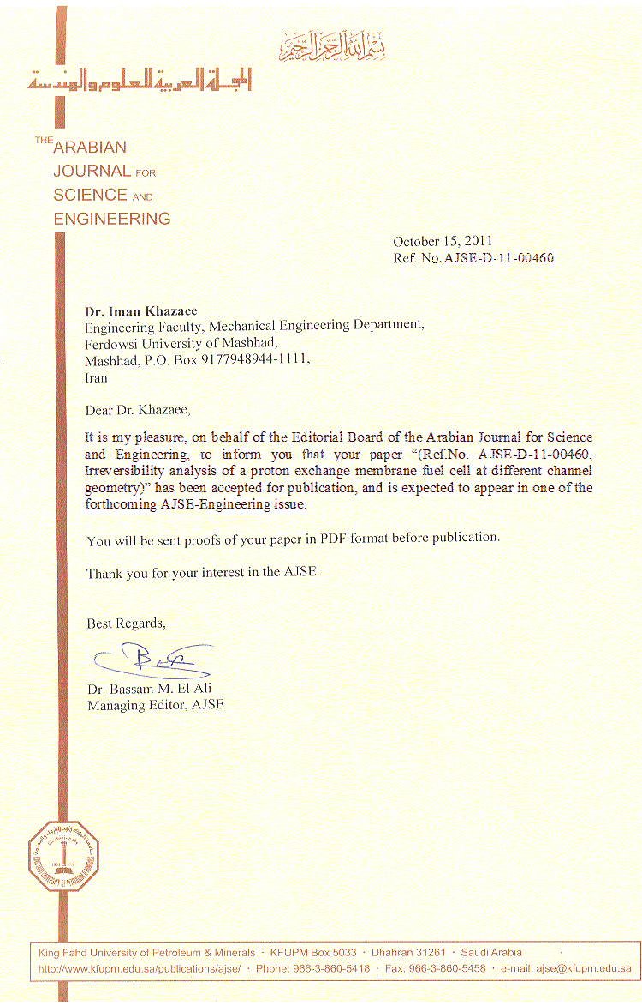
Irreversibility analysis of a proton exchange membrane fuel cell at different channel geometry

Iman. Khazaee${}^{a∗}$ , Mohsen. Ghazikhani${}^{b}$

Department of Mechanical Engineering, Torbat-e-jam branch, Islamic Azad University, Torbat-e-jam, Iran, Imankhazaee@yahoo.com
${}^{b}$Engineering Faculty, Mechanical Engineering Department, Ferdowsi University of Mashhad, Mashhad, P.O. Box 9177948944-1111, Iran

Abstract
In this study, the exergy analysis of a PEM fuel cell at different channel geometry is investigated experimentally. The geometry of the cell is rectangular, elliptical and triangular. Also some parameters such as input oxygen temperature ($T_{O2}$), input hydrogen temperature ($T_{H2}$), cell temperature ($T_{\text{cell}}$), input pressure (P), oxygen flow rate (${\overset{˙}{m}}_{O2}$) and hydrogen flow rate (${\overset{˙}{m}}_{H2}$) affect the performance and irreversibility of the cell. A series of experiments are carried out to investigate the influence of the above parameters and changing the geometry of the cell on irreversibility under the normal conditions. A PEM fuel cell with $\text{25}{\text{cm}}^{2}$ active area and Nafion 117 membrane with 0.004 $\text{gr}\text{cm}2$ Platinum for the anode and cathode is employed as a membrane electrode assembly. The results show that when the geometry of the cell is rectangular, the irreversibility of the cell is at lower value and the exergy efficiency is at higher value.

Keywords: Fuel cell, channel geometry, Irreversibility, Exergy efficiency, operating parameters.

_____________________
* Corresponding author. Tel.: +98 511 8796580; fax: +98 511 8763304
E-mail address: imankhazaee@yahoo.com
List of symbols
A active cell area (${\text{cm}}^{2}$)
$C_{H2}^{\text{contact}}$ concentration of hydrogen gas at the surface of the catalyst at the anode
$C_{O2}^{\text{contact}}$ concentration of oxygen gas at the surface of the catalyst at the cathode
ex Exergy (J/kg)
$\overset{˙}{E}$ Exergy (W)
E reversible potential of each cell (V)
$E^{∘}$ reference potential (V)
$E_{N}$ Nernst voltage (V)
F Farady constant
$G_{f}$ Gibbs function
i current density (A/${\text{cm}}^{2}$)
I current (A)
$\overset{˙}{I}$ Irreversibility (W)
$l_{m}$ membrane thickness (cm)
${\overset{˙}{m}}_{H2}$ Hydrogen flow rate (L/min)
${\overset{˙}{m}}_{O2}$ Oxygen flow rate (L/min)
P cell pressure (bar)
$P_{H2}^{\text{contact}}$ pressure of hydrogen gas at surface of the catalyst at the anode (bar)
$P_{O2}^{\text{contact}}$ pressure of oxygen gas at surface of the catalyst at the cathode (bar)
$P_{H2O}^{\text{sat}}$ saturation pressure of water vapor at a given temperature (bar)
$\overset{˙}{Q}$ Heat transfer (W)
R ohmic resistance ($Ω{\text{cm}}^{2}$)
$R^{\text{elec}}$ ohmic electronic losses resistance ($Ω{\text{cm}}^{2}$)
$R^{\text{prot}}$ ohmic protonic losses resistance ($Ω{\text{cm}}^{2}$)
T external temperature (K)
$T_{\text{cell}}$ cell temperature (K)
$T_{H2}$ Input hydrogen temperature ($C$)
$T_{O2}$ Input oxygen temperature ($C$)
V terminal voltage (V)
$x_{H2O}^{\text{sat}}$ molar fraction of water in gas for a given temperature
$x_{\text{othergasses}}^{\text{channel}}$ molar fraction of other apart oxygen in the air stream
$x_{n}$ mole fraction

Greek symbols
$λ_{\text{air}}$ air stoichiometry
$α$ charge transform coefficient
$δ_{j},j=1,2,3,4$ parameters of activation loss, eq (13)
$η_{a}$ activation loss (V)
$η_{o}$ ohmic loss (V)
$η_{c}$ concentration loss (V)
μ chemical potential (J/mol)

Introduction
Proton exchange membrane fuel cells (PEMFCs) represent a viable alternative power source for various applications. However, to satisfy the requirements for compactness, low cost, high power density, performance and stability, various aspects of the PEMFC must be optimized. Among the various fuel cell types, the proton exchange membrane (PEM) fuel cell is drawing more attention due to its low operating temperature, ease of start-up and shut-down and compactness. Furthermore, the PEM fuel cell is being investigated as an alternate power generation system especially for distributed generation and transportation. The PEM fuel cell is providing reliable power at steady state; however, it is not able to respond promptly to a load step change. Since the fuel cell is an electrochemical energy conversion device that converts fuel into electricity, its dynamic behavior depends both on chemical and thermodynamic processes that described by Larminie and Dicks [1].
There are several thermodynamic models and performance investigation of PEM fuel cells reported in the literature. These models can be categorized into two types as theoretical models based on physical conservation laws and semi-empirical models based on experiments.
Kazim [2,3] studied the exergy and exergoeconomic analyses of a PEM fuel cell at variable operating conditions and presented an approach on the determination of the minimal operating efficiency of a PEM fuel cell. He found that the fuel cell should operate at stoichiometric ratios less than 4 in order to maintain the relative humidity level in the product air and to avoid the membrane drying out at high operating temperatures.
Cownden et al. [4] gave a novel study on the performance analysis of a PEM fuel cell system including the system components other than the fuel cell stack, such as compressor, hydrogen supply and the cooling system. Based on the first and second laws of thermodynamics, they suggested that substantial improvements can be made in the performance of the fuel cell system.
Xue and Dong [5] used a semi-empirical model of the Ballard Mark IV fuel cell and models for the auxiliary systems to create a model of the fuel cell system. Using this model and numerical optimization, the optimal active stack area and air stoichiometric ratio was obtained to maximize net power output, and, at the same time, minimized production costs.
Miansari et al. [6] investigated a parametric study to examine the effect of the varying operating conditions on the exergy efficiency of the cell. They found that with the increase of cell operating temperature and pressure, exergy efficiency of the cell increases and irreversibilities decrease. Also they found that there is no appreciable increase in exergy efficiencies with the increase of air stoichiometry.
Yilanci et al. [7] investigated energy and exergy analyses for a 1.2 kW PEM fuel cell unit in a solar based hydrogen production system to investigate the performance of the system for different operating conditions using experimental setup and thermodynamic model. They found that there are reductions in energy and exergy efficiencies (about 14%) with increase in current density. Also they found that the PEM fuel cell system has lower exergy efficiencies than the corresponding energy efficiencies due to the irreversibilities that are not considered by energy analysis.
Ferng et al. [8] performed analytical and experimental work to investigate a single PEM fuel cell. In their paper, they presented a study of the cell performance covering the effects of operating temperature and pressure on performance and the flow characteristics within the cell. Their paper shows the positive effects of temperature and pressure on the performance of a single PEM fuel cell.
Del Real et al. [9] investigated a simple empirical equation to model the fuel cell voltage with considering the variations of the main process variables. The model equation has 11 parameters: one parameter related to the mass of liquid water at the anode channel must be estimated due to technical constraints, and the other parameters are obtained from experimental data. Although the model proposed by them, fitted well with the experimental data, the equation of the fuel cell voltage does not have a theoretical basis, and, therefore, it is based on assumptions relating to the effects of temperature and partial pressures that are not proven to be general for fuel cells other than those used by Del Real et al. [9].
Scrivano et al. [10] presented an experimental analysis of a 6W proton exchange membrane fuel cell (PEMFC) system, including on-site hydrogen production by electrolysis. They investigated the effects of environmental parameters such as the external temperature and the humidity of the gases on the performance of fuel cells. Also they proposed a simple semi-empirical mathematical model capable to perform rough prediction on the behavior of such systems when exposed at different ambient temperatures that this model threats the stacks of fuel cell, not investigating singularly the inner phenomena which occur in the cell.
In the present work, the effects of choosing different channel geometry, oxygen temperature, hydrogen temperature, cell temperature, input pressure, oxygen flow rate and hydrogen flow rate on the performance, irreversibility and exergy efficiency of a PEM fuel cell have been studied experimentally and the results were compared with available data. Several irreversibility curves have been obtained in different conditions, displaying the trend of the cell losses against current. The main objective of this paper contrary to another works is to analyze the influence of different geometries of the channels or flow fields on the irreversibility and exergy efficiency supplied to a PEM fuel cell at different levels of cell current.

Description of the Experiments and Method of the Measurements

A setup has been constructed for experimental investigation of the performance of the fuel cell. A schematic flow of the test bench is shown in Fig. 1.

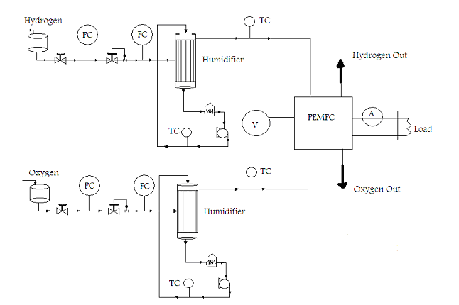
Fig. 1. Schematic of the PEMFC system.

The test bench is made up of four main subsystems. First, the gases supply system, which sends the oxygen and hydrogen flow into the system. Second, the two humidifiers that humidify the oxygen and hydrogen before going into the cell. Third, the nitrogen supply system is applied to inert any flammable mix inside the ducts and to purge the system before activation. Finally, the electrical power supply, regulated from an AC/DC voltage regulator driven from the control panel. The examined prototype can operate at a maximum 5 bar absolute pressure; a pressure regulator valve is included, to make possible to vary the operating pressure of the FC system and the accuracy of monitoring the pressure is$±2\text{\%}$. Two flow meters are used to measure the flow rate of the oxygen and hydrogen that the accuracy of them is$±0\text{.}1L\text{/min}$. In order to plot the polarization curve and simulate a variable load, a resistors box was used that the accuracy of monitoring the voltage and ampere is$±1\text{\%}$. The resistors box, located outside the test chamber, is manually operated. The temperature of the inlet gases was measured by digital thermometer with $±0\text{.}1^{∘}C$ accuracy.

The specifications of the test system for this study are:

- The humidifier system is membranous.
- The test bench has the system of announcement the leakage of hydrogen.
- The system can control and show the temperature of the oxygen and hydrogen.
- The system can control and show the temperature of the cell.
- The system can control and show the flow rate of the oxygen and hydrogen.
- The system can control and show the inlet pressure of the oxygen and hydrogen.
- The system can show the voltage of the cell.
- The system can show the current of the cell.

Table 1 shows the environs of operation of the experimental setup in this study.
The PEM fuel cell considered in this study is a single cell with the size of $\text{45}×\text{95}×\text{101}{\text{mm}}^{2}$ and an active area of $\text{25}{\text{cm}}^{2}$ and serpentine and elliptical flow field geometries of channels with the weight of 1300 gr. The width, land width and depth of the channel were selected to be 1, 0.8 and 1.27 mm respectively. For a bipolar plate, non-porous graphite is selected. A Nafion 117 membrane with 0.004 $\text{gr}\text{cm}2$ Platinum for the anode and cathode was employed as a membrane electrode assembly. On both sides of the MEA, there were 0.33 mm thick carbon papers that acted as diffusion layers. The thickness of the catalyst layer and the proton exchange membrane is about 0.01 mm and 0.051 mm. The maximum output power of the cell is 11 watts at 0.6 cell voltage. The geometry of the channels of the cell in the experimental setup is shown in Fig. 2.

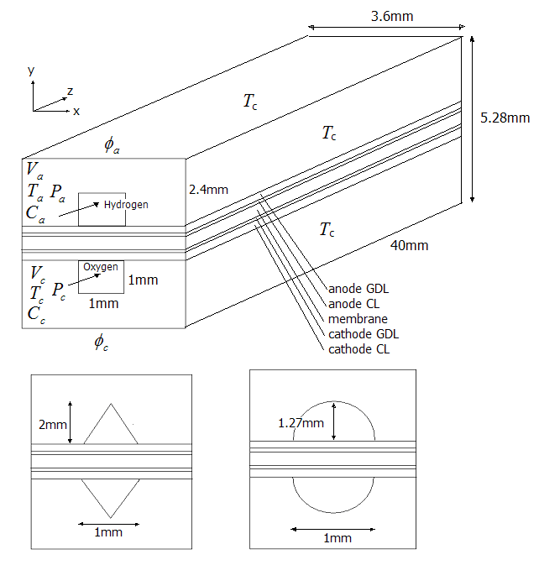
Fig. 2. Schematic of the channels of the fuel cells.

Table 1- Operational characteristics of the test bench.
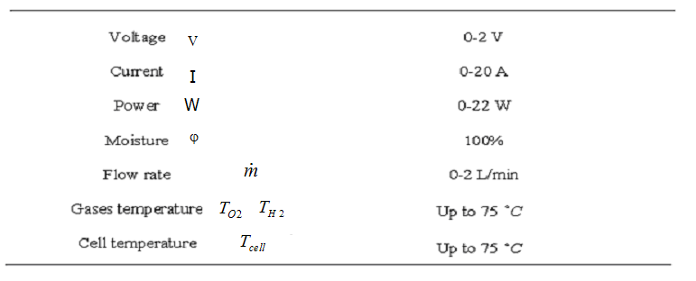

The changed parameters are: input oxygen temperature ($T_{O2}$), input hydrogen temperature ($T_{H2}$), cell temperature ($T_{\text{cell}}$), input pressure (P), oxygen flow rate (${\overset{˙}{m}}_{O2}$) and hydrogen flow rate (${\overset{˙}{m}}_{H2}$) and the measured parameters are voltage and current of the cell.
At first, we perform the experiments by humidifying the membrane of the fuel cell by saturation water vapor and then change the input oxygen temperature, input hydrogen temperature, cell temperature, input pressure, oxygen flow rate and hydrogen flow rate and measure the pointed parameters and the voltage and the current of the cell after steady state condition. Fig.3 shows the experimental setup. In this figure the components of testing a fuel cell such as the PEM fuel cell, temperature indicators, flow meters, the oxygen and hydrogen tank, the humidifier of the gases and the switch keys are shown.

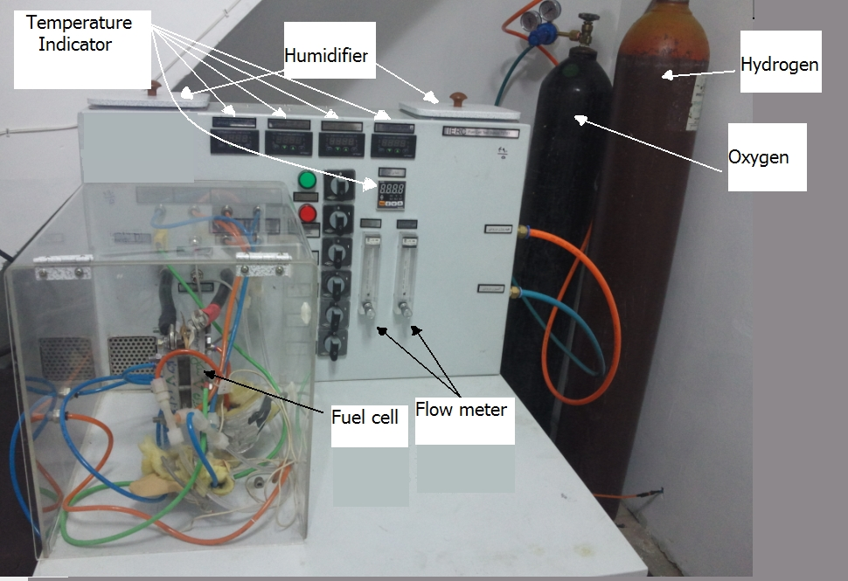
Fig.3. A photo of the experimental setup.

Fuel cell Models

A proton exchange membrane fuel cell uses the following electrochemical reaction which produces heat and electrical current.
$H_{2}+\frac{1}{2}O_{2}→H_{2}O$ (1)
This phenomenon in fuel cell is the change of Gibbs free energy of formation, ${ΔG}_{f}$ that gives us the energy released. If the system is reversible, the Gibbs free energy released will be equal to the electrical work done moving the charge on one mole of electrons. Electrical work done is $−2\text{FE}$ Joules, so the reversible open circuit voltage of the hydrogen fuel cell is:
$E=−\frac{{ΔG}_{f}}{2F}$ (2)
The output voltage of a single cell at any operating condition is given by:
$V=E_{N}+η_{a}+η_{o}+η_{c}$ (3)
where $E_{N}$ is the Nernst equation, which is an expression for the electromotive force (EMF) for given product and reactant activities. The (EMF) calculated from such equations is known as the Nernst voltage, and is the reversible cell voltage that would exist at a given temperature and pressure. Also $η_{a}$ is the activation losses that is the most important irreversibility and cause of voltage drop, and occurs mainly at the cathode, $η_{o}$ is the ohmic losses that is due to the electrical resistance of the electrodes, and the resistance to the flow of ions in the electrolyte and finally $η_{c}$ is the concentration losses, which is the voltage lost when the concentration of reactant at the electrode is diminished.
The Nernst voltage for hydrogen fuel cell is:

$E_{N}=E^{∘}−0\text{.}\text{85}×{\text{10}}^{−3}(T_{\text{cell}}−\text{298}\text{.}\text{15})+4\text{.}\text{31}×{\text{10}}^{−5}T_{\text{cell}}\left[\text{ln}(p_{H2}^{\text{contact}})+0\text{.}5\text{ln}(p_{O2}^{\text{contact}})\right]$ (4)

where $E^{∘}$ is the open circuit voltage and it is equal to $E^{∘}=1\text{.}\text{229}V$, $T_{\text{cell}}$ is the surface cell temperature (K), $p_{H2}^{\text{contact}}$ is the hydrogen partial pressure (bar) at the surface of catalyst and anode and $p_{O2}^{\text{contact}}$ is the oxygen partial pressure at the surface of catalyst and cathode that is proposed by Amphlett et al. [11] as:
$p_{H2}^{\text{contact}}=(12p_{H2O}^{\text{sat}})\left[\frac{1}{\text{exp}(1\text{.}\text{653}i/{T_{\text{cell}}^{1\text{.}\text{334}}})\text{.}x_{H2O}^{\text{sat}}}−1\right]$ (5)
$p_{O2}^{\text{contact}}=P\left[1−x_{H2O}^{\text{sat}}−x_{\text{othergasses}}^{\text{channel}}\text{exp}(0\text{.}\text{291}i/{T_{\text{cell}}^{0\text{.}\text{832}}})\right]$ (6)

where $i$ is the current density, $x_{H2O}^{\text{sat}}$ is the molar fraction of water in a gas stream at saturation for a given temperature, p is the cell pressure and $x_{\text{othergasses}}^{\text{channel}}$ is the molar fraction of other gasses apart from oxygen in the air stream. These equations come from the Maxwell-Stefan equations in which all the constants and the approximate diffusion coefficient come from kinetic theory.
The molar fractions of water and other gasses is proposed by Amphlett et al. [11] as:
$x_{H2O}^{\text{sat}}=\frac{p_{H2O}^{\text{sat}}}{p}$ (7)
$x_{\text{othergasses}}^{\text{channel}}=\frac{0\text{.}\text{79}(1−x_{H2O}^{\text{sat}})−\frac{1−x_{H2O}^{\text{sat}}}{1+(λ_{\text{air}}−1/{λ_{\text{air}}})(0\text{.}{\text{21}}/0\text{.}\text{79})}}{\text{ln}\left[0\text{.}\text{79}(1−x_{H2O}^{\text{sat}})/{(1−x_{H2O}^{\text{sat}})}(1+(λ_{\text{air}}−1/{λ_{\text{air}}})(0\text{.}{\text{21}}/0\text{.}\text{79}))\right]}$ (8)

where $λ_{\text{air}}$ is the stoichiometry of air stream and the 0.21 term and 0.79 term refer to the dry molar fraction of oxygen and other gasses in air. The saturation pressure of water vapor can be computed from the following empirical equation:
$\text{ln}(p_{H2O}^{\text{sat}})=\text{70}\text{.}\text{43464}−\frac{\text{7362}\text{.}\text{698}}{T_{\text{cell}}}+0\text{.}\text{006952}T_{\text{cell}}−9\text{ln}(T_{\text{cell}})$ (9)
The activation voltage loss is present when the rate of the electrochemical reaction at the electrode surface is controlled by sluggish electrode kinetics. Activation loss increases as the current increases. The activation losses can be obtained by Tafel equation that is proposed by Mann et al. [12] as:
$η_{a}=δ_{1}+δ_{2}T_{\text{cell}}+δ_{3}T_{\text{cell}}\text{ln}(C_{O2}^{\text{cot}\text{act}})+δ_{4}T_{\text{cell}}\text{ln}(I)$ (10)
where
$C_{O2}^{\text{contact}}=\frac{p_{O2}^{\text{contact}}}{5\text{.}\text{08}×{\text{10}}^{6}\text{exp}(−{\text{498}}/{T_{\text{cell}}})}$ (11)
and coefficients $δ_{j}$ are obtained from the experimental data of Mann et al. [12] and they are all constant apart from $δ_{2}$ which varies with the active area of the fuel cell (A):

$$δ_{1}=−0\text{.}\text{948}$$
$δ_{2}=0\text{.}\text{00286}+0\text{.}\text{0002}\text{ln}(A)+4\text{.}3×{\text{10}}^{−5}\text{ln}(C_{H2}^{\text{contact}})$ (12)
$$δ_{3}=7\text{.}6×{\text{10}}^{−5}$$
$$δ_{4}=−1\text{.}\text{93}×{\text{10}}^{−4}$$
where
$C_{H2}^{\text{contact}}=\frac{p_{H2}^{\text{contact}}}{1\text{.}\text{09}×{\text{10}}^{6}\text{exp}({\text{77}}/{T_{\text{cell}}})}$ (13)
Ohmic loss is due to the electrical resistance of the electrodes and the resistance to the flow of ions in the electrolyte. The ohmic loss is proposed by Mann et al. [12] as:
$η_{o}=−i(R^{\text{elec}}+R^{\text{prot}})$ (14)
where $R^{\text{elec}}$ is assumed to be a constant over the operating temperature of the PEM fuel cell. The electronic resistance is further assumed to be inconsequential in comparison to protonic resistance, and is thus ignored. The term $R^{\text{prot}}$ is known to be a complex function of water content and distribution in the membrane, which in turn is a function of the cell temperature and current.
${{\text{AR}}^{\text{prot}}}/{l_{m}}=\frac{\text{181}\text{.}6\left[1+0\text{.}\text{03}i+0\text{.}\text{062}({T_{\text{cell}}}/{\text{303}})^{2}i^{2\text{.}5}\right]}{(\text{14}−3i)\text{exp}(3\text{.}\text{25}(T_{\text{cell}}−{\text{303}}/{T_{\text{cell}}}))}$ (15)
where A is the active area and $l_{m}$ is the thickness of the membrane (cm).
Concentration loss is the loss of voltage, which is the voltage loss when the concentration of reactant at the electrode is diminished. If the anode of a fuel cell is supplied with hydrogen, then there will be a slight drop in pressure, if the hydrogen is consumed as a result of a current being drawn from the cell. The expression for the concentration loss is proposed by Larminie and Dicks [1] as:
$η_{c}=−m\text{exp}(\text{ni})$ (16)
where m is the electrolyte conductivity that varies with the cell temperature:
$m=1\text{.}1×{\text{10}}^{−4}−1\text{.}2×{\text{10}}^{−6}(T_{\text{cell}}−\text{273}\text{.}\text{15})T_{\text{cell}}≥{\text{39}}^{∘}C$ (17)
$m=3\text{.}3×{\text{10}}^{−3}6−8\text{.}2×{\text{10}}^{−5}(T_{\text{cell}}−\text{273}\text{.}\text{15})T_{\text{cell}}≤{\text{39}}^{∘}C$ (18)
and n is the porosity of the gas diffusion layer and that in this paper n=0.3 is used. For low current density, the concentration losses can be dispensed.
Depending on the current density and voltage output, gross power produced by a single PEM fuel cell can be calculated as:
$W_{\text{FC}}=V×i×A$ (19)
where A is the effective geometric area of the cell (cm${}^{2}$).
The usage mass flow rates of oxygen and hydrogen and product water in (kg/s) are calculated based on Faraday’s law that proposed by Larminie and Dicks [1] :
${\overset{˙}{m}}_{O2,\text{usage}}=8\text{.}\text{29}×{\text{10}}^{−8}I$ (20)
${\overset{˙}{m}}_{H2,\text{usage}}=1\text{.}\text{05}×{\text{10}}^{−8}I$ (21)
${\overset{˙}{m}}_{H2O,\text{product}}=9\text{.}\text{34}×{\text{10}}^{−8}I$ (22)
Therefore the output mass flow rates of the above gases are:
${\overset{˙}{m}}_{O2,\text{out}}={\overset{˙}{m}}_{O2,\text{in}}−8\text{.}\text{29}×{\text{10}}^{−8}I$ (23)
${\overset{˙}{m}}_{H2,\text{out}}={\overset{˙}{m}}_{H2,\text{in}}−1\text{.}\text{05}×{\text{10}}^{−8}I$ (24)
${\overset{˙}{m}}_{H2O,\text{out}}={\overset{˙}{m}}_{H2O,\text{in}}+9\text{.}\text{34}×{\text{10}}^{−8}I$ (25)
Exergy analysis is an effective thermodynamic method for using the conservation of mass and energy principles together with the second law of thermodynamics for the design and analysis of thermal systems and is an efficient technique for revealing whether or not and by how much it is possible to design more efficient thermal systems by reducing the inefficiencies. The total exergy of a stream divided to four different exergy as the physical exergy (${\text{ex}}^{\text{ph}}$), chemical exergy (${\text{ex}}^{\text{ch}}$), kinetic exergy (${\text{ex}}^{\text{ki}}$) and potential exergy (${\text{ex}}^{\text{po}}$) that described by Dincer [13]:
$\text{ex}={\text{ex}}^{\text{ph}}+{\text{ex}}^{\text{ch}}+{\text{ex}}^{\text{ki}}+{\text{ex}}^{\text{po}}$ (26)
The changes in the kinetic and gravitational potential exergies are considered to be negligible in the present study. The general expression of the physical exergy can be described as:
${\text{ex}}^{\text{Ph}}=(h−h_{0})−T_{0}(s−s_{0})$ (27)
where $h_{0}$ and $s_{0}$ denote the specific enthalpy and entropy evaluated at standard conditions, respectively. The physical exergy of an ideal gas with constant specific heat Cp and specific heat ratio k can be written as:
${\text{ex}}^{\text{Ph}}=C_{p}T_{0}\left[\frac{T}{T_{0}}−1−\text{ln}\left(\frac{T}{T_{0}}\right)+\text{ln}{\left(\frac{P}{P_{0}}\right)}^{\frac{k−1}{k}}\right]$ (28)
The chemical exergy is associated with the departure of the chemical composition of a system from that of the environment. For the sake of simplicity, the chemical exergy considered in the analysis is rather a standard chemical exergy that is based on the standard values of the environmental temperature of 298 K and pressure of 1 atm can be written as follows that described by Wark [14]:
${\text{ex}}^{\text{CH}}=\sum_{n}{x_{n}(μ_{n0}−μ_{n\text{00}})}$ (29)
Heat will be lost to the surroundings and to the air stream through two heat transfer processes: radiation and convection. Thus, the amount of heat lost to the air stream and surroundings can be calculated using the following expression:
${\overset{˙}{Q}}_{\text{tot}}={\overset{˙}{Q}}_{\text{rad}}+{\overset{˙}{Q}}_{\text{conv}}$ (30)
${\overset{˙}{Q}}_{\text{rad}}={σA}_{\text{cell}}(T^{4}−T_{0}^{4})$ (31)
${\overset{˙}{Q}}_{\text{conv}}={\overset{˙}{Q}}_{\text{conv},\text{top}+\text{bottom}}+{\overset{˙}{Q}}_{\text{conv},\text{sides}}$ (32)
that the constants of these equations described by Yilanci et al. [7].
The exergy balance for a system can be written as:
$\sum{{\overset{˙}{E}}_{\text{mass},\text{in}}−\sum{{\overset{˙}{E}}_{\text{mass},\text{out}}+\sum{{\overset{˙}{E}}_{Q}−{\overset{˙}{E}}_{w}−\sum{\overset{˙}{I}}=0}}}$ (33)
where the ${\overset{˙}{E}}_{\text{mass},\text{in}}$, ${\overset{˙}{E}}_{\text{mass},\text{out}}$, ${\overset{˙}{E}}_{Q}$, ${\overset{˙}{E}}_{W}$ and $\overset{˙}{I}$ is the exergy transfer by inlet mass, exergy transfer by outlet mass, exergy transfer by heat, exergy transfer by work and total irreversibility respectively. Therefore the exergy balance for a PEM fuel cell system can be written as:
$\begin{aligned}{\overset{˙}{I}}_{\text{CV}}=\left(1−\frac{T_{0}}{T_{\text{cell}}}\right){\overset{˙}{Q}}_{\text{CV}}−{\overset{˙}{W}}_{\text{FC}}+(\overset{˙}{m}⋅\text{ex})_{H2,\text{in}}+(\overset{˙}{m}⋅\text{ex})_{O2,\text{in}}+(\overset{˙}{m}⋅\text{ex})_{H2O,\text{in}}− \\ −(\overset{˙}{m}⋅\text{ex})_{H2,\text{out}}−(\overset{˙}{m}⋅\text{ex})_{O2,\text{out}}−(\overset{˙}{m}⋅\text{ex})_{H2O,\text{out}}\end{aligned}$ (34)
In Eq. (34) if $T_{\text{cell}}=T_{0}$ then the internal or control volume irreversibility changes to total irreversibility that they can be compared with them [14].
The exergy efficiency of the cell described by Midilli and Dincer [15]:
$η_{\text{II}}=1−\frac{\overset{˙}{I}}{\sum{{\overset{˙}{E}}_{\text{mass},\text{in}}}}$ (35)

Results and discussion

The main goal of this study is to investigate the effects of changing the channel geometry on the irreversibility and exergy efficiency at different operating conditions. The Range of changing the parameters in this study is shown in Table 2 and the experiments for each of the parameters done and repeated while the steady state condition occurred.

Table 2- Range of changing the parameters in this study.
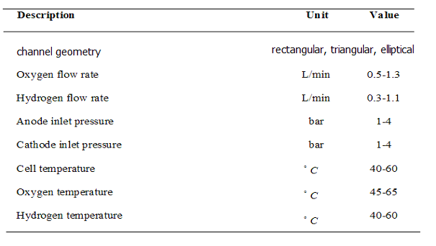

Fig. 4 shows the experimental and calculated irreversibility and exergy efficiencies at different current density values for $T_{\text{cell}}={\text{60}}^{∘}C$, $T_{O2}={\text{55}}^{∘}C$, $T_{H2}={\text{55}}^{∘}C$, ${\overset{˙}{m}}_{O2}=0\text{.}5L\text{/min}$ and P=2.905 bar for triangular channel geometry PEM fuel cell. It can be seen that exergy efficiency decreases while net power production increases but irreversibility of the cell increases that it is because of increases the losses of the voltage by increasing the current of the cell. It is also clear from Fig.4 that these results from the thermodynamic model for the given operating conditions are consistent with the corresponding experimental data.

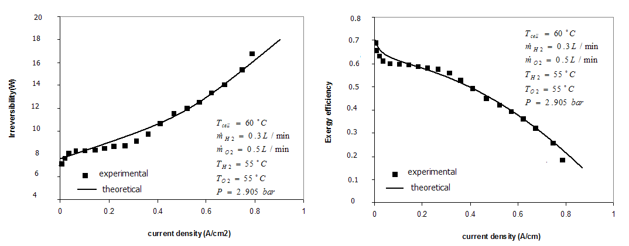
Fig.4 Comparison of irreversibility and exergy efficiency for experimental and theoretical results.

Fig. 5 and Fig. 6 show the irreversibility and exergy efficiency of the PEM fuel cell at $T_{\text{cell}}={\text{60}}^{∘}C$, $T_{H2}={\text{55}}^{∘}C$, $T_{O2}={\text{55}}^{∘}C$, ${\overset{˙}{m}}_{H2}=0\text{.}3L\text{/min}$ and P=2.905 bar for three different channel geometry at ${\overset{˙}{m}}_{O2}=0\text{.}5L\text{/min}$ and ${\overset{˙}{m}}_{O2}=0\text{.}9L\text{/min}$. Heat transfer, friction, mixing, chemical reactions, activation, ohmic and concentration polarizations can also increase thermodynamic irreversibility and decrease the exergy efficiency of PEM fuel cell. An overall inspection of Fig.5 and Fig. 6 indicate that at the conditions of the lower current density, the influence of the internal flow modification on the irreversibility and exergy efficiency is nearly small for elliptical and triangular geometry but at higher current density on the other hand, the effect of the internal flow modification becomes important. Also it can be seen that the irreversibility is at lower value and exergy efficiency is at higher value when the geometry of the channel is rectangular but when the geometry of the channels shift to triangular and elliptical the results is different that this is due to the fact that a reflection of the more efficient fuel transport and the chemical reaction reduces the local current density more obviously in the downstream region. Also it can be seen that with the increase of oxygen flow rate, the exergy efficiencies of the cell increase and irreversibilities decrease that this is due to increase the penetrating of the oxygen into gas diffusion layer and increasing the chemical reaction at the catalyst layer.
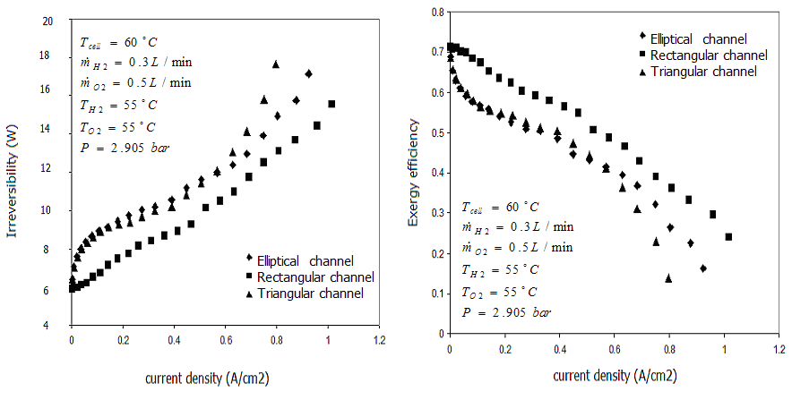
Fig.5. Variation of irreversibilities and exergy efficiencies.

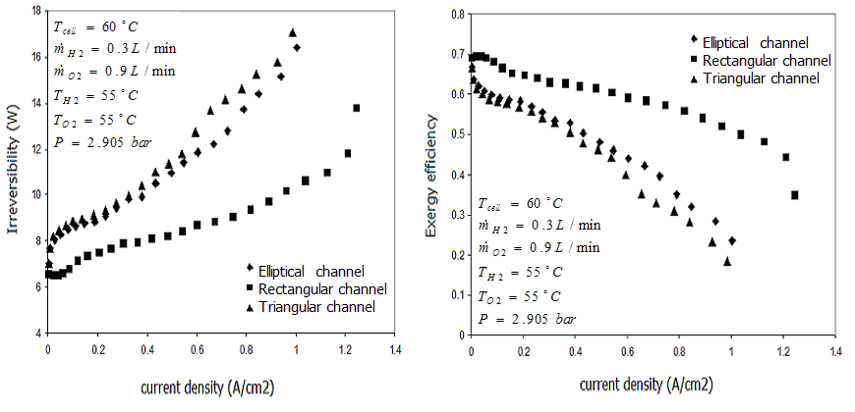
Fig.6. Variation of irreversibilities and exergy efficiencies at $T_{\text{cell}}={\text{60}}^{∘}C$, $T_{H2}={\text{55}}^{∘}C$, $T_{O2}={\text{55}}^{∘}C$, ${\overset{˙}{m}}_{H2}=0\text{.}3L\text{/min}$ and P=2.905 bar for changing the oxygen flow rate against Fig.5.

Fig. 7 shows the irreversibility and exergy efficiency of the PEM fuel cell at $T_{\text{cell}}={\text{60}}^{∘}C$, $T_{H2}={\text{55}}^{∘}C$, $T_{O2}={\text{55}}^{∘}C$,${\overset{˙}{m}}_{O2}=0\text{.}5L\text{/min}$,${\overset{˙}{m}}_{H2}=0\text{.}7L\text{/min}$ and P=2.905 bar for three different channel geometry in comparison of Fig. 5 for hydrogen flow rate. It is clear that with increase in current density the irreversibility of the cell increases and exergy efficiency decreases that this is due to increase in losses of the cell. Also it can be seen that the irreversibility is at lower value and exergy efficiency is at higher value when the geometry of the channel is rectangular but when the geometry of the channels shift to triangular and elliptical the results is different. Also it is clear that when the flow rate of hydrogen increases the irreversibility of the cell increases.
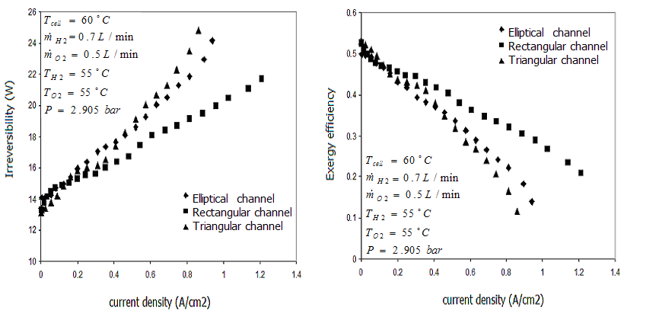
Fig.7. Variation of irreversibilities and exergy efficiencies at $T_{\text{cell}}={\text{60}}^{∘}C$, $T_{H2}={\text{55}}^{∘}C$, $T_{O2}={\text{55}}^{∘}C$,${\overset{˙}{m}}_{O2}=0\text{.}5L\text{/min}$ and P=2.905 bar for changing the hydrogen flow rate against Fig.5.

Fig. 8 shows the irreversibility and exergy efficiency of the PEM fuel cell at $T_{\text{cell}}={\text{60}}^{∘}C$, $T_{H2}={\text{55}}^{∘}C$, $T_{O2}={\text{60}}^{∘}C$,${\overset{˙}{m}}_{O2}=0\text{.}5L\text{/min}$,${\overset{˙}{m}}_{H2}=0\text{.}3L\text{/min}$ and P=2.905 bar for three different channel geometry in comparison of Fig. 5 for oxygen temperature. It is clear that with increase in current density the irreversibility of the cell increases and exergy efficiency decreases that this is due to increase in losses of the cell. Also it can be seen that the irreversibility is at lower value and exergy efficiency is at higher value when the geometry of the channel is rectangular but when the geometry of the channels shift to triangular and elliptical the results is different. Also it can be seen that with the increase of oxygen temperature, the exergy efficiencies of the cell increase and irreversibilities decrease. This is in fact due to the decrease in irreversible voltage losses of the cell with the increase of temperature, which in turn enhance the membrane conductivity and diffusion of proton in the membrane.

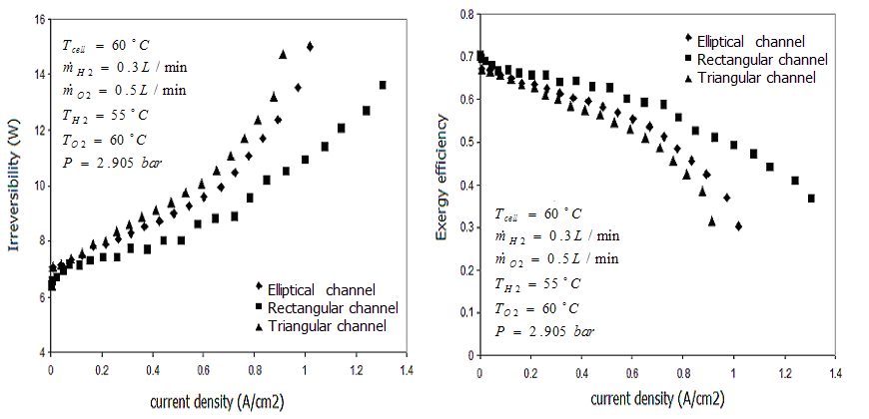
Fig.8. Variation of irreversibilities and exergy efficiencies at $T_{\text{cell}}={\text{60}}^{∘}C$, $T_{H2}={\text{55}}^{∘}C$,${\overset{˙}{m}}_{O2}=0\text{.}5L\text{/min}$,${\overset{˙}{m}}_{H2}=0\text{.}3L\text{/min}$ and P=2.905 bar for changing the oxygen temperature against Fig.5.
Fig. 9 shows the irreversibility and exergy efficiency of the PEM fuel cell at $T_{\text{cell}}={\text{60}}^{∘}C$, $T_{H2}={\text{45}}^{∘}C$, $T_{O2}={\text{55}}^{∘}C$,${\overset{˙}{m}}_{O2}=0\text{.}5L\text{/min}$,${\overset{˙}{m}}_{H2}=0\text{.}3L\text{/min}$ and P=2.905 bar for three different channel geometry in comparison of Fig. 5 for hydrogen temperature. It can be seen that the irreversibility is at lower value and exergy efficiency is at higher value when the geometry of the channel is rectangular but when the geometry of the channels shift to triangular and elliptical the results is different. Also it can be seen that with the increase of hydrogen temperature, the exergy efficiencies of the cell increase and irreversibilities decrease. This is in fact due to the decrease in irreversible voltage losses of the cell with the increase of temperature, which in turn enhance the membrane conductivity and diffusion of proton in the membrane.
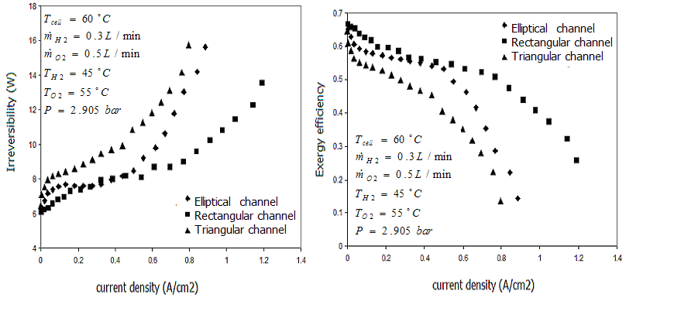
Fig.9. Variation of irreversibilities and exergy efficiencies at $T_{\text{cell}}={\text{60}}^{∘}C$, $T_{O2}={\text{55}}^{∘}C$,${\overset{˙}{m}}_{O2}=0\text{.}5L\text{/min}$,${\overset{˙}{m}}_{H2}=0\text{.}3L\text{/min}$ and P=2.905 bar for changing the hydrogen temperature against Fig.5.

Fig. 10 shows the irreversibility and exergy efficiency of the PEM fuel cell at $T_{\text{cell}}={\text{50}}^{∘}C$, $T_{H2}={\text{45}}^{∘}C$, $T_{O2}={\text{55}}^{∘}C$,${\overset{˙}{m}}_{O2}=0\text{.}5L\text{/min}$,${\overset{˙}{m}}_{H2}=0\text{.}3L\text{/min}$ and P=2.905 bar for three different channel geometry in comparison of Fig. 5 for cell temperature. It is clear that with the increase of cell temperature, the exergy efficiencies of the cell increase and irreversibilities decrease. Also it can be seen that the irreversibility is at lower value and exergy efficiency is at higher value when the geometry of the channel is rectangular but when the geometry of the channels shift to triangular and elliptical the results is different.
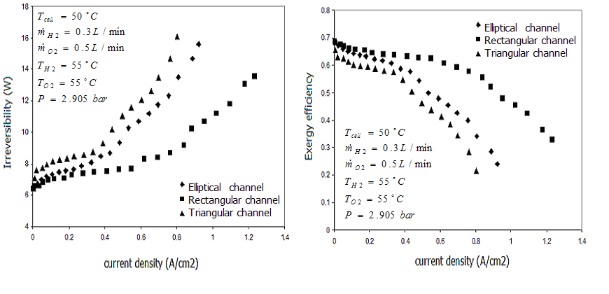
Fig.10. Variation of irreversibilities and exergy efficiencies at $T_{H2}={\text{45}}^{∘}C$, $T_{O2}={\text{55}}^{∘}C$,${\overset{˙}{m}}_{O2}=0\text{.}5L\text{/min}$,${\overset{˙}{m}}_{H2}=0\text{.}3L\text{/min}$ and P=2.905 bar for changing the cell temperature against Fig.5.

Fig. 11 shows the irreversibility and exergy efficiency of the PEM fuel cell at $T_{\text{cell}}={\text{60}}^{∘}C$, $T_{H2}={\text{45}}^{∘}C$, $T_{O2}={\text{55}}^{∘}C$,${\overset{˙}{m}}_{O2}=0\text{.}5L\text{/min}$,${\overset{˙}{m}}_{H2}=0\text{.}3L\text{/min}$ and P=3.905 bar for three different channel geometry in comparison of Fig. 5 for inlet pressure. It is clear that with the increase of inlet pressure, the exergy efficiencies of the cell increase and irreversibilities decrease. Increasing the inlet pressure, leads to increases the concentration of the reactants at the reaction sites and decreases the irreversible losses in the anode and cathode, which in turn enhances the performance of the cell with the increase of the reversible thermodynamic potential according to the Nernst equation. Also it can be seen that the irreversibility is at lower value and exergy efficiency is at higher value when the geometry of the channel is rectangular but when the geometry of the channels shift to triangular and elliptical the results is different.
Fig. 12 shows the effect of inlet oxygen temperature on the irreversibility and exergy efficiency of the PEM fuel cell at $T_{\text{cell}}={\text{60}}^{∘}C$, $T_{H2}={\text{55}}^{∘}C$, ${\overset{˙}{m}}_{O2}=0\text{.}5L\text{/min}$ ,${\overset{˙}{m}}_{H2}=0\text{.}3L\text{/min}$ and P=2.905 bar . Heat transfer, friction, mixing, chemical reactions, activation, ohmic and concentration polarizations can also increase thermodynamic irreversibility and decrease the exergy efficiency of PEM fuel cell.
It can be seen that with the increase of oxygen temperature, the exergy efficiencies of the cell increase and irreversibilities decrease. This is in fact due to the decrease in irreversible voltage losses of the cell with the increase of temperature, which in turn enhance the membrane conductivity and diffusion of proton in the membrane.

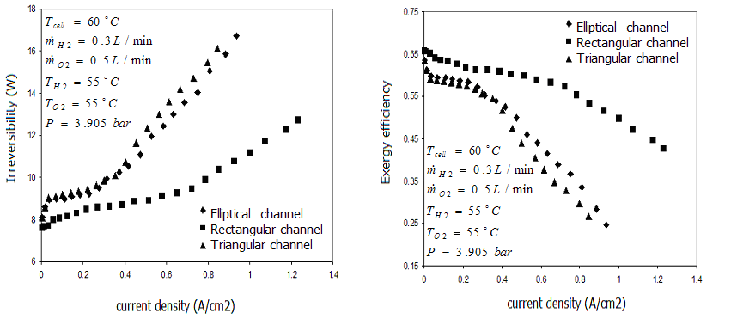
Fig.11. Variation of irreversibilities and exergy efficiencies at$T_{\text{cell}}={\text{60}}^{∘}C$, $T_{H2}={\text{45}}^{∘}C$, $T_{O2}={\text{55}}^{∘}C$,${\overset{˙}{m}}_{O2}=0\text{.}5L\text{/min}$,${\overset{˙}{m}}_{H2}=0\text{.}3L\text{/min}$ for changing the input pressure against Fig.5.

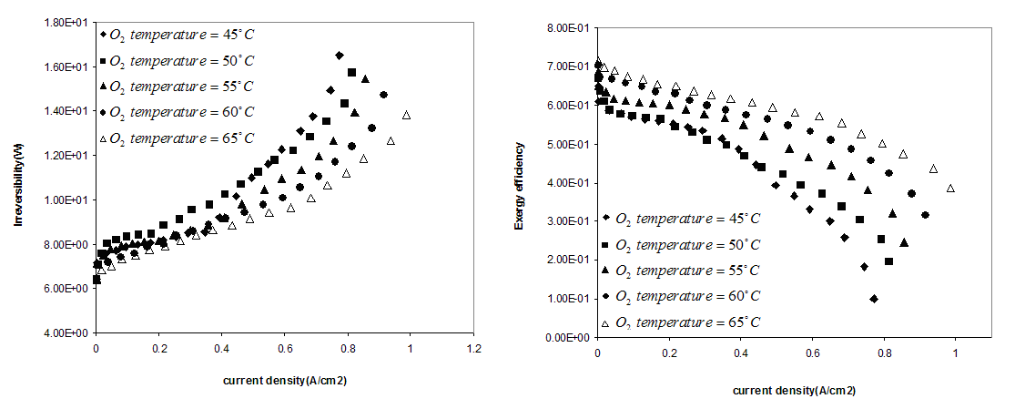
Fig.12. Variation of irreversibilities and exergy efficiencies at different oxygen temperatures for $T_{\text{cell}}={\text{60}}^{∘}C$, $T_{H2}={\text{55}}^{∘}C$, ${\overset{˙}{m}}_{O2}=0\text{.}5L\text{/min}$ ,${\overset{˙}{m}}_{H2}=0\text{.}3L\text{/min}$ and P=2.905 bar .

Conclusion

In this study, the effects of using different channel geometry and also the effect of input oxygen temperature ($T_{O2}$), input hydrogen temperature ($T_{H2}$), cell temperature ($T_{\text{cell}}$), input pressure (P), oxygen flow rate (${\overset{˙}{m}}_{O2}$) and hydrogen flow rate (${\overset{˙}{m}}_{H2}$) on the irreversibility and exergy efficiency of a PEM fuel cell have been investigated experimentally. We have found out that:
1- When the geometry of the cell is rectangular the performance of the cell is better than elliptical and triangular geometry.
2- When the geometry of the cell is rectangular the irreversibility of the cell is at lower value and the exergy efficiency is at higher value.
3- With the increase of oxygen and hydrogen temperature, the exergy efficiencies of the cell increase and irreversibilities decrease that this is in fact due to the decrease in irreversible voltage losses of the cell with the increase of temperature.
4- With the increase of cell temperature, the exergy efficiency of the cell increases and irreversibilities decreases that the exergy efficiency varied from 58% to 42% in 40 °C while the current density changed from 0.2 to 0.6 $A/{{\text{cm}}^{2}}$.
5- With the increase of inlet pressure, the exergy efficiency of the cell increases and irreversibilities decreases.
6- With the increase of oxygen and hydrogen flow rate, the exergy efficiencies of the cell increase and irreversibilities decrease.

Acknowledgment

This work was partially supported by Renewable Energy Organization of Iran.

References
[1] J. Larminie, and A. Dicks, Fuel cell system explained., John Wiley and Sons.,2nd edition, 2003.
[2] A. Kazim, "Exergy analysis of a PEM fuel cell at variable operating conditions", Energy Conversion and Management, 45(2004), pp.1949-1961.
[3] A. Kazim, "Exergoeconomic analysis of a PEM fuel cell at various operating conditions", Energy Conversion and Management. 46(2005), pp.1073-1081.
[4] R. Cownden, M. Nahon, and M.A. Rosen, "Modelling and analysis of a solid polymer fuel cell system for transportation applications", International Journal of Hydrogen Energy. 26(2001), pp.615–23.
[5] D. Xue, and Z. Dong, "Optimal fuel cell system design considering functional performance and production costs", Journal of Power Sources. 76 (1) (1998), pp.69–80.
[6] M. Miansari, K. Sedighi, M. Amidpour, E. Alizadeh, and M.O. Miansari, "Experimental and thermodynamic approach on proton exchange membrane fuel cell performance", Journal of Power Sources. 190(2009), pp.356-361.
[7] A. Yilanci, I. Dincer, and H.K. Ozturk, "Performance analysis of a PEM fuel cell unit in a solar-hydrogen system", International Journal of Hydrogen Energy. 33(2008), pp.7538-7552.
[8] Y.M. Ferng, Y.C. Tzang, B.S. Pei, C.C. Sun, A. Su, "Analytical and experimental investigations of a proton exchange membrane fuel cell", International Journal of Hydrogen Energy. 29 (2004), pp.381–91.
[9] A.J. Del Real, A. Arce, and C. Bordons, "Development and experimental validation of
a PEM fuel cell dynamic model", Journal of Power Sources. 173(2007), 310–324.
[10] G. Scrivano, A. Piacentino, and F. Cardona, "Experimental characterization of PEM fuel cells by micro-models for the prediction of on-site performance", Renewable energy. 34(2009), 634-639.
[11] J.C. Amphlett, R.M. Baumert, R.F. Mann, B.A. Peppley, and P.R. Roberge, "Performance modeling of the Ballard Mark IV solid polymer electrolyte fuel cell. I – mechanistic model development", Electrochem. Sc. Tech.142 (1995), pp.1–8.
[12] R.F. Mann, J.C. Amphlett, M.A.I. Hooper, H.M. Jensen, B.A. Peppley, and P.R. Roberge, "Development and application of a generalised steady-state electrochemical model for a PEM fuel cell", Journal of Power Sources. 86(2000), pp.173–180.
[13] I. Dincer, "The role of exergy in energy policy making", Energy Policy. 30(2002), pp.137–49.
[14] Jr. Keneth Wark, Advanced thermodynamics for engineers, 1st ed, McGraw-Hill, Inc.1995.
[15] M. Ay, A. Midilli, and I. Dincer, "Thermodynamic modeling of a proton exchange membrane fuel cell", International Journal of Exergy. 3(1)(2006), pp.16-44.

