Abstract-- Power system restoration is an important task for system operators. Therefore, much research has been carried out to optimize restoration process, among which, recognition and access to the network skeleton during restoration has been considered as a dominant approach. If the main skeleton-network is recognized appropriately, then reconfiguration and restoring major parts of the network can be performed at the shortest possible time.
Proposing a New Market based Approach for Restoration of Power Systems
H. R. Jafarian, M. Rajabi Mashhadi, and M. H. Javidi
Restructuring in power industry has introduced new challenges to power system. While, restructuring has affected power system operation seriously, little attention has been paid to restoration process as an extra ordinary mode of system operation in a market based environment. One approach for restoration problem is based on performance indices introduced to rank nodes of the network. In this paper, a new method based on a comprehensive ranking index for electrification of network buses during restoration process is proposed which results in reduction of both the interruption cost and restoration cost. In our ranking approach, both the network configuration and the value of lost load at different buses of the network have been considered in a market based operated system. In the method, the dominant network skeleton for restoration is distinguished such that the restoration time for the rest of network from this skeleton network will be reduced. Our simulation results confirm the validity and efficacy of our proposed approach, especially in a market-based environment. We have used the Genetic Algorithm (GA) to solve the optimization problem. The method has been tested on IEEE 30-bus network. Results show that this method in compare with similar methods has a better performance
Index Terms-- Restructured power industry, Genetic algorithm, Power system restoration, Skeleton-network reconfiguration

Introduction
Modern societies are dependent on electrical energy. On the other hand, while, the demand for electric energy as a reliable energy is increasing, the power system and its operation becomes more and more complicated. Exposure of power systems to serious blackouts during the past decade has been a consequence of heavy loading of these systems together with uncertainties introduced to the system due to serious structural changes of power industry [1].
Serious blackouts have occurred all over the world during the past decade. Some examples are two blackouts in 1999 in Taiwan [2], in Brazil (2002) [3], in Sweden and Denmark (2003) [4], in big parts of North America (2003), in java-bali in Indonesia (2005) and in a big part of the Europe connected network (2006) [5].
Long time blackouts may have serious economical effects on both the society and power industry itself. On the other hand, a fast and suitable restoration plan can alleviate the affects and losses associated with duration of blackouts [6]. As a result, attention has been paid to fast restoration techniques after the blackout during the past decade, especially in market-oriented environment [ , , , ].
The restoration of power system after a partial or complete blackout has always been considered as a challenging problem for system operators. Various research works have been carried out in the field. Essentially, two different strategies for restoration can be distinguished known as restoration by zone and restoration by path [8].
Restoration by zone: In this strategy (also known as island restoration method), after a blackout occurs, first the power system status is assessed. Then, the network is divided into separated subsystems (islands) each having a black-start plant. Finally, after restoration of each area and before complete load pick-up, they are synchronized with each other. Using this method, the restoration of different zones can be done in parallel and simultaneously. Therefore, the restoration time decreases to the less possible amount for subscribers. The step, which usually causes some problems, is to synchronize these islands and restore the network to its former integrated state. It should be note that in this method many black-start plants are needed.
Restoration by path: In this strategy, first, the main part of the network is energized. Then, the rest of network buses and loads are energized in parallel. Because of the stability of the premier network and step by step energizing of the power network, this method, as compared with restoration by zone method, is more reliable. However, the main problem with this strategy is the time needed for energizing the whole network, which is longer than that of restoration by zone [8].
As restoration time is one of the most important factors in energizing the network after a blackout, most researches on restoration problem have been focused on the island restoration method. In this method, because of the parallel restoration of several islands, it is possible to energize more subscribers at the premier steps of restoration. However, in this method synchronizing the islands is a complicated problem and may result in network collapse again. This may cause serious damages to electrical devices.
In this paper, we have focused on reduction of restoration time needed when restoration path method is used which is the only method for restoration in cases where only few black-start power plants are available.
Almost all restoration techniques relying on path method, utilize a performance index for ranking the network buses. While the performance of these techniques mainly depends on the indices associated with them, less attention has been paid to their comprehensiveness. Furthermore, they may not necessarily have an appropriate performance for some networks.
In this article, a combined performance index for recognition of network skeleton is proposed. Using this index, both the time and cost of restoration are reduced. The index is market oriented. The method has been test on IEEE 30-bus network. The optimization problem has been solved by genetic algorithm. Simulation results confirm the priority and efficacy of the proposed algorithm.
Coming up, in part II, the new method is explained. Section III explains the flowchart of the main program. Simulation results are analytically discussed in section IV. Finally, concluding remarks appear in section V.

Description of new network reconfiguration method

Generally, the restoration process for power systems, which relies on path method, includes two separated stages: first; assigning the skeleton network and second; performing practical actions in order to energize the whole network from skeleton network [9]. In this paper, attention has been paid to the first stage, recognizing a subsystem of the network as the skeleton network. This subsystem is assigned such that it includes most of important buses necessary for restoration process.
To determine the skeleton network, an index is defined for ranking network buses. This index assigns a value to each bus of the network, which is a measure for the importance of network buses. Traditionally, the total number of buses directly connected to a bus in the network (the degree of bus) has been used for ranking network buses. This means that according to network topology, the nodes directly connected to more buses are ranked as buses that are more important. Although this index is valid for most of the networks, the most important nodes in compare to other network nodes do not necessarily have the highest degree in some exceptions. Some examples for such exceptions are illustrated in fig. 1 [10]. In this figure, while node 12 is ranked lower than nodes 10 and 11, it is the more important than those. In 2007, SSSS et. al. introduced an index for ranking network buses which also considers the degrees of adjacent buses together with the bus degree itself for ranking the buses. In their approach, they used a parameter called node importance degree (α)[10].********

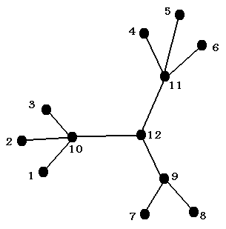
Fig. 1. Improper performance of node degree

However, this index also has inappropriate performance for some networks. For example in fallowing figure, nodes 11 and 12 have the same node importance degree (α=0.0625), but node 12 in compare to node 11 is much more important. In this article, a combined and flexible index is going to be presented. Further description will be given also.
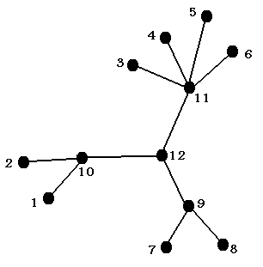
Fig. 2. Improper performance of node importance degree

Until now several indices has been presented to measure the importance of the complicated network nodes. Such as, betweenness index [11], closeness index [12], eigenvector index, sub graph index [13] and many other indices. However, none of them can show the difference between various nodes in complicated power networks by themselves. Therefore, combinational node ranking index ($η$) is presented in this article which is a weighted combination of some indices. Therefore, we will be able to rank the network nodes in the best way by its use.
This index is defined as follow.
$$η(i)=w_{1}×α(i)+w_{2}×β(i)+w_{3}×γ(i)+w_{4}×δ(i) \left(1\right)$$
In which
Node number
Node importance degree of ith node
$β(i)$ Betweenness of ith node
Closeness of ith node
$δ(i)$ Inverse of interruption cost of ith node
$w_{1}$,$w_{2}$,$w_{3}$ and $w_{4}$ are weighted coefficient for each index that $w_{1}$+$w_{2}$+$w_{3}$+$w_{4}$=1
In order to calculate $α$ for each node, it is necessary to combine that node with its adjacent nodes and create a combined node. After making a new network, this index for the wanted node will measure as follow [10]:
$$α(i)=\frac{1}{n_{i}×l_{i}}\begin{matrix}\begin{matrix}\begin{matrix} & & & \end{matrix} & & & \end{matrix} & & & \begin{matrix} & \end{matrix}\end{matrix}\left(2\right)$$
$$l_{i}=\frac{\sum_{i,j∈V_{i}}{d_{{\text{min}}_{i,j}}}}{n_{i}(n_{i}−1)}\begin{matrix}\begin{matrix}\begin{matrix} & & & \end{matrix} & & & \end{matrix} & & & \end{matrix} \left(3\right)$$

Where
$n_{i}$ Number of network's nodes after combining the ith node with its adjacent nodes
$l_{i}$ The average of minimum distance in the network after the combination of ith node with adjacent nodes
$d_{\text{min}i,j}$ The shortest distance between i and j after combination of node i

Betweenness index for each node is calculated as follow [12].

$$β(i)=\sum_{j,k∈N,j≠k}{\frac{n_{\text{jk}}(i)}{n_{\text{jk}}}} \begin{matrix}\begin{matrix} & & & \end{matrix} & & & \end{matrix} \left(4\right)\begin{matrix} & \end{matrix}$$
Where
The number of shortest path between j and k
$n_{\text{jk}}(i)$ The number of shortest path between j and k, which pass through i
Closeness index ($γ$) for each node will be calculated by dividing 1 by sum of distances between that node and other network nodes. It is obvious that the lesser the sum of distances to other nodes is the bigger the index is and that node is more important [12].
$$γ(i)=\frac{1}{\sum_{j∈N}{d(i,j)}}\begin{matrix}\begin{matrix}\begin{matrix} & & \end{matrix} & & & \end{matrix} & & & \end{matrix} \left(5\right)$$
Where
$d(i,j)$ Distance between i and j
Following table shows the amounts of different indices for nodes 11 and 12 in fig.2. As it can be seen, although the amount of node importance degree is the same for both nodes, the amounts of betweenness and closeness indices for node 12 is more than node 11 and that shows node 12 is more important than node 11.

TABLE I
comparison of node importance degree, betweenness and closeness
Node no.
11 | 0.0625 | 0.4242 | 0.0476
12 | 0.0625 | 0.5909 | 0.0526

Fitness function is defined as fallow.
$$f=\frac{N_{s}}{\sum_{i∈N}{η(i)}}\begin{matrix}\begin{matrix}\begin{matrix} & & & \end{matrix} & & & \end{matrix} & & & \begin{matrix} & \end{matrix}\end{matrix}\left(6\right)$$
Where
$N$ The set consisting of all nodes in skeleton network
$N_{s}$ Total number of nodes in skeleton network
And constraints of the problem are:
$$ΔU<{ΔU}_{\text{max}}\begin{matrix}\begin{matrix}\begin{matrix}\begin{matrix}\begin{matrix} & \end{matrix} & \end{matrix} & \end{matrix} & & & \end{matrix} & & & \begin{matrix} & \end{matrix}\end{matrix}\left(7\right)$$
$$ΔP<{ΔP}_{\text{max}}\begin{matrix}\begin{matrix}\begin{matrix} & & & \end{matrix} & & & \end{matrix} & & & \begin{matrix} & \end{matrix}\end{matrix}\left(8\right)$$

Where
$$ΔU=\frac{n_{ΔU}}{n_{c}}\begin{matrix}\begin{matrix}\begin{matrix} & & & \end{matrix} & & & \end{matrix} & & & \begin{matrix} & \end{matrix}\end{matrix}\left(9\right)$$
$$ΔP=\frac{\sum_{i∈L}{({\text{MP}}_{i}−{\text{CP}}_{i})}}{L_{c}}\begin{matrix}\begin{matrix} & & & \end{matrix} & & & \begin{matrix} & \end{matrix}\end{matrix}\left(\text{10}\right)$$

In which:
$n_{c}$ The number of existed nodes in reconfigured network
$n_{ΔU}$ The number of nodes that their voltage is over the limited area
$L$ Set of existed lines in reconfigured network
$L_{c}$ The number of existed lines in reconfigured network
${\text{MP}}_{i}$ The maximum capacity of ith transmission line
${\text{CP}}_{i}$ The current capacity of ith transmission line

For solving the restoration problem, which is multi-objective, multi-constraints, complicated and nonlinear, using the traditional optimization algorithms cannot be beneficial. Therefore, in this article to solve this optimization problem, genetic algorithm is used. Genetic algorithm is an algorithm based on repetition that its premier principles are adopted from genetic science. This algorithm uses the natural selection principle to find an optimal answer or path [14].

methodology
Fig.3. shows a general structure of the algorithm that is used in this paper. In the first step, values of node importance degree, betweenness and closeness indices and inverse of interruption cost of each node should be calculated. Values of each index should be normalized in terms of maximum of that index. After that, a random set of GA solutions should be created. A solution is defined with the state sequence denoting which lines are selected to take part in reconfiguration network. When a certain transmission line is selected, corresponding position in state sequence takes one value. Otherwise, zero value is taken. The next step is checking the connection of the solution. If a solution is not integrated, it will change to an integrated one. After this step, fitness function should be calculated and after running power flow and checking constraints, the best solutions will be recorded. This process will continue until it reaches the stop criteria.

Yes
No
Yes
No
Calculating the value of each index for network nodes
Creating a random set of GA solutions
Generating the new population
Running power flow
Calculating the combinational node ranking index and fitness function for each solution
Change this solution to the connected ones
Is the solution a connected network?
Does the solution satisfy the constraints?
Recording the best solutions
Is the stopping criteria reached?
End
No
Yes

Fig. 3. Flow of the main program

case study and results of simulation
In order to analyze the performance of combinational node ranking index that was suggested in this paper and compare it to former suggested indices, this method was applied on modified IEEE 30-bus network which is showed in fig. 4. Values of indices for this network's nodes are calculated. To show the relative importance of nodes, value of each index for each node should be normalized in terms of maximum of that index. Normalized values of all indices for this network’s nodes are shown in the Table IV. Based on load’s importance and load of each node, an interruption cost assign to load nodes of network. Table III shows the interruption costs of load nodes of this network. Weighted coefficients$w_{1}$,$w_{2}$, $w_{3}$ and $w_{4}$ take value of 0.25, 0.5, 0.2 and 0.05, respectively. Betweenness, because of its priority takes the maximum coefficient. The second and third priorities are node importance degree and closeness. Finally, inverse of interruption cost takes 0.05 because economical issues are not so important in first stage of restoration.
TABLE III
value of interruption cost for load nodes
Node no. | Interruption cost $/h | Node no. | Interruption cost $/h | Node no. | Interruption cost $/h
1 | --- | 11 | 50 | 21 | 60
2 | 80 | 12 | 70 | 22 | ---
3 | 55 | 13 | --- | 23 | 70
4 | 65 | 14 | 60 | 24 | 70
5 | 50 | 15 | 70 | 25 | 55
6 | 60 | 16 | 55 | 26 | 60
7 | 65 | 17 | 60 | 27 | ---
8 | 65 | 18 | 55 | 28 | 50
9 | 55 | 19 | 60 | 29 | 55
10 | 70 | 20 | 55 | 30 | 55

Power system restoration problem is multi-objective, combinatorial, non-linear and a constrained optimization problem. Because of good performance of genetic algorithm in solving problems like this, GA is used in this paper. In this algorithm, every chromosome has 41 genes because there are 41 transmission lines in this network. Tournament selection method is used to select the solution that contributes in the production of new generation and crossover, mutation and selection rates are 0.5, 0.3 and 0.2 respectively.

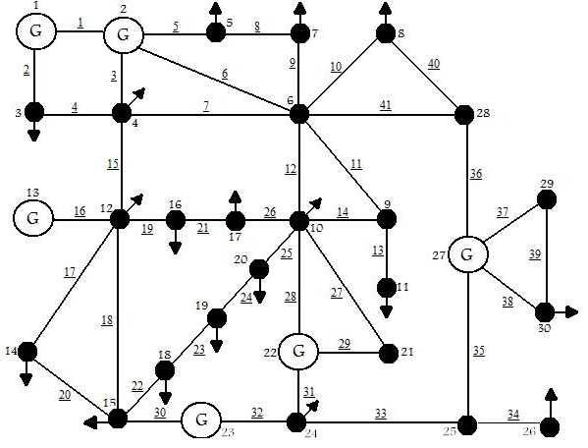
Fig. 4. IEEE 30-bus network

TABLE IV
value of indices for network nodes
$$γ$$ | $$β$$ | $$α$$ | Node no. | $$γ$$ | $$β$$ | $$α$$ | Node no.
0.6667 | 0.0590 | 0.6898 | 16 | 0.6168 | 0.0057 | 0.6823 | 1
0.7333 | 0.0902 | 0.6898 | 17 | 0.8148 | 0.2296 | 0.7764 | 2
0.6055 | 0.0652 | 0.6972 | 18 | 0.6535 | 0.0227 | 0.6819 | 3
0.6055 | 0.0666 | 0.6972 | 19 | 0.8800 | 0.5087 | 0.8286 | 4
0.7079 | 0.1488 | 0.6972 | 20 | 0.6168 | 0.0057 | 0.6770 | 5
0.7021 | 0 | 0.6870 | 21 | 1 | 1 | 1 | 6
0.7765 | 0.1989 | 0.7391 | 22 | 0.7174 | 0.0482 | 0.6770 | 7
0.6804 | 0.1776 | 0.7205 | 23 | 0.7500 | 0 | 0.7007 | 8
0.7333 | 0.3207 | 0.8910 | 24 | 0.8049 | 0.1587 | 0.7403 | 9
0.6667 | 0.2768 | 0.7736 | 25 | 0.9167 | 0.6509 | 0.8872 | 10
0.5197 | 0 | 0.7626 | 26 | 0.6000 | 0 | 0.6555 | 11
0.7021 | 0.4355 | 0.8075 | 27 | 0.7952 | 0.4941 | 0.8319 | 12
0.8148 | 0.4138 | 0.7764 | 28 | 0.5946 | 0 | 0.6584 | 13
0.5455 | 0 | 0.7019 | 29 | 0.6471 | 0 | 0.6984 | 14
0.5455 | 0 | 0.7019 | 30 | 0.7333 | 0.3080 | 0.7939 | 15

Optimal skeleton-network obtained from GA is shown in fig. 5. Twelve branches labeled in bold lines are identified to participate in reconfiguration network. Fig. 6 shows the skeleton network that is suggested in 2007. Fitness functions of these networks are 0.6462 and 0.7209 respectively. In order to compare these two networks, number of switching that required for energizing other nodes of network is calculated. It is obvious that the lesser the sum of switching is the lesser are the cost and the time of restoration process are. In TABLE IV number of switching that is needed for energizing the other nodes of these two networks are compared. Two shortest paths for each node are mentioned in this table. For nodes, that there is only one way for energizing them, that way is also mentioned for second path. This table shows that average of switching for energizing other nodes via both paths in the network that suggested in this paper is lesser. This means that energizing whole network from this skeleton-network is faster and cheaper. Average of normalized interruption cost for networks that are shown in fig. 5 and fig. 6 are 0.6346 and 0.5848, respectively. This shows that by using combinational node ranking index cost of blackout is decreased.

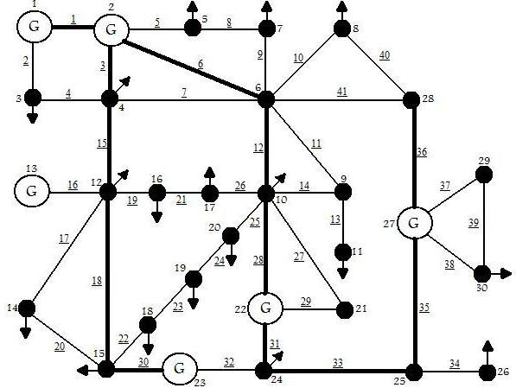
Fig. 5. Optimal skeleton-network

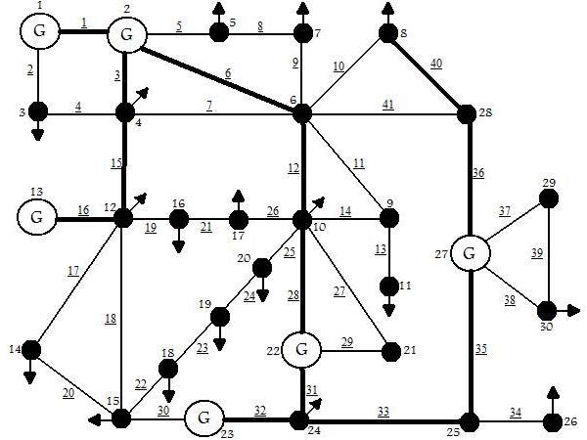
Fig. 6. skeleton-network suggested in past

TABLE IV
comparison between two suggested networks
Suggested network in this paper |  |  | Suggested network in 2007
Node number | Shortest path | Second path | Node number | Shortest path | Second path
3 | 1 | 1 | 3 | 1 | 1
5 | 1 | 2 | 5 | 1 | 2
7 | 1 | 2 | 7 | 1 | 2
8 | 1 | 1 | 9 | 1 | 1
9 | 1 | 1 | 11 | 2 | 2
11 | 2 | 2 | 14 | 1 | 2
13 | 1 | --- | 15 | 1 | 1
14 | 1 | 1 | 16 | 1 | 2
16 | 1 | 2 | 17 | 1 | 2
17 | 1 | 2 | 18 | 2 | 2
18 | 1 | 3 | 19 | 2 | 3
19 | 2 | 2 | 20 | 1 | 4
20 | 1 | 3 | 21 | 1 | 1
21 | 1 | 1 | 26 | 1 | ---
26 | 1 | --- | 29 | 1 | ---
29 | 1 | --- | 30 | 1 | ---
30 | 1 | --- | --- | --- | ---
average | 1.117 | 1.588 | average | 1.187 | 1.750

conclusion
Restructuring of electrical power industry have increased the posibility of blackouts in power networks. Network restoration after a blackout is a complicated matter that needs an appropriate programming. Generally, this article focused on the first stage of restoration process of power system, which is identifying the skeleton-network.
In this article, a combined index was presented for analyzing complicated networks that by its use it is possible to rank network busses and reduce the time needed for restoration. The issues, which have been dictated by the power market to power system restoration problem such as interruption cost, were considered in defining suggested index. Using this index could decrease the cost of blackout and the cost of the power system restoration.
This index in compare to former indices has more creditability and in networks that former indices were not practical has a better performance. This index was used for identifying the skeleton network of modified IEEE 30-bus network. This problem was solved by using genetic algorithm. By comparing results were obtained from this method with results were obtained from former methods efficiency of this new method was seen.

References

- Adibi MM; Fink LH, "Power system restoration planning", IEEE Transactions on Power Systems 1994;9(1):22-8.
- Lee, C.-H.; Hsieh, S.-C, "Lessons learned from the power outages on 29 July and 21 September 1999 in Taiwan", Generation, Transmission and Distribution, IEE Proceedings-, Volume 149, Issue 5, Sept. 2002 Page(s):543 – 549
- Gomes, P.; de Lima, A.C.S.; de Padua Guarini, A, "Guidelines for power system restoration in the Brazilian system", Power Systems, IEEE Transactions on, Volume 19, Issue 2, May 2004 Page(s):1159 – 1164
- Larsson, S.; Danell, A, "The black-out in southern Sweden and eastern Denmark, September 23, 2003.", Power Systems Conference and Exposition, 2006. PSCE '06. 2006 IEEE PES, Oct. 29 2006-Nov. 1 2006 Page(s):309 - 313
- Chunyan Li; Yuanzhang Sun; Xiangyi Chen, "Analysis of the blackout in Europe on November 4, 2006", Power Engineering Conference, 2007. IPEC 2007. International, 3-6 Dec. 2007 Page(s):939 - 944
- Zhenzhi Lin; Fushuan Wen, "Power System Restoration in Restructured Power Industry", Power Engineering Society General Meeting, 2007. IEEE, 24-28 June 2007 Page(s):1 - 6
- D. Lindenmeyera,, H.W. Dommela, M.M. Adibi, " Power system restoration -- a bibliographical survey", Electrical Power and Energy Systems 23 (2001) 219±227
- Stefano Barsali, Romano Giglioli, Davide Poli, Marino Sforna, Roberto Salvati, Roberto Zaottini, "The restoration of an electric power system: International survey and discussion of possible innovative enhancements for the Italian system", Electric Power Systems Research 78 (2008) 239–247
- yan Liu; Xueping Gu, " Reconfiguration of network skeleton based on discrete particle-swarm optimization for black-start restoration", Power Engineering Society General Meeting, 2006. IEEE, 0-0 0 Page(s):7 pp
- Yan Liu; Xueping Gu," Skeleton-Network Reconfiguration Based on Topological Characteristics of Scale-Free Networks and Discrete Particle Swarm Optimization ",IEEE TRANSACTIONS ON POWER SYSTEMS, VOL. 22, NO. 3, AUGUST 2007
- K. –I. Goh, E.Oh, B. Kahng, and D. Kim, “Betweenness centrality correlation in social networks”, Phys. Rev. E 67, 017101 (2003).
- David A. Bader; Kamesh Madduri; " Parallel Algorithms for Evaluating Centrality Indices in Real-world Networks ", Parallel Processing, 2006. ICPP 2006. International Conference on 14-18 Aug. 2006 Page(s):539 – 550
- Ernesto Estrada, Juan A. Rodriguez-Velazquez, “Subgraph centrality in complex networks”, Physical Review E 71 ,2005
- Germano Lambert-Torres; Helga G. Martins; Maurilio P. Coutinho; Luiz Eduardo Borges da Silva Felipe; M. Matsunaga, Rômulo; A. Carminati; and Jose Cabral Neto;" Genetic Algorithm to System Restoration"The Online Journal on Electronics and Electrical Engineering (OJEEE), Vol. (1) – No. (1), Reference Number: W09-0003


Biographies
Jafarian Hamidreza was born in Mashhad, Iran, on November 21, 1983. He received the B.Sc. degrees in Electrical Power Engineering in 2007 from Amirkabir University of Tehran, Iran. He is currently pursuing the M.Sc. degree in Ferdowsi University of Mashhad.
Her areas of interest include Electricity Market, Power System Restoration and Power System Operation, Planning and Optimization.

Mostafa Rajabi Mashhadi was born in Mashhad Iran, on June 2, 1971. He received his B.Sc and M.Sc degrees both in electrical engineering from Ferdowsi university of Mashhad, Mashhad, Iran, in 1995 and 2001, respectively. He is currently a Ph.D. student at Ferdowsi university of Mashhad, Iran.
Since 2003, he has been employed in Khorasan Regional Electric Company (KREC) and has been engaged in electric and control department of khorasan gas turbine power plants, as the manager of Khorasan power market department and the manger of Dispatching Center of North East Area of Iran. His special fields of interest include power system control and operation and planning, restructuring, and artificial intelligence.
He is a member of power system studies and restructuring laboratory.

M. Hossein Javidi received his B.Sc. degree from Tehran University, Tehran, Iran in 1980, M.Sc. degree from Nagoya University, Nagoya, Japan in 1985 and Ph.D. degree from McGill University, Montreal, Canada in 1994, all in electrical engineering.
He is currently a professor in the Department of Electrical Engineering, Ferdowsi University of Mashhad, Mashhad, Iran. He was a board member, as well as the secretary of the electricity regulatory body in Iran (2003-2010). His research interests include power system operation and planning, restructuring and market design, and artificial intelligence.

 This work was supported in part by Khorasan Regional Electric Company. H. R. Jafarian graduate student of Ferdowsi University of Mashhad, Mashhad, Iran, (ha_ja784@stu-mail.um.ac.ir) M. Rajabi Mashhadi Deputy of research and planning of Khorasan Regional Electric Co., Mashhad, Iran, (m.rajabimashhadi@krec.ir) H. M. Javidi professor in the Department of Electrical Engineering, Ferdowsi University of Mashhad, Mashhad, Iran(h-javidi@ferdowsi.um.ac.ir)

