NEW APPROACHES TO BOND BETWEEN BAMBOO AND CONCRETE

Arash Azadeh^{1,a}, Hassan Haji Kazemi^{2,b}

¹M.Sc. in Civil Engineering, Ferdowsi University of Mashhad, Iran
²Prof. in Civil Engineering, Ferdowsi University of Mashhad, Iran
ªarashazadeh@yahoo.com, ^{b}hkazemi@um.ac.ir

Keywords: Bamboo, Concrete, Bond, Corrugation

Abstract. Increasing bond between bamboo and concrete is one of the important concerns in using bamboo as reinforcement. Among many different reasons for concrete elements rupture that have been reinforced by bamboo, concrete cover rupture and bond failure could be considered as two important causes.
In this paper, bamboo corrugation as a new method has been proposed. Bamboo corrugation is suggested as a mechanism to interlock bamboo and concrete in order to assist the cohesion and skin friction and increase the total bond. Because of remarkable difference between steel shear strength and longitudinal shear strength of bamboo, the interlock mechanism is different. First, the relation between parameters like bamboo longitudinal shear strength, concrete shear strength and the kind of coating or treating of bamboo has been investigated. Then, the proper shape of bamboo corrugation (relation between size, depth and space between dents) can be obtained. Using corrugated bamboo strip can improve bond between these two materials even bamboo strips have not been treated.

1. Introduction
Substituting steel bars by a composite such as bamboo in concrete structures in recent decades has been the concern of many researchers around the world. Proper use of bamboo as reinforcement in concrete can prominently improve the strength of concrete members.
The present article is an effort striving to propose some points based on theories and experiments in order to improve the bond between bamboo and concrete. Any sliding between these two materials shall be restrained. If any sliding happens, it could produce concentrated tensile force that can split the concrete cover by wedging effect mechanism. Unlike a plain steel bar, the shape of whole bamboo or bamboo splits are not prismatic, especially at the nodal points. This kind of geometry not only couldn’t assist to interlock between bamboo and concrete but also can increase the concrete cover rupture possibility. On the other hand, the interlock mechanism between steel deformed bar and concrete is totally different with corrugated bamboo and concrete because the longitudinal shear strength in bamboo (as an orthotropic material) is much less than shear strength of steel.

2. Literature Review
Many experiments and investigations have been done about reinforcing concrete by bamboo heretofore. Some of these investigations are related to bond between bamboo and concrete. Pull-out test is a routine and important test to realize the bond between bamboo and concrete. The pull-out test has been carried out with different shapes (whole bamboo, bamboo strips with and without node) and with or without treatment. Also the treatment of bamboo has many different ways like using thick tar (60-70), diluted tar (85-100), Polydimethylsiloxane (PDMS), Varnish, Epoxy, Alkyd oil, Negrolin, Sikadur 32-Gel and so on. These types of coatings can be used with nail, sand and wire to increment the bond. As they are various then the combinations and results can be numerous. All of these variations can be used with whole bamboo, bamboo strips with node or bamboo strips without node.
For example some experiment has been carried out by Arghand [1] from Ferdowsi University of Mashhad (1994). In this research bamboo strips have been treated in 11 different groups and each group has 3 specimens. The final result of test summarized in Table 1.

Table 1 Bonding strength for different treatment at moment of sliding and ultimate bond strength [1]
Group No. | $$f_{c}^{'}$$  ($MPa$) | condition | treatment method | ultimate bond strength ($MPa$)
1 | 16.0 | green & with node | No- treatment | 0.71
2 | 16.0 | green & without node | No- treatment | 0.24
3 | 16.0 | green & with node | 2 layers of varnish + 1" nails at every 5 Cm | 2.38
4 | 16.0 | green & with node | 2 layers of varnish + sand | 1.23
5 | 16.0 | dry & without node | 1 layer of diluted tar (85-100) +sand | 2.54
6 | 16.0 | dry & with node | 2 layers of alkyd oil color +sand | 2.97
7 | 16.0 | dry & with node | 1 layer of thick tar (60-70) +sand | 2.58
8 | 16.0 | dry & with node | 2 layers of varnish + sand | 1.89
9 | 28.6 | dry & without node | 1 layer of diluted tar (85-100) +sand | 2.10
10 | 13.1 | dry & with node | No- treatment | 0.90
11 | 13.1 | dry & without node | No- treatment | 0.39

Other investigation in this regard has been done by K. Ghavami [2] from PUC, Rio de Janeiro, Brazil (2005). In this investigation some methods for improving the bond between bamboo and concrete have been proposed. One of the methods for improving the bond between these two materials is using Sikadur 32-Gel. More than impermeability, this material can increase remarkably the bond. This method can increase the bond between bamboo and concrete to 5.29 times. Table 2 as an all-inclusive table can assist to comparing different treatment methods as well as untreated bamboo.

Table 2 Bonding strength of bamboo segment subjected to pull-out test [2]
Treatment | Bond strength of  treated bamboo $τ_{b}$  (MPa) | Bond strength regarding to untreated bamboo $τ_{b}/τ_{bnt}$
1. Without treatment | 0.52 | 1.00
2. Negrolin + sand | 0.73 | 1.40
3. Negrolin + sand + wire | 0.97 | 1.87
4. Sikadur 32-Gel | 2.75 | 5.29
5. Steel | 3.25 | 6.25

Sakaray et al. [3] carried out similar pull-out test. Moso type bamboo with two types of uncoated bamboo and water proofing material coated bamboo (ALGICOAT RC-104) have been used for this test. From Table 3 is observed that bond stresses of coated and uncoated bamboo samples are close together.

Table 3 Pull-out test results for coated and uncoated bamboo and steel [3]
No | Bond Stress of uncoated Bamboo (MPa) | Bond Stress of water proof material (MPa)
1 | 1.68 | 1.45
2 | 1.45 | 1.95
3 | 1.74 | 1.51
Average | 1.62 | 1.64

In 2011 N. Plangsriskul and N. Dorsano [4] carried out some other experiments on bond between bamboo and concrete. Two types of bamboo - Dendrocalamus Asper and Bambusa Oldhamii – have been considered as samples for this test. Two coatings, asphalt emulsion and polydimethylsiloxane (PDMS), were applied to the bamboo sample ends and were tested along with the control samples, which contained no coatings. The test results indicated that the bonding strength between the bamboo and concrete with the asphalt emulsion coating was the greatest at 339.27 psi (2.34 MPa). The next strongest was the control sample (no coating) at 319.07 psi (2.2 MPa), then PDMS resulting in 154.20 psi (1.06 MPa).

Table 4 Pull-out test results for uncoated, asphalt and PDMS coating [4]
Treatment | Bond strength  (MPa)
1. Without treatment | 2.2
2. Asphalt emulsion coating | 2.34
3. PDMS coating | 1.06

Another important factor is using bamboo splits with or without node in pull-out test. There are two failure modes for the bamboo with and without node during the pull out test [4] (Fig. 1). By reviewing the results of tests which has been done by Plangsriskul and Dorsano[4], observed that using the bamboo strips with node in pull-out test, can split the concrete (Fig. 1-b).

Fig. 1 (a) Failure mode 1: the bamboo samples without the node were being pulled out smoothly. (b) Failure mode 2: the samples with the node cracked the concrete [4]. | 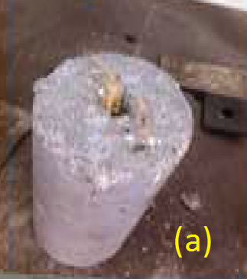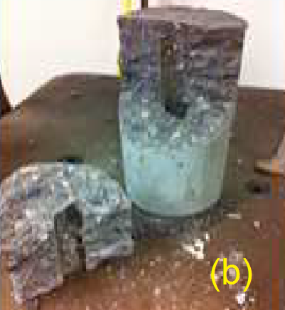

The non-prismatic shape of the bamboo splits at node can act as a wedge and produce a concentrated tensile force in nodal area [5]. This force can split concrete cover. General shape of a bamboo split at node is usually as below (Fig. 2):
Fig. 2 Bamboo split at node [5]. | 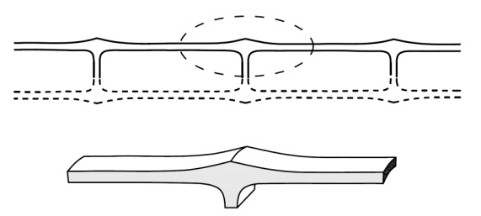
Fig. 3 (a) Strip without node (b) Strip with node. | 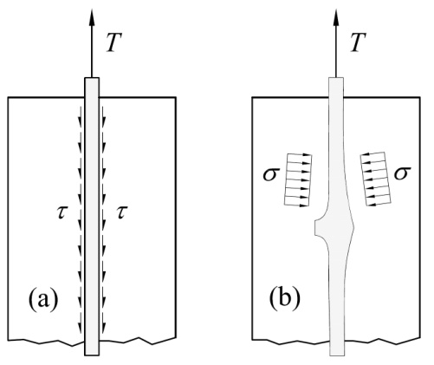

Stress transition between concrete and bamboo in Fig. 3-b mainly concentrated in nodal zones that could be a weak point for using bamboo strips. These zones are the locations that cracks can be initiated and developed.
For a bamboo strip the distance between two nodes can be divided to 3 zones (not necessarily equal parts): 1. no-touch zone 2. skin friction zone 3. wedging action zone.
Fig. 4 Stresses on a bamboo split between two nodes. | 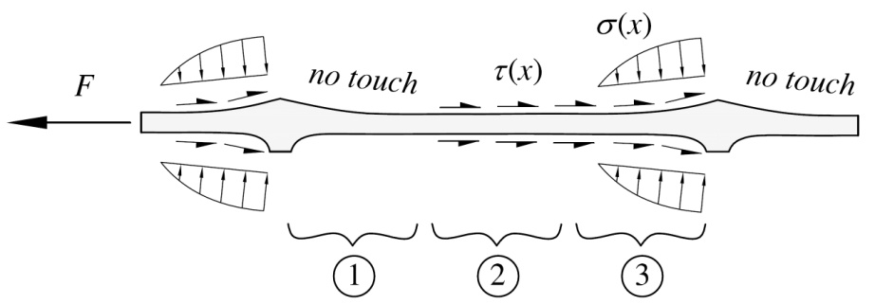
As it can be observed in Fig. 4, Most of tensile force (F) can be concentrated in frontal faces of node (zone 3). Concrete cover splitting cracks can be easily initiated in this zone. For distributing the concentrated stress$σ(x)$, bamboo corrugation can be a proper solution for eliminating this corruptive phenomenon.

3. Literature Review Results
With the same situation, the pull-out test results can be very different from together. It can be happened because of some possible reasons:
- Using different variety of bamboo: at the same situation, the results show that Bambusa Oldhamii has higher pull out strengths than the Dendrocalamus Asper for all types of coatings [4].
- Using different type of aggregates for concrete.
- Using sand for coating with different size and coarseness.
- Using different amount of cement ${(f}_{c}^{'})$ [1].
- Using different amount of W/C for concrete (different Slump test results).
- The effect of bamboo Poisson’s ratio.
- Using different shape of concrete molding (cubic or cylinder form) with different dimensions.
- Using different bamboo strip dimensions (thickness and width).
- Using different pulling speed.
- Using bamboo without coating and with different moisture content.
- Using bamboo splits without parallel faces. The process of making bamboo splits usually produces splits that the cut faces are not parallel together. By making them parallel the pull-out results would be closer to the reality. By using narrow end in concrete the pull-out test result can show less value than expectations but by using thick end in concrete, the bamboo strip can act like a wedge (Fig. 5).
Fig. 5 (a) Recommended. (b) It pulls out with less than usual force. (c) The wedging action and concrete splitting can occur. | 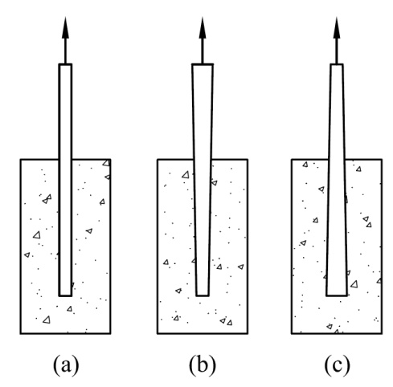
- Contrary to expectations, some treatments decrease the bond strength between bamboo and concrete. For example using polydimethylsiloxane (PDMS) coating [4] reduces the bond to$1.06 MPa$ comparing with $2.2 MPa$ for uncoated bamboo.
- A summary result [1,2,3,4] for bond between bamboo and concrete in three different treatment methods including: without treatment, coated and coated + sand is presented in Fig. 6. It is observed that using sand and coating as treatment can increase the bond between bamboo and concrete about two times:

Fig. 6 Bond strength for three types of treatment. | 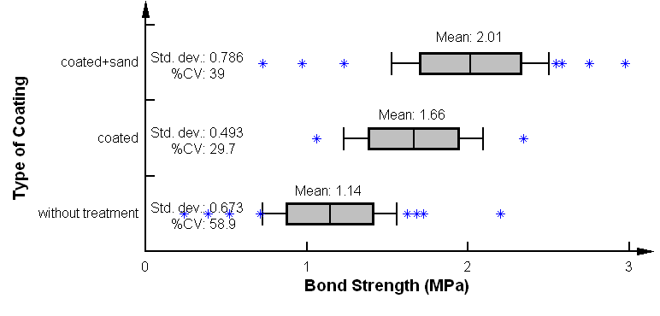

4. A Proposed Method for Bond Improvement
4.1 Introduction
Like using steel deformed bar as reinforcement, corrugation of bamboo can improve the bond between bamboo and concrete. Also bamboo corrugation can diminish the destructive effect of shrinkage, thermal expansion and wedging effect in untreated bamboo strips.
Although, using proper coating as interface between bamboo and concrete (in addition to water proofing) at some cases can provide adequate skin friction, but this value is much less than the bamboo longitudinal shear strength (7.45 MPa for dry and 4.12 MPa for wet bamboo [5] versus treated bamboo bond strength in Table 1 to Table 4). The longitudinal shear strength of bamboo is more determinative when the interlock mechanism between bamboo and concrete is important.
Because of some similarities between reinforced concrete by steel bars and reinforced concrete by bamboo strips, the same shapes and equations can be considered. The simplest model representing the stress transfer between a plain bar (bamboo, steel or any other composite) and concrete is frictional model that can be shown as Fig. 7:

Fig. 7 Frictional model [6]. | 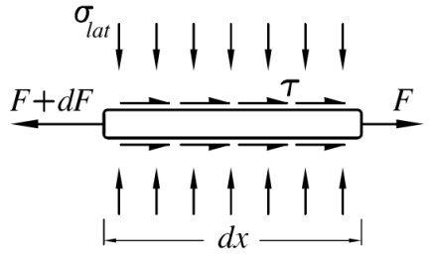

In this shape the relation between parameters are simple ($D_{b}:$ bar diameter - $μ:$ friction coefficient - $σ_{lat}:$ lateral tension –$C$: adhesion):

$${dF=τ.π.D_{b}.dx \atop τ=\left(μ.σ_{lat}+C\right) .}$$ | (1)

In this type, the skin friction is directly depend on lateral tension (compression) and friction coefficient.
The theory of interlocking between deformed bar and concrete is different from using a prismatic and plain bar (Fig. 8).

Fig. 8 Bond force transfer mechanism in a deformed bar [7]. | 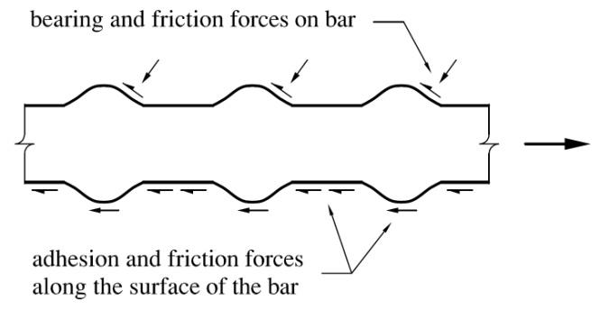

In this mechanism, the failure surface would be a cone that is started from dents and the base of cone is toward the tensile force [8]. Due to remarkable difference between steel shear strength and longitudinal shear strength of bamboo ($7.45 MPa$ for dry and $4.12 MPa$ for wet bamboo [5]), all of assumptions and calculations are different. In a steel deformed bar, the root connection of the dent $(b)$ regarding to distance between dents $(c)$ is small (Fig. 9-1). It can be justified because of remarkable difference between steel and concrete shear strength.

Fig. 9 (1) Typical shape of a steel deformed bar (2) Bamboo corrugated strip. | 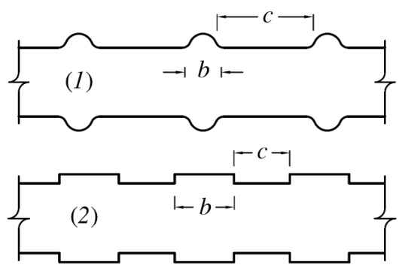

As the bamboo longitudinal shear strength and concrete shear strength are close together then the length of dent $(b)$ would be closer to distance between dents $(c)$:
Because of proper bamboo workability, it can be easily filed and corrugated in field. By using this method for improving the bond, the necessity of using other chemical coating for increasing the bond will be lessened.

4.2 Theory
Three main factors can justify the corrugation of bamboo strips. There are: 1. high capacity of bamboo compression strength, 2. adequate longitudinal shear strength of bamboo beside skin friction or adhesion and 3. proper shear resistance of concrete.
Some typical shapes of bamboo corrugation could be presented as below (Fig. 10):
Fig. 10 Some typical shapes of bamboo corrugation. | 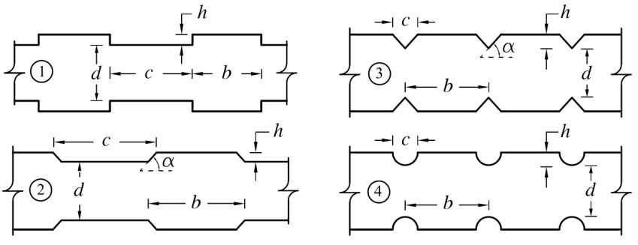
The first one in Fig. 10 can be chosen as the simplest shape for modeling. It is important to find the relations between b, c and h. Two independent equations can relate these three geometrical parameters (b, c and h) together. Then by defining one of them, the two others can be achievable. For this purpose the equilibrium equations shall be extracted from Fig. 11:
Fig. 11 Skin friction, shears and compression on a corrugated bamboo split. | 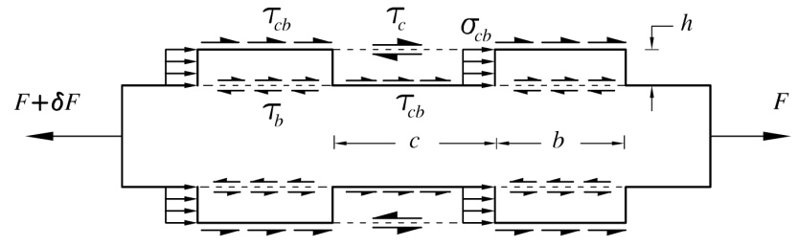
$τ_{cb}:$Skin friction between bamboo and concrete
$τ_{b}:$Bamboo longitudinal shear tension
$τ_{c}:$Concrete shear tension
$σ_{cb}:$Compression between bamboo and concrete
Relation between b and c: in order to finding relation between these parameters at first a diagram only for one period of denting (containing a bamboo dent and one distance between two dents) should be extracted from Fig. 13:
Fig. 12 Tensions in one period of corrugation. | 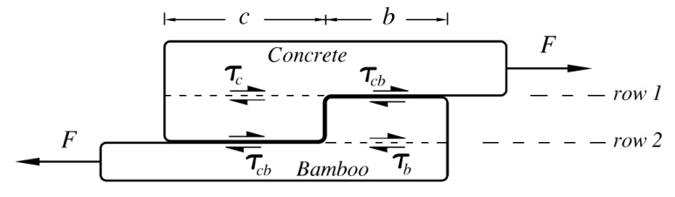
Skin friction plus shear in each material in row 1 and row 2 in Fig. 14 should be the same (these are valid only when $τ_{cb}<τ_{b}$ and $τ_{cb}<τ_{c}$):
$$τ_{b}×b+τ_{cb}×c=τ_{c}×c+τ_{cb}×b → \frac{b}{c} =\frac{τ_{c}-τ_{cb}}{τ_{b}-τ_{cb}} .$$ | (2)
Relation between h and b (or c): For the bamboo element between row 1 and 2 in Fig. 14, the equilibrium equation would be as below (the same diagram and equation can be drafted and written for concrete element):
Fig. 13 Bamboo element (dent) between row 1 and 2. | 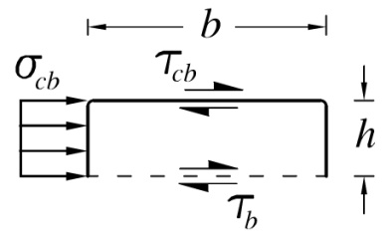
$$\frac{h}{b}=\frac{\left(τ_{b}-τ_{cb}\right)}{σ_{cb}} or \frac{h}{c}=\frac{\left(τ_{c}-τ_{cb}\right)}{σ_{cb}} .$$ |  | (3)
These two equations (Eq. 2 & 3) can define relation between b, c and h. by assuming one of these parameters, two others can be calculated easily. For $σ_{cb}$, the minimum value among ultimate bamboo compression stress $(σ_{b})$ and ultimate concrete compression stress $(σ_{c})$ should be considered.
$$σ_{cb}=\min\left(σ_{c} ,{ σ}_{b}\right) .$$ | (4)
Then the proportional relation between $b$, $c$ and $h$ can be written as below:
$$h:b:c=h:\frac{σ_{cb}}{\left(τ_{b}-τ_{cb}\right)}h:\frac{σ_{cb}}{\left(τ_{c}-τ_{cb}\right)}h .$$ | (5)
The percentage of bond increment due to corrugation: In this section the amount of bond increment for untreated and different types of treatment due to corrugation are investigated. If the section area of bamboo strip is considered as a rectangular, then for each side and for one period of corrugation, $τ_{ave}$ can be calculated as below:
$$τ_{ave}=\frac{τ_{b}τ_{c}-{τ_{cb}}^{2}}{τ_{b}+τ_{c}-2τ_{cb}} .$$ | (6)
As the corrugation is done for two opposite sides then totally average bonding stress for two sides from four sides of corrugation $(τ_{tot(2)})$ would be:
$$τ_{tot(2)}=\frac{τ_{ave}+τ_{cb}}{2} .$$ | (7)
Generally for $n$ sides corrugation (up to maximum 4 sides) the totally average bonding stress ${(τ}_{tot(n)})$ will be calculated as below:
$$τ_{tot(n)}=\frac{nτ_{ave}+\left(4-n\right)τ_{cb}}{4} .$$ | (8)
Then the percentage of bond stress increment ($α$) for $n$ sides is:
$$α\%=\frac{τ_{tot(n)}-τ_{cb}}{τ_{cb}}×100 .$$ | (9)
4.3 Practical Example
As a practical example, the numerical values of some parameters like $σ_{cb}$,$σ_{c}$,${ σ}_{b}$, $τ_{b}$, $τ_{c}$ and $τ_{cb}$ that have been defined already, will be used here then the relation between these three parameters can be obtained.
Concrete compressive stress $(σ_{c})$ can be considered as $f_{c}^{'}$ and for this example at mid range it has been taken as $21 MPa$ but bamboo compressive stress $(σ_{b})$ can be too variable and depends on different varieties of bamboo and different moisture content (wet or dry). The compression stress that has been measured by Godbole et al. [9] from department of aeronautical engineering, Indian institute of technology (1986), for dry bamboo splits $63.2 MPa$ and for soaked in distilled water for 144 hr, 34.3 MPa has been reported.
Then:
$$σ_{cb}=\min\left(σ_{c} ,{ σ}_{b}\right)=f_{c}^{'}=21 MPa .$$ | (10)
(Note: as $σ_{c}$ is always less than ${ σ}_{b}$ in both dry and water saturated condition, then in this conditional equation $σ_{cb}=f_{c}^{'}$ has been selected.)
For wet and dry bamboo longitudinal shear strength [5]:
$$τ_{b}=\left\{\begin{aligned}4.12 MPa for wet bamboo \\ 7.45 MPa for dry bamboo .\end{aligned}\right.$$ | (11)
The behavior of concrete between dents as a shear element is complicated. Finding the exact value for concrete shear strength in this special case needs more investigation. Concrete tensile stress is about 10 to 15 percent of the compressive strength [10] or can be $\sqrt{f_{c}^{'}}/1.8$ [11]. By a Mohr’s Circle analysis based on tensile and compressive strength of concrete, the shear strength of concrete can be indicated. But it should be reminded that this value is only a rough estimation of concrete shear strength:
Fig. 14 Mohr’s Circle based on tensile and compressive strength of concrete. | 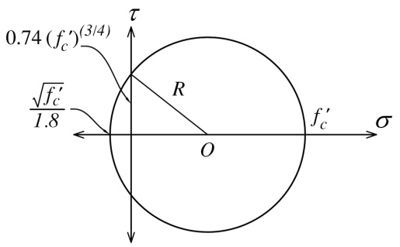
By considering $f_{c}^{'}=21 MPa$ , shear strength based on Mohr’s Circle is:
$$τ_{c}=0.74{(f_{c}^{'})}^{3/4}=7.3 MPa .$$ | (12)
For $τ_{cb}$ or adhesion shear tension between bamboo and concrete, the value can be extracted from Table 1 to Table 4.
It should be noted that the restrictive factor in this regard is the depth of corrugation (h). The worse case is related to using water saturated bamboo split (untreated) in concrete. Maximum tangential strain is equal to $0.048$[5]. Then by using a $4 Cm$ width bamboo split, maximum shrinkage in tangential direction will be equal to:
$$δ_{tangential}={40}^{mm}×0.048={1.92}^{mm} .$$ | (13)
The notch should cover this value then it should be more than$1.92 mm$. On the other hand, by increasing the depth of notch, the remaining depth will be decreased and the result would be the decrement of effective tensile area. By considering the above mentioned factor and depth of notch for each side about 5% of width of bamboo and assuming $4 cm$for width of bamboo strip, 2 mm at each side could be proposed as the optimum depth of notch or $h$.
Eventually for untreated and water saturated bamboo, the proportional relation between$b$, $c$ and $h$ by using equation (5) and $h=2 mm$ will be calculated as below (for example $τ_{cb}=0.52 MPa$ has been considered for untreated bamboo):
$$h:b:c=2:\frac{21}{4.12-0.52}×2:\frac{21}{7.3-0.52}×2=2 :12 :6 .$$ | (14)

In this case, $τ_{ave}$ and $α$ can be calculated by using Eq. (6) to (9) only for one face:
$$τ_{ave}=2.87 → α=450\% .$$ | (15)
A table for other treating method with or without considering skin fiction based on Table 2 has been prepared:

Table 5 The increment percentage of skin friction and related corrugating dimensions
 | Case | $${ τ}_{c }$$  (MPa) | $${ σ}_{cb}$$  (MPa) | $${ τ}_{b}$$  (MPa) | $${ τ}_{cb}$$  (MPa) | $${ τ}_{ave}$$  (MPa) | $$α$$  % | $$h$$  (mm) | $$b$$  (mm) | $$c$$  (mm)
1. | wet bamboo without treatment | 7.3 | 21 | 4.12 | 0.52 | 2.87 | 450 | 2 | 12 | 6
2. | wet bamboo without treatment (skin friction ignored) | 7.3 | 21 | 4.12 | 0 | 2.63 | - | 2 | 10 | 6
3. | bamboo treated with negrolin + sand | 7.3 | 21 | 7.85 | 0.73 | 4.15 | 470 | 2 | 6 | 6
4. | bamboo treated with negrolin + sand (skin friction ignored) | 7.3 | 21 | 7.85 | 0 | 3.78 | - | 2 | 5 | 6
5. | bamboo treated with negrolin + sand+wire | 7.3 | 21 | 7.85 | 0.97 | 4.27 | 340 | 2 | 6 | 7
6. | bamboo treated with negrolin + sand+wire (skin friction ignored) | 7.3 | 21 | 7.85 | 0 | 3.78 | - | 2 | 5 | 6
7. | bamboo treated with Sikadur 32-Gel | 7.3 | 21 | 7.85 | 2.75 | 5.15 | 87 | 2 | 8 | 9

5. Conclusion
Some of the results that can be inferred from this investigation can be summarized and listed as below:
- The first and the most important advantage of corrugation is the increment of bond between bamboo and concrete.
- Uniform distribution of transferring load between bamboo and concrete by bamboo corrugation.
- Using corrugated bamboo strips can be practicable for temporary structures with using it in the mortar or concrete without any special coating and extra costs.
- Corrugation can reduce the wedging effect because of changing the stress transition mechanism between bamboo and concrete.

References
[1] | M.A. Arghand, Concrete reinforcement by Bamboo, M.Sc. thesis, Ferdowsi University of Mashhad, 1994.
[2] | K. Ghavami, Bamboo as reinforcement in structural concrete elements. Cement & Concrete Composites 27, 637–649, 2005.
[3] | H. Sakaray, N.V. Vamsi Krishna Togati, I.V. Ramana Reddy, Investigation on Properties of Bamboo as Reinforcing Material in Concrete. International Journal of Engineering Research and Applications (IJERA), Vol. 2, Issue 1, Jan-Feb 2012, pp.077-083.
[4] | N. Plangsriskul, N. Dorsano, Materials Characterization of Bamboo and Analysis of Bonding Strength and Internal Strength as a Structural Member in Reinforced Concrete, California Polytechnical State University San Luis Obispo, Materials Engineering, Senior Project, 2010-2011.
[5] | A. Azadeh, Experimental and Theoretical Investigation of Bamboo & Concrete Interaction, M.Sc. thesis, Ferdowsi University of Mashhad, 1999.
[6] | S.P. Tastani, S.J. Pantazopoulou, Experimental Evaluation of The Direct Tension -Pullout Bond Test. Bond in concrete from research to standards, Budapest, Hungary, 2002.
[7] | ACI Committee 408R (2003), Bond and Development of Straight Reinforcing Bars in Tension. Journal of the American Concrete Institute.
[8] | K. Maekawa, A. Pimanmas, H. Okamura, Nonlinear Mechanics of Reinforced Concrete. Spon Press, 2003.
[9] | V.S. Godbole, S.C. Lakkad, Effect of Water Absorption on the Mechanical Properties of Bamboo. Journal of Materials Science Letters 5, 303- 304,1986.
[10] | ACI Committee 318 (2005), Building Code Requirements for Structural Concrete and Commentary. ACI 318M-05, R10.2.5.
[11] | ACI Committee 318 (2005), Building Code Requirements for Structural Concrete and Commentary. ACI 318M-05, R11.2.1.1.

