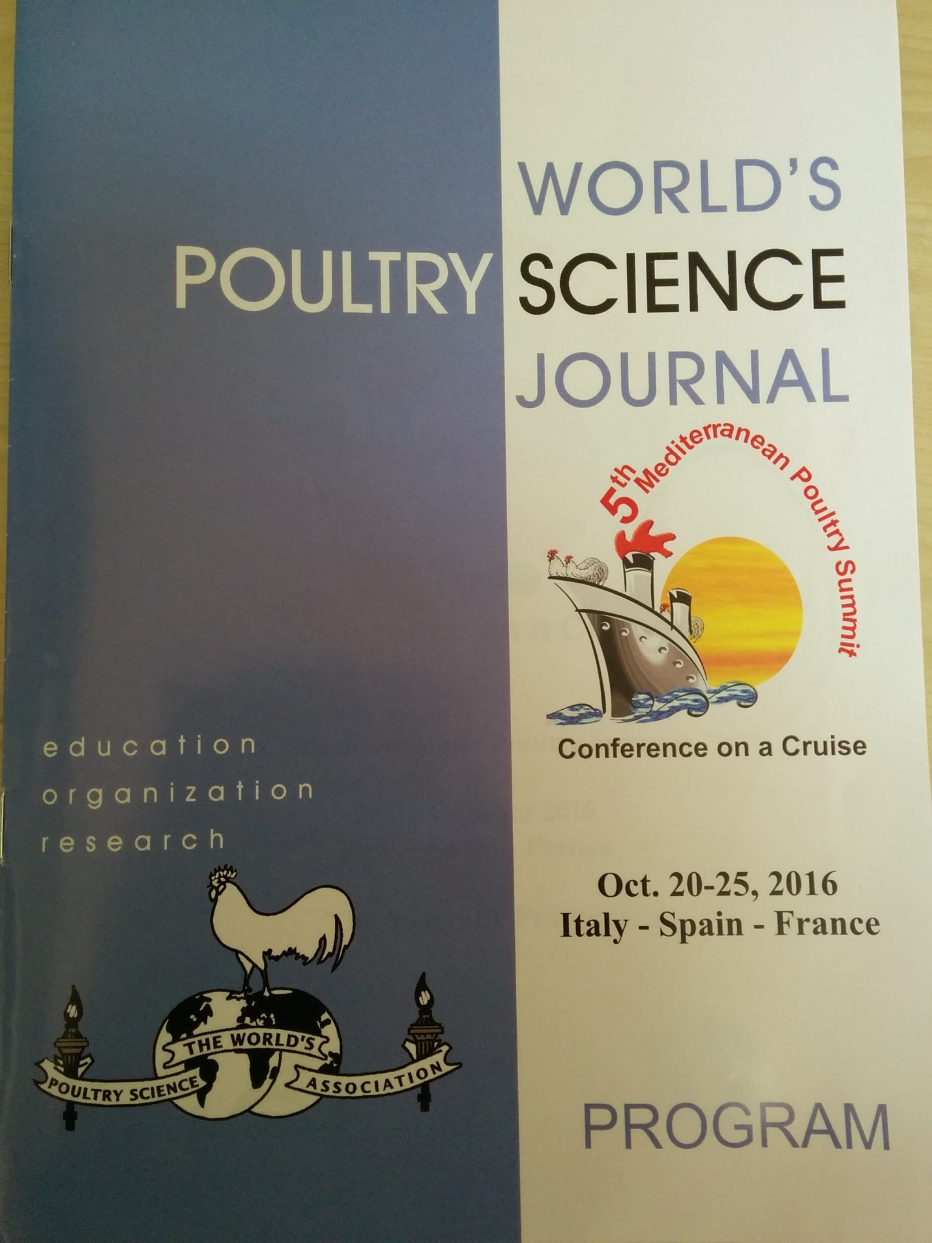

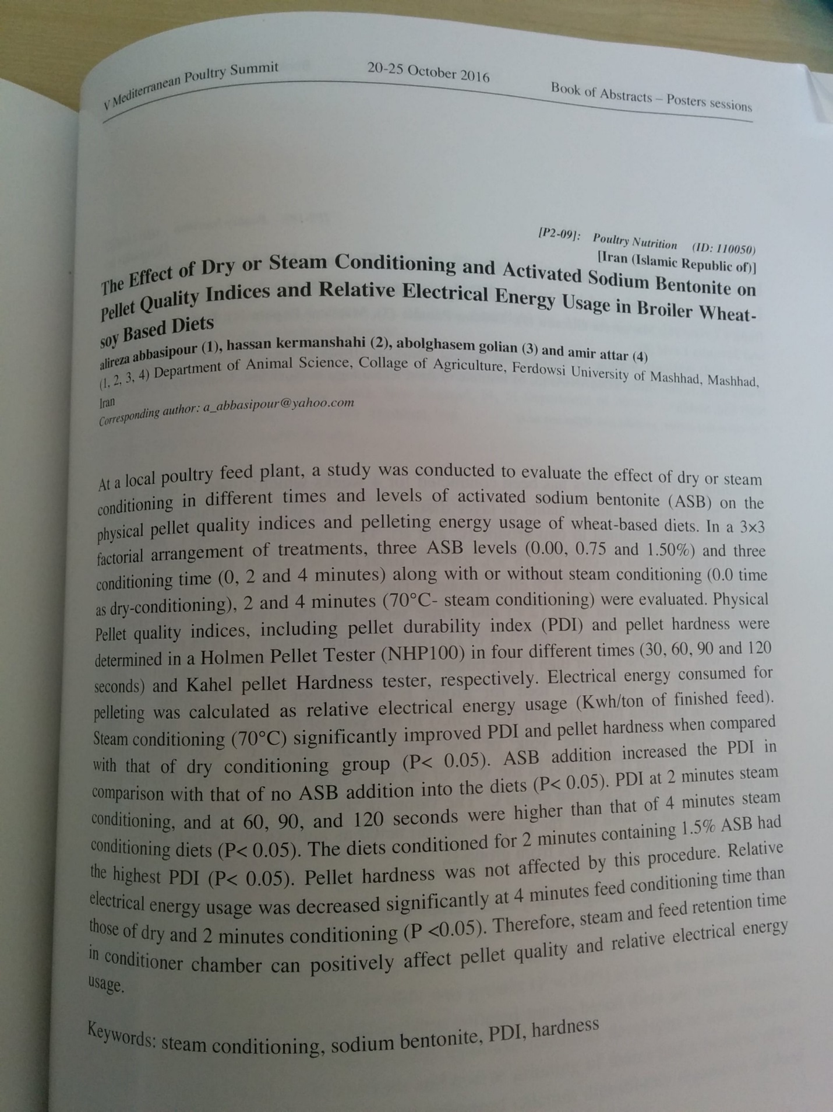

The effect of steam or dry conditioning and sodium bentonite levels on pellet quality, performance and digestive tract development of growing broilers fed corn-soy based diet
A. Attar^{1*}, H. Kermanshahi¹, A. Golian¹, and A. Abbasipour¹
¹Department of Animal Science, Faculty of Agriculture, Ferdowsi University of Mashhad, Mashhad, Iran. P.O. Box 91775-1163
*Amirattar58@yahoo.com
Abstract: The effect of steam conditioning time and different levels of sodium bentonite (SB) on pellet quality, performance and digestive tract development of growing broilers (11-24 d) fed corn-soybean meal based diet was studied. In a completely randomized design with a 3×3 factorial arrangement of treatments, three SB levels (0.00, 0.75 and 1.50%) and three conditioning times (0, 2 and 4 minutes) were evaluated. Steam conditioning in 2 and 4 minutes increased (P< 0.05) weight gain of the chickens when compared with those of birds in dry conditioning group. Birds fed diets conditioned in 2 and 4 minutes had similar (P> 0.05) weight gains. Addition of different levels of SB had no significant effect on weight gain. Steam and dry conditioning with or without SB had no significant effect on feed intake (P> 0.05). Birds fed the conditioned diet in 2 minutes had lower (P <0.05) feed to gain ratio (FCR) than those of birds fed dry conditioned diet but similar (P> 0.05) to those fed the diet conditioned in 4 minutes. The addition of SB improved FCR and the best FCR was obtained by 1.5% SB (P< 0.05).No significant differences in relative weights of duodenum, jejunum and ileum among treatments were observed. The main effect of conditioning (dry/steam) time was significant (P< 0.05) for relative length of jejunum, ileum and small intestine. However, birds fed pelleted steam conditioning in 2 minutes had shorter jejunum, ileum and small intestine than those of birds fed the pellet diets conditioned in 4 minutes and in dry conditioned. Addition of SB (0.75, 1.5%) decreased relative length of ileum (P< 0.05). Pellet durability index (PDI) and hardness of the diets conditioned in 2 minutes with 1.5% SB were higher than those of other dietary treatments (P< 0.05). Under the condition of this study, it was suggested that steam conditioning improves weight gain and FCR. Steam conditioning and SB improve PDI and hardness.

Keywords: conditioning; sodium bentonite; pellet quality; performance; broiler

Introduction
The technology of poultry feed processing involves a wide range of thermal treatments including extrusion, expansion, conditioning and pelleting. Although pelleting represents the greatest energy expenditure in feed manufacturing processes, when the cost-benefit is considered, pelleting is still cost effective and is the most widely used thermal processing method. The main aim of pelleting is to agglomerate smaller feed particles by the use of mechanical pressure, moisture and heat (Peisker, 2006). Conditioning of mash feed prior to pelleting is a major step in the pelleting process. Generally, conditioning is accomplished by adding steam to the mash feed to be pelleted. Steam has the
ability to provide the proper balance of heat and moisture and, due to its relatively inexpensive, easy to control and easy to introduce, it has presented itself as an important component in pelleting (Wellin, 1976).
The increased use of pelleted feeds has prompted feed manufacturers to become vitally interested in efficiency of pelleting and pellet durability to increase the durability of pellets, manufacturers have used various types of pellet binders. The bentonite type of binders would supply little nutritive value. However, bentonite is a tri-layered aluminum silicate having sodium or calcium as its exchangeable cation. Feed inclusion is about 1-2%, and this mineral must be hydrated to be functional (Wellin, 1976). The objectives of the present experiment were to study the effect of steam or dry conditioning and sodium bentonite (SB) levels on pellet quality, performance and digestive tract development of growing broilers fed corn-soybean meal based diet.

Materials and methods
Method of selecting SB: Two samples of aluminosilicates (SB) from two different active mines and one sample of activated aluminosilicate (G-bindTM) from Paya Farayand Company were tested. At first, the aluminosilicates were classified and prepared in 4 different particle sizes of 45, 90, 180 and 360 microns. Then each sample was evaluated for both one and two hours water absorption test and swelling index test. For measuring the water absorption, at first the weight of dry and wet filter paper was measured and then two grams of samples was placed on dry filter paper and put them on water for one hour. After one hour the difference between sample weights before and after being in water showed the amount of one hour water absorption. For two hours water absorption, we increased the time for two hours. For measuring the swelling index, the samples were added gradually into a graduated cylinder with 100 ml distilled water and then after one hour the increasing of bentonite volume showed the two grams swelling index. Then the best sample in water absorption and swelling index was selected.
In this study, 810 day-old male broiler chickens (Ross 308 strain) were allocated to nine dietary treatments with 3*3 factorial arrangements in a completely randomized design to evaluate the effect of three SB levels and three conditioning times on the performance of chickens fed the commercial corn-soybean meal based diets. The experiment had nine treatments, six replicates and 15 birds per replicate. The diets used in the experiment were adjusted based on the nutritional requirements recommended in the manual of Ross 308 for the period of 11-24 d. Treatments were three levels of G-bind (0.00, 0.75, and 1.5%), and each of these levels was processed with three conditioning time (zero (dry conditioning), 2 and 4 minutes (steam conditioning)) in 70 ºC. Body weights and feed intake were recorded weekly. Feed and water were offered ad libitum. On d 24, one bird from each replicate, with body weights closest to the mean weight of the pen, were selected, weighed and euthanized by cervical dislocation. The weight of digesta contents and empty weight and length of digestive tract segments from proventriculus to caeca of each bird were determined according to the procedures described by Amerah and Ravindran (2009). Pellet durability was determined using a Holmen Pellet Tester (New Holmen Pellet Tester, TekPro Ltd., Norfolk, UK). The pellet hardness was determined by hardness tester machine of Amandus Kahl Company in Germany, using the method described by Svihus et al. (2004). At first, a sample of pellet with average length were inserted between a one bar pressure piston and by increasing pressure applied by means of the pressure piston, the force (Kg) needed to break the pellets was determined.
Data were analyzed as a two-way factorial arrangement of treatments using the General Linear Models procedure of SAS (2004). Pen means served as the experimental unit. For digestive tract measurements, individual birds were considered as the experimental unit. Differences were considered to be significant at P < 0.05 and significant differences between means were separated by the least significant difference test.

Results and discussion
The performance parameters of broilers are shown in Table 1. The results showed that conditioning, G-bind and their interactions had no significant effect on feed intake. Abdollahian et al (2014) reported that there were no significant difference on feed intake between mash and pellet diets at 72, 82 and 92 degree centigrade during days from 15 to 28. Pellet feed prepared with die No.4 and then crumbled. So the feed was easily available for broilers and feed type and PDI were not important at this stage to change the feed (P > 0.05). The result of the present study showed that broilers fed steam-pelleted diets had a higher weight gain when compared with those of birds fed non-conditioned pellets (P < 0.05). However, there wasn't any significant effect on broiler weight gain fed by different conditioning time 2 and 4 minutes.
Table 1. effect of conditioning and G-bind levels on body-weight gain, feed intake and feed to gain ratio of broiler chickens (11-24 d)
Feed/gain  FCR | Daily feed intake (g) | Daily gain  (g) | G-bind  % | Steam-conditioning time
1.41 | 93.75 | 64.91 | 0.0 | Zero  (Dry conditioning)
1.46 | 98.34 | 68.92 | 0.75
1.51 | 97.82 | 66.25 | 1.5
1.31 | 98.13 | 71.42 | 0.0 | 2 min
1.36 | 98.38 | 73.61 | 0.75
1.33 | 97.11 | 75.41 | 1.5
1.42 | 100.81 | 76.00 | 0.0 | 4 min
1.42 | 99.77 | 71.20 | 0.75
1.32 | 97.71 | 74.55 | 1.5
0.04 | 2.38 | 2.34 |  | SEM
1.41 ª | 96.51 | 66.71 ^{b} |  | Dry Conditioning
1.31 ^{b} | 97.81 | 73.50 ª |  | 2 minutes steam- Conditioning
1.33 ^{ab} | 98.91 | 73.66 ª |  | 4 minutes steam- Conditioning
0.02 | 1.38 | 1.36 |  | SEM
1.44 ª | 98.13 | 70.11 |  | 0% G-bind
1.40 ^{ab} | 98.91 | 70.14 |  | 0.75% G-bind
1.31 ^{b} | 97.59 | 71.90 |  | 1.5% G-bind
0.02 | 1.38 | 1.36 |  | SEM
 |  |  |  | P-Values
<0001 | 0.124 | <0001 |  | Conditioning
0.012 | 0.756 | 0.802 |  | G-bind
0.058 | 0.203 | 0.630 |  | Conditioning* G-bind
^{a-b} Means in each column with different superscripts are significantly different (P< 0.05).

It seems that the higher weight gain in broilers fed processed diets may be due to both decreasing anti-nutritional factors such as trypsin inhibitors on soybean meal and decreasing feed microbial levels and also breaking disulfide bonds (Abdollahian et al., 2010; Corzo et al., 2012). The recent experiment showed that although the interaction between different conditioning levels and G-bind had no significant effect on FCR, but conditioning by itself had a significant effect on FCR (P < 0.05). The minimum and maximum FCR were at 2 minutes steam-conditioning and dry-conditioning, respectively (P < 0.05). Two and 4 minutes steam-conditioning didn't show any significant difference (P > 0.05). It seems that, improving FCR on conditioning when compared with non- conditioning might be due to starch gelatinization and increasing energy digestibility and breaking disulfide bonds (Abdollahi et al, 2011). Although starch gelatinization in pellet feed is about 10 to 20% (Stevens, 1987), the improving of FCR at 2 and 4 minutes of steam-conditioning in comparison with non- conditioning might be related to gelatinization. It is suggested that the higher FCR on broilers fed diet conditioned for 4 minutes might be due to nutrients destruction, and consequently decreasing nutrients digestibility and availability in this treatment. The recent study also showed that, G-bind had a significant effect on broiler FCR during days 11 to 24 (P< 0.05) and the minimum FCR was at 1.5% G-bind treatment. Damiri et al (2011) reported that different levels of bentonite (0 and 0.75 and 1.5%) had no effect on FCR. Similarly, Salari et al (2006) reported that FCR on broilers fed different levels of bentonite improved during starter period. In addition, the different types and levels of SB showed different results in the present study. It seems that, SB is able to absorb water and reduces the passage rate in the small intestine that leads to higher nutrients digestibility and improving both FCR and performance in broilers fed by SB.
The effect of conditioning and G-bind levels on relative weight (g/kg body weight) and relative length (cm/kg body weight) of different parts of the small intestine of broiler chickens are shown in Table 2. The relative weight of duodenum, jejunum and ileum were not affected by the interaction between different levels of conditioning and G-bind. No significant main effects of different levels of G-bind and conditioning on relative weight of the duodenum, jejunum and ileum was also seen in this study. Mingbin et al (2015) stated that steam-conditioning diet has no effect on the relative weight of the duodenum, jejunum and ileum in broilers.
No interaction effect was found for the relative length of the duodenum, jejunum, ileum and small intestine among different levels of conditioning and G-bind. The main effect of different levels of conditioning on relative length of jejunum and ileum and small intestine was significant (P < 0.05). It can be hypothesized that the minimum length of jejunum and ileum might be related to 2 minutes steam-conditioning. The effects of G-bind was not significant on relative length of the jejunum.
The results showed significant differences between the main effects of G-bind levels on relative length of the ileum (P < 0.05). So that, 0.75 and 1.5% G-bind levels were not significantly different, but a significant difference with no G-bind was achieved and the lowest relative length of the ileum was related to 1.5% G-bind. The results showed that the main effects of different levels of conditioning on relative length of the small intestine were significant (P < 0.05). The results showed no significant effect of G-bind levels on relative length of the small intestine. Nir et al (1994) indicated that in processed diets in comparison with mash diets the relative length of the duodenum, jejunum and ileum were shorter. Amerah et al (2007) reported that in pellet diets, bird performance was improved and the relative length of different parts of the small intestine was reduced. The reason can be expressed as the possibility of more heat process at four minutes conditioning that is 2 folds of two minutes processing, and consequently some nutrients might be destroyed and therefore lower digestibility and longer gut length is expected.

Table 2. The effect of conditioning and G-bind levels on relative weight and relative length of different parts of small intestine of broiler chickens (d 24)
Relative length (cm/kg body weight) |  |  |  |  | Relative weight (g/kg body weight)
Small intestine | Ileum | Jejunum | Duodenum |  | Ileum | Jejunum | Duodenum | G-bind  % | Steam-conditioning time
155.38 | 69.29 | 61.25 | 22.82 |  | 8.12 | 10.40 | 5.86 | 0.0 | Zero  (dry conditioning)
150.66 | 64.09 | 61.54 | 25.01 |  | 7.87 | 10.59 | 5.94 | 0.75
147.23 | 62.65 | 62.17 | 25.11 |  | 7.84 | 11.72 | 6.57 | 1.5
136.32 | 60.59 | 54.47 | 23.11 |  | 7.65 | 10.34 | 7.09 | 0.0 | 2 min
144.02 | 60.23 | 58.55 | 22.93 |  | 8.71 | 11.71 | 6.20 | 0.75
132.33 | 54.73 | 53.86 | 22.91 |  | 7.11 | 10.17 | 6.82 | 1.5
146.91 | 64.27 | 60.26 | 24.92 |  | 8.02 | 10.27 | 7.22 | 0.0 | 4 min
144.43 | 57.65 | 57.10 | 24.27 |  | 7.22 | 10.20 | 6.52 | 0.75
150.91 | 58.83 | 63.15 | 25.32 |  | 7.16 | 10.03 | 6.11 | 1.5
5.08 | 2.46 | 2.17 | 0.88 |  | 0.64 | 0.92 | 0.49 |  | SEM
150.69 ª | 65.11 ª | 61.67 ª | 24.41 |  | 7.94 | 10.90 | 6.12 |  | Dry Conditioning
137.48 ^{b} | 58.39 ^{b} | 55.45 ^{b} | 23.99 |  | 7.82 | 10.74 | 6.70 |  | 2 min steam- Conditioning
146.88 ª | 59.94 ^{b} | 59.42 ª | 24.78 |  | 7. 47 | 10.18 | 6.64 |  | 4 min steam- Conditioning
2.95 | 1.42 | 1.41 | 0.51 |  | 0.37 | 0.53 | 0.28 |  | SEM
144.37 | 64.71 ª | 58.51 | 23.72 |  | 7.93 | 10.34 | 6.73 |  | 0.0% G-bind
146.64 | 60.50 ^{b} | 58.98 | 24.13 |  | 7.90 | 10.80 | 6.23 |  | 0.75% G-bind
141.94 | 58.73 ^{b} | 59.04 | 24.25 |  | 7.38 | 10.68 | 6.52 |  | 1.5% G-bind
2.952 | 1.424 | 1.409 | 0.507 |  | 0.370 | 0.532 | 0.280 |  | SEM
 |  |  |  |  |  |  |  |  | P-Value
0.006 | 0.004 | 0.009 | 0.334 |  | 0.645 | 0.610 | 0.169 |  | Conditioning
0.759 | 0.020 | 0.873 | 0.677 |  | 0.483 | 0.803 | 0.678 |  | G-bind
0.438 | 0.631 | 0.319 | 0.449 |  | 0.564 | 0.649 | 0.426 |  | Conditioning* G-bind
^{a-b} Means in each column with different superscripts are significantly different (P< 0.05).

The effect of conditioning and G-bind levels on Pellet durability and hardness are shown in Table 3. Results showed that, the main effect of different levels of conditioning and G-bind and the interaction between them in terms of PDI, there were significant differences at 30, 60, 90 and 120 seconds. In this experiment, the interaction and main effects of different levels of conditioning and G-bind on pellet hardness were significant (P < 0.05). The highest pellet hardness were observed in 2 minutes steam-conditioning and 1.5% G-bind. Skoch et al (1981) showed that the use of steam conditioning (65 and 78 ºC) when compared with dry conditioning improved PDI. Abdollahi et al (2013) demonstrated that addition of water and pellet binder improve PDI and pellet hardness.
Conclusion
In conclusion, it is evident that broilers fed steam-pelleted diets had a higher weight gain and better FCR when compared with those birds fed dry-conditioned pellets. The relative weight of different parts of the small intestine and relative length of duodenum were not affected by conditioning and G-bind levels, but relative length of jejunum, ileum and small intestine were affected by these treatments. The main effects of conditioning and G-bind levels and interaction between them were significant on hardness and pellet durability and the highest pellet hardness and PDI were observed in 2 minutes steam-conditioning with 1.5% G-bind.
Table 3. The effect of conditioning and G-bind levels on Pellet durability and hardness of corn-soy based diets

hardness | 120  Seconds | 90  Seconds | 60  Seconds | 30  Seconds | G-bind  % | Steam-conditioning time
1.50 ^{c} | 6.20 ^{e} | 9.33 ^{e} | 14.26 e | 29.60 e | 0.0 | Zero  (dry conditioning)
2.00 ^{c} | 6.96 ^{e} | 9.10 e | 12.63 ^{e} | 33.20 ^{e} | 0.75
1.90 ^{c} | 6.36 e | 8.00 ^{e} | 11.86 e | 31.16 e | 1.5
3.30 ^{b} | 42.03 ^{b} | 51.76 ^{b} | 66.80 ^{b} | 81.16 ^{b} | 0.0 | 2 min
2.30 ^{bc} | 23.76 ^{c} | 35.80 ^{c} | 51.66 ^{c} | 76.43 ^{b} | 0.75
6.80 ª | 69.36 ª | 76.10 ª | 83.36 ª | 91.26 ª | 1.5
2.90 ^{bc} | 18.90 ^{d} | 24.36 ^{d} | 36.93 ^{d} | 62.63 ^{d} | 0.0 | 4 min
1.70 ^{c} | 17.33 ^{d} | 26.06 ^{d} | 40.60 ^{d} | 68.76 ^{c} | 0.75
2.30 ^{bc} | 15.56 ^{d} | 24.23 ^{d} | 39.46 ^{d} | 66.30 ^{cd} | 1.5
0.376 | 1.335 | 0.902 | 1.623 | 1.689 |  | SEM
1.80 ^{b} | 6.51 ^{c} | 8.81 ^{c} | 12.92 ^{c} | 31.32 ^{c} |  | Dry Conditioning
4.13 ª | 45.05 ª | 54.44 ª | 67.27 ª | 82.95 ª |  | 2 minutes steam- Conditioning
2.18 ^{b} | 17.26 ^{b} | 24.88 ^{b} | 39.00 ^{b} | 65.90 ^{b} |  | 4 minutes steam- Conditioning
0.217 | 0.771 | 0.520 | 0.937 | 0.975 |  | SEM
2.45 ^{b} | 22.37 ^{b} | 28.48 ^{b} | 39.33 ^{b} | 57.80 ^{b} |  | 0.0% G-bind
2.00 ^{b} | 16.02 ^{c} | 23.65 ^{c} | 34.96 ^{c} | 59.46 ^{b} |  | 0.75% G-bind
3.66 ª | 30.43 ª | 36.11 ª | 44.90 ª | 62.91 ª |  | 1.5% G-bind
0.217 | 0.771 | 0.520 | 0.937 | 0.975 |  | SEM
 |  |  |  |  |  | P-Values
0.0001> | 0.0001> | 0.0001> | 0.0001> | 0.0001> |  | Conditioning
0.0001> | 0.0001> | 0.0001> | 0.0001> | 0.0052 |  | G-bind
0.0001> | 0.0001> | 0.0001> | 0.0001> | 0.0004> |  | Conditioning* G-bind
^{a-d} Means in each column with different superscripts are significantly different (P < 0.05).

References
ABDOLLAHI, M.R ., RAVINDRAN, V., WESTER, T.J., RAVINDRAN, G. and. THOMAS, D.V. (2010) Influence of conditioning temperature on the performance, nutrient utilisation and digestive tract development of broilers fed on maize- and wheat based diets. British Poultry Science 51 (5): 648—657.
ABDOLLAHI, M.R ., RAVINDRAN, V., WESTER, T.J., RAVINDRAN, G. and. THOMAS, D.V. (2011) Influence of feed form and conditioning temperature on performance, apparent metabolisable energy and ileal digestibility of starch and nitrogen in broiler starters fed wheat-based diet. Animal Feed Science and Technology 168: 88-90.
ABDOLLAHI, M.R ., RAVINDRAN, V. and SVIHAS, B. (2013) Influence of grain type and feed form on performance, apparent metabolisable energy and ileal digestibility of nitrogen, starch, fat, calcium and phosphorus in broiler starters. Animal Feed Science and Technology 186: 193– 203.
ABDOLLAHIAN, A.H., NOURI EMAMZADEH, A. and KERAMATI, K. (2014) comparative effect of mash and pellet feed with different pelleting temperature on blood metabolites, carcass characteristics and broiler performance. Advanced Biological and Biomedical Research 2 (1): 141-145.
AMERAH, A.M., RAVINDRAN, V., LENTLE, R.G. and THOMAS, D.G. (2007) Influence of feed particle size and feed form on the performance, energy utilisation, digestive tract development, and digesta parameters of broiler starters. Poultry Science 86: 2615–2623.
AMERAH, A. M. and RAVINDRAN, V. (2009) Influence of maize particle size and microbial phytase supplementation on the performance, nutrient utilisation and digestive tract parameters of broiler starters. Animal Production Science 49: 704–710.
CORZO, A., MEJIA, L., MCDANIEL, C.D. and MORITZ, J.S. (2012) Interactive effects of feed form and dietary lysine on growth responses of commercial broiler chicks. Applied Poultry Science 21: 70-78.
DAMIRI, H., CHAJI, M., BOJARPOUR, M. and MAMUEI. M. (2012) Effect of different sodium bentonite levels on performance, carcass traits and passage rate of broilers. Pak Vet J, 32 (2): 197-200.
MINGBIN, L.V., LEI YAN, N., ZHENGGUO, W., SHA, A.N., MIAOMIAO, W.U. and ZUNZHOU, L.V. (2015) Effects of feed form and feed particle size on growth performance,
carcass characteristics and digestive tract development of broilers. Animal Nutrition 1: 252–255.
NIR, I., TWINA, Y., GROSSMAN, E. and NISTAN, Z. (1994) Quantitative effects of pelleting on performance, gastrointestinal tract and behavior of meat-type chickens. British Poultry Science 35: 589–602.
PEISKER, M. (2006) Feed processing — impacts on nutritive value and hygienic status in broiler feeds. Proceedings of the Australian Poultry Science Symposium 18: 7–16.
SALARI, S., KERMANSHAHI, H. and NASIRI MOGHADAM, H. (2006) Effect of sodium bentonite and comparison of pellet vs mash on performance of broiler chickens. International Journal of Poultry Science 5 (1): 31-34.
SAS INSTITUTE. (2004) SAS Qualification Tools User’s Guide. Version 912. SAS Institute Inc., Cary, NC.
SKOCH, E.R., BEHNKE, K.C., DEYOE, C.W. and BINDER, S.F. (1981) The effect of steam-conditioning rate on the pelleting process. Animal Feed Science and Technology 6: 83—90.
STEVENS, C.A. (1987) Starch gelatinization and the influence of particle size, steam pressure and die speed on the pelleting process. Ph.D. Thesis, Kansas State University, Manhattan, Kansas.
SVIHUS, B., KLØVSTAD, K.H., PEREZ, V., ZIMONJA, O., SAHLSTROM, S., SCHULLER, R.B., JEKSRUD, W.K. and PRESTLØKKEN, E. (2004) Physical and nutritional effects of pelleting of broiler chicken diets made from wheat ground to different coarsenesses by the use of roller mill and hammer mill. Animal Feed Science and Technology 117: 281–293.
WELLIN, F. (1976) Pelleting equipment operations, in: PFOST, H.B. & PICKERING, D. (Eds) Feed Manufacturing Technology, pp. 329—332 (Arlington, American Feed Manufacturers Association).

