

The Maximum Iikelihood estimator of P from the Pareto distribution contaminated by k outliers is obtained as

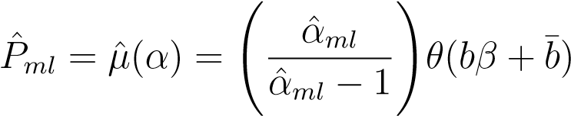

The Bayesian estimator of P under symmetric (squared error) and asymmetric (Linex and entropy) loss functions is derived, which are defined, respectively, as

$L_{s}\left(\hat{u}\left(α\right),u\left(α\right)\right)={(\hat{u}\left(α\right)-u\left(α\right))}^{2}$ $L_{L}\left(\hat{u}\left(α\right),u\left(α\right)\right)=e^{m(\hat{u}\left(α\right)-u\left(α\right))}-m\left(\hat{u}\left(α\right)-u\left(α\right)\right)-1, m≠0$

$$L_{E}\left(\hat{u}\left(α\right),u\left(α\right)\right)={\left(\frac{\hat{u}(α)}{u(α)}\right)}^{q}-qlog\left(\frac{\hat{u}\left(α\right)}{u\left(α\right)}\right)-1, q≠0$$

Where $\hat{u}\left(α\right)$ is an estimator of $u(α)$.If we assume that $u\left(α\right)=μ\left(α\right),$ Then the Bayesian estimator under the loss function $L_{s}$ is the posterior mean of $μ\left(α\right)$, which is denoted by ${\hat{P}}_{BS}$. The corresponding Bayesian estimators under the loss function $L_{L}$ and $L_{E}$ are given by,

$${\hat{P}}_{BL}=-\frac{1}{m}log⁡(E_{α}\left(e^{-mμ\left(α\right)} | x_{1}, x_{2},…,x_{n}\right) {\hat{P}}_{BE}=⁡{\left(E_{α}\left(μ^{-q}(α) | x_{1}, x_{2},…,x_{n}\right)\right)}^{-\frac{1}{q}}$$

Note that the estimators described above are of the form of ratio of two integrals, which cannot be calculated into a closed form. So, we use from Importance sampling method for approximating the Bayesian Premium estimator.

**­­**Let a set of random variables (*X*1*,X*2*,...,Xn*) represent the claim amounts of a motor insurance company. It is assumed that some of these claims are *β* times higher than the claims of normal vehicles. Therefore the random variables (*X*1*,X*2*,...,Xn*) are assumed such that any *k* (number of outliers) of them are distributed with pdf

*,*

and n − k out of n random variables are distributed with pdf

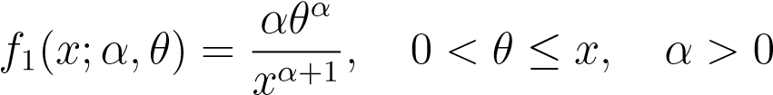*,*

where the shape parameter α is unknown. The marginal distribution of Xi, i = 1,2,...,n, is



where, and. Also, the net Premium (P) is given

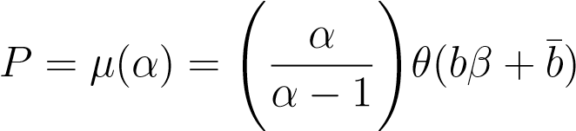*.*

In this study, an attempt has been made to examine the Bayesian estimators for the Pareto distribution in the presence of outliers with insurance applications. The Bayesian estimators of Premium (*P*) were obtained under squared error, Linex and entropy loss functions by using gamma and Jeffreys prior through the importance sampling procedure. By using the simulation study the average values and MSEs of the estimates ${\hat{P}}_{BS} , {\hat{P}}_{BL}$ and ${\hat{P}}_{BE}$ of *P* were presented for different choices of *k*. We concluded that MSEs of Bayesian Premium estimator under entropy loss are smaller than the MSEs of other estimators under Linex and squared error loss functions. It may be noted that when *k* increases, *P* also increases and with the increase in sample size, the Bayesian Premium estimator tends to *P*. Also, based on the results it has been seen that under different loss functions, using the gamma prior distribution is more appropriate than the Jeffreys prior distribution for all sample sizes. It may be mentioned that the proposed method can be extended for other positive value distributions.

**­**

The study of Premium principles is one of the essential topics in actuarial science, and there are several approaches to determine a Premium (see Young, 2004, for a complete review). In this paper, we use the concept of net Premium that is determined by using the expectation of X, where X represents the claim size or loss amount of one contract in an insurance company. The credibility theory is a statistical tool for calculating future period Premiums based on past experiences of insured. This theory was introduced by Mowbray in 1914, and Bailey (1950) showed the relation between credibility theory and Bayesian method. . An outlier usually refers to some of the observations in a distribution that deviate very much from the other observations. In many studies, the presence of outliers might have a significant effect on the analysis and conclusion. In this regard, many statistical models in the presence of outliers are proposed, for example, Kale and Sinha (1971), Joshi (1972), and Dixit (1987) introduced a model contaminated by outliers. So by using the concept of net Premium, the Bayesian Premium estimator proposed by Bailey is obtained, where the Pareto distribution in the presence of k outliers is used as the claim size distribution

**­**

We consider the estimation of the Bayesian Premium under squared error loss function (symmetric), linear exponential and entropy loss function (asymmetric), using informative and non-informative priors. We use the Markov Chain Monte Carlo methods such as the importance sampling procedure. The results are analyzed by using simulation studies.

**کلمات‌کلیدی:**

Estimation of Premium in the presence of outliers

**نام نویسنده: (R.Mollaie) نام نویسنده: M.Jabbari Nooghabi**