***In silico* identification of a putative lncRNA-miRNA regulatory network associated with mucin regulation in colon cancer**

**Sayyed Emad Aldin Tayyebi**1[1], **Mahyar Heydarpour**2 [2], **Hesam Dehghani**1,3,4 [3][4]

1 Department of Basic Sciences, Faculty of Veterinary Medicine, Ferdowsi University of Mashhad, Mashhad, Iran.

2 Department of Medicine, Division of Endocrinology, Brigham & Women's Hospital, Harvard Medical School, Boston 02115, MA, USA.

3 Division of Biotechnology, Faculty of Veterinary Medicine, Ferdowsi University of Mashhad, Mashhad, Iran.

4 Stem Cell Biology and Regenerative Medicine Research Group, Research Institute of Biotechnology, Ferdowsi University of Mashhad, Mashhad, Iran.

**Running title:** Anon-coding regulatory network associated with mucin regulation in colon cancer

**Keywords:** colon cancer, lncRNAs, miRNAs, mucins, *MUC13*, regulatory networks.

## Abstract

Colorectal cancer is one of the most common cancers and is one of the leading causes of cancer-related deaths worldwide. The underlying biological mechanisms for the development of colorectal cancer are largely unidentified. Several genes have been identified that are most likely involved in the pathogenesis of colorectal cancer disease. However, some other genes might have less evident functions. One gene family with prominent functional roles in the normal colon is mucin. Multiple studies have demonstrated the involvement of mucins in the pathogenesis of human malignancies. Therefore, due to the lack of an inclusive investigation for mucins' expression, mechanism of action, and their involvement in the underlying biology, diagnosis, and prognosis of colon adenocarcinoma, we sought to unearth their potential involvement and their related regulatory networks in this disease. In this investigation, through a stepwise manner, a plethora of databases and algorithmic tools were applied. Due to a significant upregulation at both mRNA and protein levels and following a thorough evaluation of diagnostic and prognostic values in colon adenocarcinoma, MUC13 was determined to be the most relevant regulatory mucin in colon carcinoma. Altogether, these findings indicate a putative ncRNA-mRNA network, including hsa-mir-136-5p, hsa-mir-27a-3p, NEAT1, and XIST to be involved in regulating MUC13 in colon cancer. This stepwise investigation implies that MUC13 may have a crucial role in the underlying molecular mechanisms for the initiation or progression of colon cancer. In addition, it provides insights into molecular mechanisms and possible regulatory non-coding RNA networks that might be responsible for regulating MUC13 expression.

**Introduction**

Globally, over 1.9 million new cases of colorectal cancer were diagnosed in 2020, resulting in approximately 935,000 deaths. This cancer accounts for 10% of cancer cases and cancer-related mortalities. Colorectal cancer is the second most common cause of cancer-related mortality and is the third most common cancer type worldwide (Sung et al., 2021). Considering the high incidence and deaths caused by this cancer, many of its risk factors especially genetic predisposition characteristics, have not been identified. Thus, molecular mechanisms underlying this malignancy need further investigation (Dekker et al., 2019).

Numerous studies have revealed the involvement of abnormal genes and proteins that play important roles in the initiation and progression of colorectal cancer. Mucins are a family of high molecular weight and heavily glycosylated proteins that are extensively expressed in mucosal tissues. Despite common structural characteristics, such as densely O-glycosylated filamentous domains, several types of mucins exist with distinct activities. Mucins have significant functions in multiple biological processes, including homeostasis, signaling, and cell protection (Corfield, 2015). The aberrant expression and the abnormal structure and function of some mucins contribute to the underlying properties related to tumorigenesis and tumor progression. However, their roles in the development of colon cancer are poorly characterized (Wi et al., 2021). Interestingly, there is a subtype of colorectal cancer that is characterized by the abundant expression of extracellular mucin known as mucinous colorectal cancer (Luo et al. 2019a).

Non-coding genes comprise the majority of the human genome. Numerous reports indicate that non-coding RNAs (ncRNAs) play pivotal roles in the biology of normal and cancerous cells (Yan & Bu, 2021). There are several types of ncRNAs, of which long non-coding RNAs (lncRNAs) and microRNAs (miRNAs) have received much attention. By definition, lncRNAs are non-coding RNAs with over 200 nucleotides that lack protein-coding ability (Yarmishyn & Kurochkin, 2015). Under physiological circumstances, lncRNAs play a major role in diverse biological processes such as transcription, splicing, epigenetic regulation of gene expression, and modification of chromatin structure. Dysregulation of lncRNA expression has been reported to contribute to the initiation, progression, and metastasis of various types of cancer, including colon, hepatocellular, and breast cancers (Marchese et al., 2017). On the other hand, microRNAs are short non-coding RNAs consisting of ~22 nucleotides that serve crucial roles in various biological pathways. In normal physiological circumstances, miRNAs operate through feedback mechanisms to protect critical biological processes, such as cell apoptosis, differentiation, and proliferation. Research findings demonstrate that miRNA expression is abnormal in human malignancies (Reddy, 2015) and the interplay between lncRNAs and miRNAs plays a crucial role in controlling the expression and functionality of proteins in cancer. The competing endogenous RNA (ceRNA) theory presented by Salmena and his colleagues states that some lncRNAs with a spongy-like action counteract the inhibitory effects of miRNAs on gene expression (Salmena et al., 2011). Based on this theory, some lncRNAs by sequestering specific microRNAs and RNA-binding proteins lead to altered levels of target mRNAs. There is substantial research showing that the ceRNA networks are involved in a broad range of human malignancies, such as colon (Sun et al., 2020), liver (Wang et al., 2017), gastric (X. Z. Yang et al., 2018), and lung (Wang et al., 2020) cancers.

Previous studies have demonstrated that some lncRNAs, such as *XIST* and *NEAT1*, are aberrantly expressed in colorectal cancer. This aberrant expression is associated with tumorigenesis, tumor progression, metastasis, and unfavorable prognosis. Due to their involvement in the progression of colon cancer, lncRNAs may have the potential to act as valuable biomarkers for detecting or predicting the disease (Liu et al., 2020; Sun et al., 2018). Nevertheless, the present knowledge on the most influential lncRNA-miRNA-mRNA networks that are highly associated with colon cancer prognosis is ambiguous.

In this study, we examined the differential expression of mucins in colon cancer tissue compared to healthy tissues. We selected candidate mucins with the highest possibility of having functional roles in colon cancer and subsequently predicted miRNAs and lncRNAs that are associated with these mucins. Based on these findings and the expression of related lncRNAs and miRNAs, we identified lncRNAs and miRNAs that could be used to construct regulatory networks related to these candidate mucins. In addition, we assessed their potential for prognostic and diagnostic purposes. Ultimately, we constructed novel regulatory networks that seem to be significantly associated with colon cancer. This study sheds light on the potential roles of non-coding RNAs in the regulation of mucins in colon cancer. These RNAs might have the value of being potential therapeutic targets or diagnostic biomarkers. Further analysis and validation of these findings in a laboratory setting may contribute to a better understanding of the development and progression of colon cancer.

## Materials and Methods

The high-throughput mass spectrometry data for colon cancer was acquired from the Clinical Proteomic Tumor Analysis Consortium (CPTAC) incorporated in the UALCAN web portal (http://ualcan.path.uab.edu/index.html). UALCAN is a web portal to perform in-depth analysis of gene expression data in cancer. This data consisted of 97 samples of colon cancer including different stages of cancer ranging from stages I through IV and 100 normal control samples. The downloaded protein expression values for each sample were log2 normalized, and Z-values were calculated (Chandrashekar et al. 2017). Then, using the GEPIA2 web server, we retrieved the values for the quantity of mucin gene family transcripts in colon adenocarcinoma. The GEPIA2 (Gene Expression Proﬁling Interactive Analysis 2) web server is a database that represents the gene expression analysis using the tumor and normal data from the TCGA and the GTEx projects, respectively (Tang et al. 2019). The analysis of gene expression in colon adenocarcinoma embedded in this database was conducted using 275 tumor samples (stages I to IV) and 349 normal controls. We identified differentially expressed genes in colon adenocarcinoma, taking log2FC> 1 as the threshold criterion for the analysis. In addition, we considered false discovery rate adjusted *p*-value < 0.05 as the statistically significant cutoff. We used the limma package which utilizes the linear model and Bayesian empirical method for analysis as the differential analysis method (Ritchie et al., 2015).

Afterward, the diagnostic value of *MUC13* was evaluated using the ROC curve with the TCGA colon cancer and normal colon expression data, and statistical significance was defined as adj. *p* value < 0.05. Then, six target gene prediction tools including PicTar, miRDB, MicroCosm, miRanda, PITA, and TargetScan, which are algorithms for the identification of microRNA targets, were utilized to predict miRNAs that potentially interact with *MUC13*. Four principal elements of the miRNA-mRNA target interaction are common characteristics on which target prediction tools are based: site accessibility, free energy, seed match, and conservation. All the predicted miRNAs were used in the subsequent filtering steps. We identified differentially expressed miRNAs (DEMs) in colon adenocarcinoma using dbDEMC (Xu et al. 2022). The experiment used for this purpose included 444 cases and 8 controls, respectively. The dbDEMC is designed to provide a systematic resource for storing and querying DEMs in human cancers. The expression values were subjected to logarithmic transformation and quantile normalization. Then, the limma package was used to select miRNAs with a significant difference between their mean expression level in case and control samples, with a false discovery rate (FDR) of less than 0.05. We extracted miRNA-seq expression data from case-control design experiments.

Thereafter, for the prediction of lncRNA–*MUC13* interactions, we used the RIblast system, which is a high-speed method based on the seed-and-extension algorithm (Fukunaga and Hamada 2017). RIblast identifies seed regions by employing suffix arrays and then applies an RNA secondary structure energy model to extend the seed regions. The prediction of local base pair interactions is based on interaction energies calculated from both accessibility and hybridization energies. We used a score of -16 kcal/mol as the interaction energy threshold.

Then, we utilized starBase v2.0, a platform for studying RNA interactions, for decoding miRNA-lncRNA interaction networks from CLIP-Seq data (Li et al. 2014). In the final step, to produce a more reliable prediction of interactions for constructing regulatory networks, we conducted a manual search of the PubMed database to extract data from validation experiments. PubMed is a public database that offers access to numerous abstracts and references related to biomedicine and the life sciences. In this regard, we queried this database for related lncRNA-miRNA interactions.

## Results

The present research involves multiple sequential stages, including aggregation and exploration of RNA, miRNA, and protein expression data, curve analyses for survival and receiver operating characteristics, and multiple in silico analyses. The main objective of this study was to detect potential non-coding networks that are associated with members of the mucin gene family in colon cancer. A schematic diagram of the study for *MUC13* is represented in Figure 1.



**Figure 1.** **The workflow of the study for predicting and identifying novel non-coding networks related to *MUC13* regulation in colon cancer.** In this regard, databases including Gepia2, CPTAC, HPA, dbDEMC, starBase, and PubMed were used, and algorithmic tools, including TargetScan, miRanda, PITA, microT-CDS, miRDB, PicTar, MicroCosm, and RIblast were applied.

### Differential Expression Analysis of Mucins in Colon Cancer

In the first step, the protein expression of mucins in colon cancer was assessed using CPTAC data. The expression of *MUC13* protein in colon cancer samples was remarkably upregulated, whereas *MUC2*, *MUC5B*, and MUC4 expressions were downregulated in comparison to normal samples (Fig 2A). The expression level of *MUC13* protein progressively increased from early to advanced stages of cancer (Fig. 2B). Immunohistochemical staining of *MUC13* protein confirmed higher expression in colon cancer tumors than in normal colon tissues (Fig. 2C). On the other hand, the protein expression of *MUC12*, *MUC6*, *MUC5AC*, and *MUC1* in colon cancer samples in comparison to that in normal samples were not significantly changed (data not shown). Unfortunately, no protein expression information was available for the rest of the mucin family members in colon cancer.

Then, Gepia2 was explored to identify the mRNA levels of mucin family members in colon adenocarcinoma. Differential expression analysis results were retrieved from matched datasets for TCGA normal and GTEx. The limma package was used for the analysis of these results, and tumor or normal conditions were variables for calculating differential expression values.

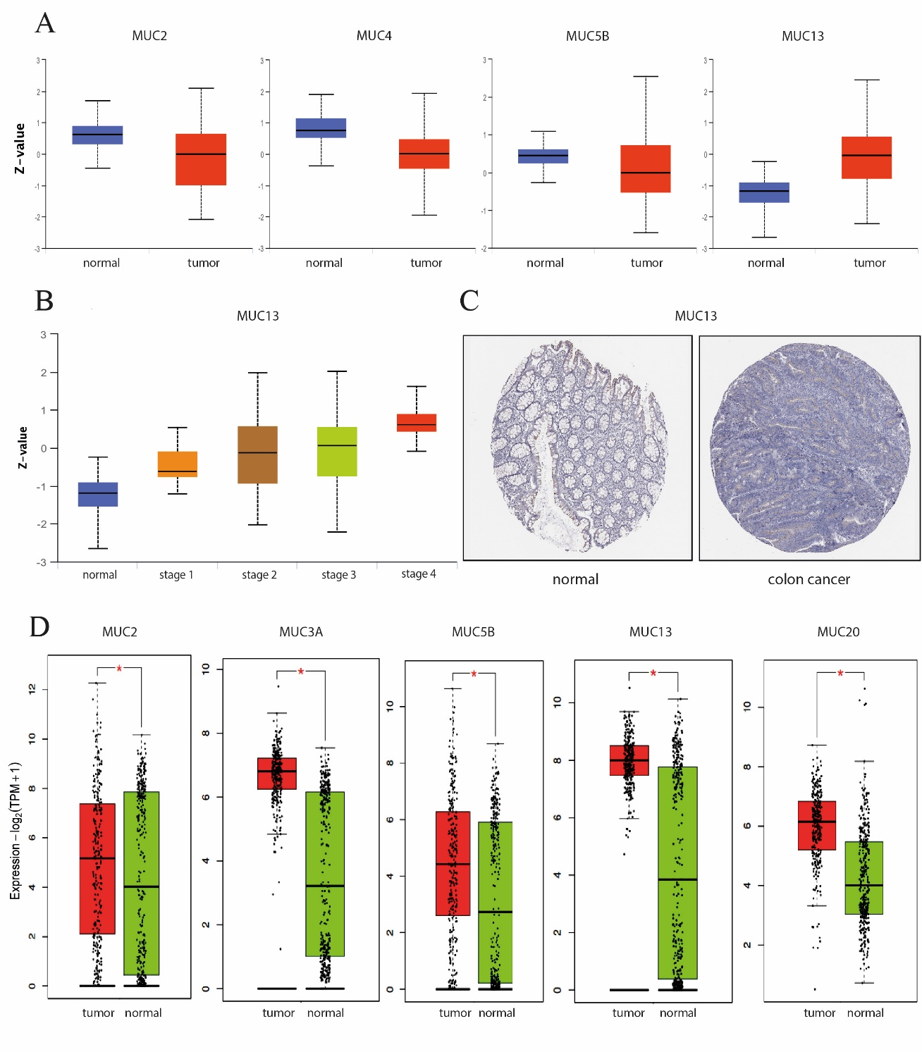

**Figure 2.** **Screening the expression status of mucins in colon cancer. A**. The Differential expression of mucin proteins in colon cancer, retrieved from CPTAC data. **B**. Proteomic expression profile of *MUC13* based on the individual cancer stages. **C**. The expression of *MUC13* in colon cancer and normal tissue samples, extracted from HPA; antibody: HPA079663. **D**. Differentially expressed mucin gene family members in colon cancer, extracted from Gepia2. Only statistically significant results are shown.\**p* < 0.05

This expression data was first log2 (Transcripts Per Million (TPM)+1) transformed for differential analysis, and the log 2FC was defined as the median. Genes with higher log 2FC values and lower q values than pre-set thresholds were considered differentially expressed genes. *MUC13*, *MUC2*, *MUC3A*, *MUC5B*, and *MUC2*0 genes were found to have significantly higher expressions in colon adenocarcinoma compared to normal pairs (Fig. 2D). These mucin family members identified as differentially expressed are shown in Table 1.

**Table 1.** Mucin family members with significantly high expression in colon adenocarcinoma

|  |  |  |  |  |
| --- | --- | --- | --- | --- |
| **Gene symbol** | **Median (Tumor)** | **Median (Normal)** | **logFC** | **adj. *p*-value** |
| *MUC5B* | 20.540 | 5.640 | 1.698 | 9.61e-8 |
| *MUC3A* | 110.990 | 8.300 | 3.590 | 1.14e-64 |
| *MUC13* | 255.043 | 13.420 | 4.150 | 4.83e-53 |
| *MUC20* | 69.589 | 15.070 | 2.135 | 6.01e-39 |
| *MUC2* | 35.009 | 15.230 | 1.150 | 3.08e-2 |

Consistent with the findings obtained from the CPTAC, and considering the significant differential expressions, *MUC13* was selected as the most significant member of the mucin gene family in colon cancer for further analysis.

### The Prognosis and Diagnosis Significance of Candidate Mucins in Colon Cancer

We aimed to determine whether the expression changes of *MUC2*, *MUC3A*, *MUC5B*, *MUC13*, and *MUC20* in colon cancer could have promising predictive values for the prognosis of this disease. Kaplan-Meier plots were used to evaluate the prognostic significance of *MUC2*, *MUC3A*, *MUC5B*, *MUC13*, and *MUC2*0 in colon cancer. The Kaplan-Meier curves were retrieved from Gepia2, and analysis was performed based on the expression status of mucins. In this section, we chose two indices: relapse-free survival and overall survival, and log-rank and hazard ratio tests were utilized for hypothesis tests. The overall survival and relapse-free survival analyses based on colon cancer did not show a significant prognostic impact for the increased expression of candidate mucins. However, in the case of *MUC13*, the difference between the two groups' median survival time was considerable (Fig. 3B).

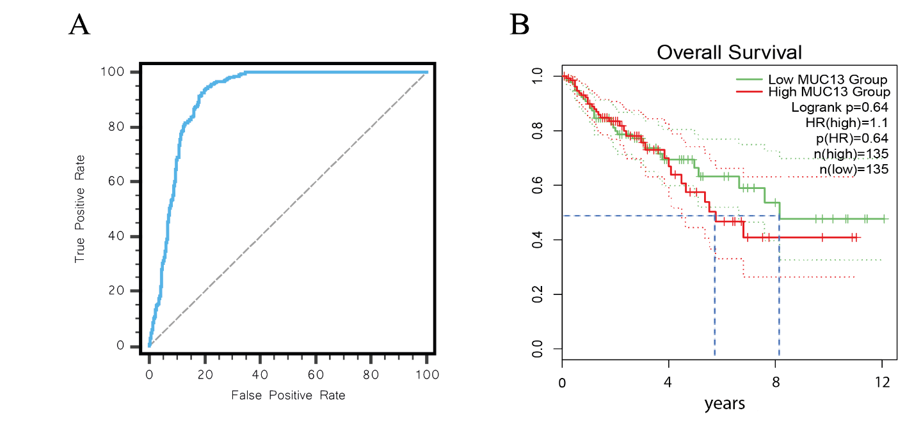

**Figure 3.** **The prognostic and diagnostic values of *MUC13* in colon cancer.** (A) The ROC curve of *MUC13* in colon cancer, AUC = 0.909, p < 0.001. (B) The overall survival curve of *MUC13* in colon cancer.

Based on the expression status of *MUC13* in colon cancer, we investigated whether it could serve as a reliable predictor for the diagnosis and prognosis of this malignancy. We assessed the diagnostic significance of this mucin in colon cancer using receiver operating characteristic curve analysis. The result of ROC curve analysis showed that *MUC13* can be used to differentiate between colon cancer cases and normal controls (Figure 3A). Considering all evaluated features, *MUC13* appears to be the most promising member of the mucin gene family in colon cancer.

### Prediction and Analysis of *MUC13*-Non-coding Interactions in Colon Cancer

We utilized several gene interaction prediction tools to identify miRNAs that probably interact with *MUC13*. These tools were microT-CDS, miRDB, PicTar, MicroCosm, TargetScan, miRanda, and PITA. As a result, a total of 127 miRNAs were obtained based on algorithmic computations. A large number of these miRNAs were excluded based on their differential expressions. The expression profiles of these miRNAs in COAD were assessed. For this purpose, we used dbDEMC. Seventeen of these miRNAs had significant differential expression (Table 2), and five of these miRNAs were significantly upregulated.

**Table 2.** List of predicted miRNAs with significant changes in expression

|  |  |  |  |
| --- | --- | --- | --- |
| **Symbol** | **average expression** | **logFC** | **adj. *p*-value** |
| hsa-miR-136-5p | 4.278 | 5.818 | 2.33E-135 |
| hsa-miR-139-5p | 4.336 | -5.238 | 4.23E-53 |
| hsa-miR-7-1-3p | 4.782 | 4.524 | 1.25E-34 |
| hsa-miR-324-3p | 3.620 | -3.392 | 4.94E-28 |
| hsa-miR-361-3p | 6.257 | -3.050 | 2.34E-23 |
| hsa-miR-324-5p | 3.942 | -1.967 | 5.53E-13 |
| hsa-miR-27a-3p | 10.470 | 2.001 | 2.42E-11 |
| hsa-miR-4723-3p | -2.393 | -0.544 | 5.55E-12 |
| hsa-miR-132-3p | 6.139 | -2.147 | 7.50E-11 |
| hsa-miR-23a-5p | 1.583 | -2.967 | 1.38E-09 |
| hsa-miR-668-3p | -2.220 | -0.953 | 6.19E-09 |
| hsa-miR-143-3p | 16.513 | 2.528 | 1.24E-07 |
| hsa-miR-6862-5p | -2.423 | -0.337 | 2.60E-08 |
| hsa-miR-1193 | -2.414 | -0.321 | 6.58E-08 |
| hsa-miR-6764-5p | -2.144 | -0.617 | 1.64E-05 |
| hsa-miR-624-5p | 0.073 | 0.576 | 0.000494914 |

To investigate the molecular interactions of *MUC13* in colon cancer, we used RIblast to predict lncRNAs that may potentially interact with *MUC13*. After specifying *MUC13* as a gene of interest, 92 lncRNAs were predicted by computational prediction. Subsequently, we evaluated the expression levels of the predicted lncRNAs using Gepia2, and seven lncRNAs with significant differential expression were identified (Table 3). The correlation between lncRNAs and *MUC13* was assessed in colon cancer data.

**Table 3.** List of predicted lncRNAs with significant changes in expression

|  |  |  |  |  |
| --- | --- | --- | --- | --- |
| **Symbol** | **Median (Tumor)** | **Median (Normal)** | **logFC** | **adj. *p*-value** |
| *NEAT1* | 153.915 | 1060.404 | -2.776 | 5.92E-75 |
| CTD-2537I9.12 | 5.1 | 18.581 | -1.683 | 3.36E-48 |
| CTD-3035K23.7 | 0.19 | 1.970 | -1.319 | 4.31E-67 |
| *XIST* | 0.21 | 3.890 | -2.015 | 9.66E-06 |
| CTD-3193O13.11 | 1.39 | 0.160 | 1.043 | 6.01E-65 |
| MIR497HG | 0.69 | 9.910 | -2.691 | 1.55E-124 |

We identified three lncRNAs with significant correlation to *MUC13* (*MUC13*-NEAT1, *MUC13*-CTD-3035K23.7, and *MUC13*-MIR497HG) that may have possible implications in colon cancer (Fig. 4).

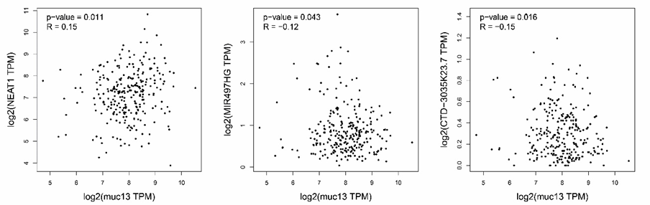

**Figure 4.** **Scatterplots displaying the correlation of *MUC13* with different lncRNAs**. *p*-value < 0.05.

### Construction of the Conceptual Regulatory Network

To identify interactions with the highest chance of occurring in our pool of genes and to acquire more reliable interactions based on validated experiments, we obtained validated interactions between our candidate lncRNAs and microRNAs by querying PubMed and starBase. We identified only two microRNAs and two lncRNAs, which were associated with our candidate gene, *MUC13*. Finally, we put together interactions between candidate miRNAs and lncRNAs and constructed potential lncRNA-miRNA-mRNA axes (including two lncRNAs, *NEAT1* and *XIST*, and two miRNAs, hsa-mir-136-5p and hsa-mir-27a-3p) that may be involved in the regulation of *MUC13* in colon cancer.

## Discussion

Mucins are involved in tumor initiation, progression, and metastasis. Aberrant localization and over-expression of *MUC13* in colon cancer are known. Based on the stepwise investigation, we determined *MUC13* as the candidate mucin. Then, we recognized candidate miRNAs (hsa-mir-136-5p and hsa-mir-27a-3p) and lncRNAs (NEAT1 and XIST) related to *MUC13* in a reverse step-wise manner based on algorithmic prediction, expression, and validated interactions. Finally, we constructed novel non-coding RNA networks consisting of these non-coding RNAs related to *MUC13*.

*MUC13*, which has two subunits, works as a transmembrane protein, and it is expressed in the normal colon. There are inconsistencies in the reports of *MUC13* expression in colon cancer. Some studies, such as those conducted by Gupta et al. and Walsh et al. indicated that *MUC13* expression in colon cancer is comparable to or higher than in normal samples (Gupta et al. 2014; Walsh et al. 2007). Sheng et al. found a significant association between high cytoplasmic *MUC13* expression and tumor grade in colorectal cancer tumors (Sheng et al. 2017). Likewise, Sheng et al. reported that higher levels of *MUC13* expression in colorectal tumors were associated with poor survival outcomes in their study patient cohorts (Sheng et al. 2019). In a newer study, Sojka et al. confirmed that higher levels of *Muc13* expression in tumor tissue in colorectal cancer patients would have inferior survival compared to those with lower levels of expression (Sojka et al. 2023). While other studies, such as those carried out by Williams et al. and Packer et al. documented a decrease in *MUC13* expression in cases of colon cancer (Packer et al. 2004; Williams et al. 2001). Our findings align with the former group of studies. These variations could potentially be attributed to dissimilarities in the sources of the samples or the types of control groups utilized. Gupta et al. studied the function of *MUC13* in colon cancer and found that overexpressed *MUC13* has promoting effects on tumorigenesis and metastasis through oncogenes and impacts on several pathways (Gupta et al. 2014). Sheng et al. proposed that *MUC13* has protective activities in colorectal cancer cells against cell death by activating the NF-κB pathway and suggested it as a gene of high importance in this malignancy (Sheng et al. 2017). Sheng et al. suggested that *MUC13* stimulates the expansion of colitis-associated colorectal tumors through β-catenin activity (Sheng et al. 2019).

We hypothesized that interactions among dysregulated non-coding RNAs, collectively constituting a regulatory network, impact the dysregulated activity and expression of *MUC13* in colon cancer. Thus, we constructed a regulatory network for *MUC13* in colon cancer by utilizing several algorithms and databases. To systematically investigate the potential non-coding regulatory network of *MUC13*, at first, candidate microRNAs were identified using several algorithmic tools. Then, based on the ceRNA theory and in combination with the differential expression status of miRNAs in colon adenocarcinoma, and validated interactions, we selected two candidate miRNAs out of 17. After that, two lncRNAs were selected based on their expression and structural profiles. One of the candidate microRNAs in this study was hsa-mir-136-5p. Several studies have investigated its role in different types of cancer, including colorectal cancer. Jin et al. found that over-expressed hsa-miR-136-5p plays a significant role in controlling *SOX9*, thereby facilitating the progression of colorectal cancer (Jin et al. 2023).

The second candidate microRNA was hsa-mir-27a-3p. The oncogenic roles of hsa-mir-27a-3p in colon cancer have already been reported. Liang and colleagues found that hsa-miR-27a-3p expression was increased in CRC tissues and significantly correlated with survival, histological differentiation, and metastasis. Their study demonstrated that the hsa-miR-27a-3p/RXRα/Wnt/β-catenin pathway is implicated in the progression of CRC. MiR-27a-3p targets RXRα, which contributes to the activity of the Wnt signaling pathway during the progression of CRC (Liang et al. 2017). Su et al. reported that, through the targeting of BTG1, hsa-miR‑27a‑3p regulates apoptosis and proliferation in colon cancer. They found that the impacts of hsa-miR-27a-3p on colon cancer cell apoptosis and proliferation were comparable to those of the BTG1, which acts as a tumor suppressor gene (Su et al. 2019). Another study by Chen et al. showed that lncRNA RMST inhibits colorectal cancer progression by inactivation of the Wnt signaling pathway and competitive interaction with the hsa-miR-27a-3p and RXRα (Chen et al. 2023).

LncRNAs have pivotal roles in many characteristics of cancer, such as apoptosis, migration, cell proliferation, and invasion (Huarte 2015). After a multi-step investigation, we determined *XIST* as one of our candidate lncRNAs. There is increasing evidence that the lncRNA X-inactive specific transcript (*XIST*) plays a critical role in the development and regulation of cell growth. Besides the primary function of *XIST* in dosage compensation of X chromosome, this lncRNA is also involved in the pathogenesis of cancer and many other human diseases by acting as a competing endogenous RNA (ceRNA) (Wang et al. 2021). According to a study by Yang et al., *XIST* functions as a competing endogenous RNA for miR-93-5p and promotes colorectal cancer progression via the HIF-1A/AXL signaling pathway (Yang et al. 2020).

The other lncRNA identified as a candidate in our investigation was *NEAT1*. The lncRNA *NEAT1* (Nuclear Enriched Abundant Transcript 1) performs a crucial role in the assembly and stability of paraspeckles and has been widely recognized as an essential element of paraspeckles. *NEAT1* promotes the development and progression of cancer by altering the levels of expression of genes that participate in several properties of cancer, such as growth, metastasis, invasion, regulation of tumor cells, and migration (Dong et al. 2018). Luo et al. reported that the lncRNA *NEAT1*, functioning as a competing endogenous RNA, contributes to colorectal cancer development by binding miR-34a competitively to SIRT1 and upregulating the Wnt/β-catenin signaling pathway (Luo et al. 2019b).

According to the competitive endogenous RNA hypothesis, some lncRNAs have regulatory roles on the downstream protein-coding genes by sequestering miRNAs. For this reason, we performed further investigation to identify potential lncRNA–miRNA interactions between the candidate miRNAs and lncRNAs. Interestingly, several of the interactions we proposed in this network have been validated in previous studies but not necessarily in colon cancer. Jiang and colleagues reported that the long non-coding RNA *NEAT1* elevates hypoxia-induced apoptosis of renal tubular epithelium by downregulating miR-27a-3p. Inhibition of *NEAT1* expression reduced miR-27a-3p overexpression, leading the authors to conclude that *NEAT1* negatively regulates the expression of hsa-miR-27a-3p. Dong et al. documented that *NEAT1* promotes Alzheimer’s disease development by downregulation of has-mir-27a-3p (Dong et al. 2021). The authors employed dual luciferase reporter gene and RNA pull-down assays to evaluate the potential interaction between the lncRNA hsa-mir-27a-3p and *NEAT1* and concluded that *NEAT1* targets hsa-mir-27a-3p. These researchers concluded that *NEAT1* contributes to the development of Alzheimer's disease via downregulating hsa-mir-27a-3p. Zhang and colleagues applied luciferase reporter and RNA immunoprecipitation assays and showed that *XIST* can interact with hsa-mir-27a-3p. They suggested that long non-coding RNA *XIST* affects cerebral ischemia/reperfusion injury by regulating miR-27a-3p/FOXO3 signaling (Zhang et al. 2021).

In conclusion, non-coding regulatory interactions and networks are receiving increasing attention in cancer research, which ultimately leads to a deeper understanding of cancer biology and subsequent applications. The constructed non-coding regulatory networks are proposed as novel networks with potential oncogenic roles in colon cancer. Here, we constructed potential regulatory networks consisting of miRNAs and lncRNAs related to *MUC13* in colon cancer utilizing a step-by-step reverse identification from mRNA to miRNA and lncRNA (**Fig**. 5). These findings might lead to novel insights into the molecular biology of colon cancer.

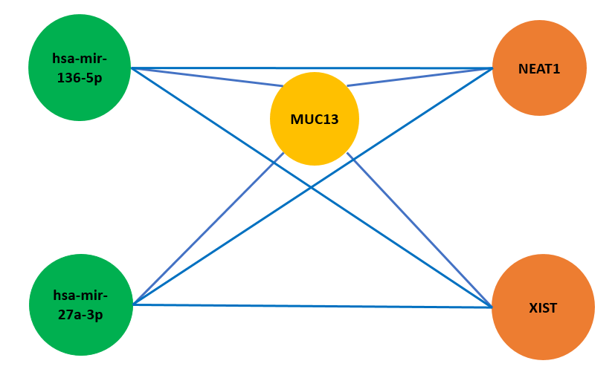

**Figure 5.** **The proposed conceptual regulatory network for the regulation of *MUC13* in colon cancer.** All the predicted and validated differentially-expressed non-coding RNAs were utilized to construct these lncRNA-miRNA-mRNA axes as potential non-coding regulators of *MUC13* in colon cancer.

However, it should be noted that the conduction of experimental validation is imperative. Subsequent investigations should concentrate on elucidating the regulatory role of the predicted *MUC13*-related non-coding axes in colon cancer through in vitro and in vivo investigations.

## Acknowledgments

This study was financially supported by grant number 48732 from Ferdowsi University of Mashhad.

## Conflict of interests

The authors declare that they have no conflict of interest.

## Author contributions

Conceived and designed the experiments: Sayyed Emad Aldin Tayyebi. Responsible for providing and quality control of the data: Sayyed Emad Aldin Tayyebi. Analysis and interpretations of the results: Sayyed Emad Aldin Tayyebi. Wrote and edited the manuscript: Sayyed Emad Aldin Tayyebi, Mahyar Heydarpour, and Hesam Dehghani.

## References

Chandrashekar DS., Bashel B., Balasubramanya SAH., Creighton CJ., Ponce-Rodriguez I., Chakravarthi BV, Varambally S (2017) UALCAN: a portal for facilitating tumor subgroup gene expression and survival analyses. Neoplasia 19:649-658

Chen S., Ji L., Wang Y., Zhang L., Xu M, Zhang X (2023) lncRNA RMST suppresses the progression of colorectal cancer by competitively binding to miR-27a-3p/RXRα axis and inactivating Wnt signaling pathway: RMST suppresses the progression of colorectal cancer. Acta Biochimica et Biophysica Sinica 55:726

Dong LX., Zhang YY., Bao HL., Liu Y., Zhang GW, An FM (2021) LncRNA NEAT1 promotes Alzheimer's disease by down regulating micro-27a-3p. American journal of translational research 13:8885-8896

Dong P., Xiong Y., Yue J., Hanley SJ., Kobayashi N., Todo Y, Watari H (2018) Long non-coding RNA NEAT1: a novel target for diagnosis and therapy in human tumors. Frontiers in genetics 9:471

Fukunaga T, Hamada M (2017) RIblast: an ultrafast RNA–RNA interaction prediction system based on a seed-and-extension approach. Bioinformatics 33:2666-2674

Gupta BK., Maher DM., Ebeling MC., Stephenson PD., Puumala SE., Koch MR, et al.Chauhan SC (2014) Functions and regulation of MUC13 mucin in colon cancer cells. Journal of gastroenterology 49:1378-1391

Huarte M (2015) The emerging role of lncRNAs in cancer. Nature medicine 21:1253-1261

Jin J., Du M., Ding D, Xuan R (2023) CircRNA circ_0013339 Regulates the Progression of Colorectal Cancer Through miR-136-5p/SOX9 Axis. Biochemical genetics:1-19

Li J-H., Liu S., Zhou H., Qu L-H, Yang J-H (2014) starBase v2. 0: decoding miRNA-ceRNA, miRNA-ncRNA and protein–RNA interaction networks from large-scale CLIP-Seq data. Nucleic acids research 42:D92-D97

Liang J., Tang J., Shi H., Li H., Zhen T., Duan J, et al.Han A (2017) miR-27a-3p targeting RXRα promotes colorectal cancer progression by activating Wnt/β-catenin pathway. Oncotarget 8:82991

Luo C., Cen S., Ding G, Wu W (2019a) Mucinous colorectal adenocarcinoma: clinical pathology and treatment options. Cancer Communications (London, England) 39:13

Luo Y., Chen J-J., Lv Q., Qin J., Huang Y-Z., Yu M-H, Zhong M (2019b) Long non-coding RNA NEAT1 promotes colorectal cancer progression by competitively binding miR-34a with SIRT1 and enhancing the Wnt/β-catenin signaling pathway. Cancer letters 440:11-22

Packer LM., Williams SJ., Callaghan S., Gotley DC, McGuckin MA (2004) Expression of the cell surface mucin gene family in adenocarcinomas. International journal of oncology 25:1119-1126

Sheng YH., He Y., Hasnain SZ., Wang R., Tong H., Clarke DT, et al.McGuckin MA (2017) MUC13 protects colorectal cancer cells from death by activating the NF-κB pathway and is a potential therapeutic target. Oncogene 36:700-713

Sheng YH., Wong KY., Seim I., Wang R., He Y., Wu A, et al.McGuckin MA (2019) MUC13 promotes the development of colitis-associated colorectal tumors via β-catenin activity. Oncogene 38:7294-7310

Sojka L., Opattova A., Bartu L., Horak J., Korenkova V., Novosadova V, et al.Vymetalkova V (2023) MUC13-miRNA-4647 axis in colorectal cancer: Prospects to identifications of risk factors and clinical outcomes. Oncol Lett 25:72

Su C., Huang DP., Liu JW., Liu WY, Cao YO (2019) miR‑27a‑3p regulates proliferation and apoptosis of colon cancer cells by potentially targeting BTG1. Oncology letters 18:2825-2834

Tang Z., Kang B., Li C., Chen T, Zhang Z (2019) GEPIA2: an enhanced web server for large-scale expression profiling and interactive analysis. Nucleic acids research 47:W556-W560

Walsh MD., Young JP., Leggett BA., Williams SH., Jass JR, McGuckin MA (2007) The MUC13 cell surface mucin is highly expressed by human colorectal carcinomas. Human pathology 38:883-892

Wang W., Min L., Qiu X., Wu X., Liu C., Ma J, et al.Zhu L (2021) Biological function of long non-coding RNA (LncRNA) Xist. Frontiers in cell and developmental biology 9:645647

Williams SJ., Wreschner DH., Tran M., Eyre HJ., Sutherland GR, McGuckin MA (2001) Muc13, a novel human cell surface mucin expressed by epithelial and hemopoietic cells. The Journal of biological chemistry 276:18327-18336

Xu F., Wang Y., Ling Y., Zhou C., Wang H., Teschendorff AE, et al.Zhang G (2022) dbDEMC 3.0: functional exploration of differentially expressed miRNAs in cancers of human and model organisms. Genomics, Proteomics and Bioinformatics 20:446-454

Yang Lg., Cao Mz., Zhang J., Li Xy, Sun Ql (2020) LncRNA XIST modulates HIF‐1A/AXL signaling pathway by inhibiting miR‐93‐5p in colorectal cancer. Molecular genetics & genomic medicine 8:e1112

Zhang H., Xia J., Hu Q., Xu L., Cao H., Wang X, Cao M (2021) Long non‑coding RNA XIST promotes cerebral ischemia/reperfusion injury by modulating miR‑27a‑3p/FOXO3 signaling. Molecular medicine reports 24

1. E-mail: [sea.tayyebi@mail.um.ac.ir](mailto:sea.tayyebi@mail.um.ac.ir)
2. E-mail: [heydarpour@bwh.harvard.edu](mailto:heydarpour@bwh.harvard.edu)
3. Email: [dehghani@um.ac.ir](mailto:dehghani@um.ac.ir)
4. Corresponding author  
   Address: Stem Cell Biology and Regenerative Medicine Research Group, Research Institute of Biotechnology, Ferdowsi University of Mashhad, Azadi Square, Mashhad, Iran. 91775-1793. Tel: +98-51-3880-3795; Fax: +98-51-3880-7029