**From Page to Screen: The Beast Symbolism in Golding’s Lord of the Flies (1954) and Hook’s Film (1990)**

Author Information  
Mahdieh Taheri  
M.A. Student  
The English Department, Ferdowsi University of Mashhad  
Email: [mahdiehtaheri3482@gmail.com](mailto:mahdiehtaheri3482@gmail.com)

Corresponding Authors

Mahmoud Reza Ghorban Sabbagh, Ph.D.  
Email: [mrg.sabbagh@um.ac.ir](mailto:mrg.sabbagh@um.ac.ir)

Sara Khazai, Ph.D.

[s.khazai@um.ac.ir](mailto:s.khazai@um.ac.ir)

**October 2024**

**Abstract**

This article analyzes the symbolic imagery of the beast in William Golding’s Lord of the Flies (1954) and its 1990 film adaptation, emphasizing how both verbal and visual elements convey themes of fear and savagery. The examination focuses on cohesive devices such as reference and repetition that establish the beast's significance in the novel. Initially, the beast is merely a product of the boys' imagination but gradually transforms into a powerful symbol of their inner fears. In the film, visual and auditory techniques vividly portray the beast, particularly through the character of Captain Benson, who serves as a concrete embodiment of fear. The findings indicate that the film successfully translates the beast's symbolism using cinematic techniques while preserving thematic depth and making the concept accessible to a wider audience. This transformation enhances the viewer's understanding of the narrative and demonstrates the relationship between verbal and visual storytelling. Ultimately, the article emphasizes how both forms adapt and effectively convey the complex themes present in Golding’s original work.

***Keywords*:** beast, Lord of the Flies, 1990 adaptation, symbolism, fear

1. **Introduction**

William Golding’s *Lord of the Flies* (1954) presents a powerful exploration of the dark undercurrents of human nature, civilization, and fear. Among its central symbols, the beast encapsulates the boys' growing terror and signals their descent into savagery. This symbol appears early in the narrative, initially introduced by one of the younger boys as a “snake-thing” or “beastie” lurking in the dark (Golding, 1954/2006, pp. 35-36). Although dismissed at first, the idea of the beast takes root in the boys' imaginations, transforming from a childish fear into a potent symbol of their internal struggles and the gradual breakdown of their social order.

As the novel progresses, the beast is reinterpreted as a dead parachutist, another symbol carrying deep thematic weight. Here, the parachutist brings a reminder of outside violence, deepening the boys' fear. The cohesive narrative techniques, as outlined by Halliday and Hasan (1976), such as reference and repetition, emphasize the beast's importance by embedding it in the boys' thoughts and conversations, heightening the sense of paranoia and loss of order.

The 1990 film adaptation by Harry Hook interprets this theme through a different lens, introducing Captain Benson, a wounded adult character absents in the novel, who eventually becomes the boys’ tangible beast. His physical and mental decline and his erratic behavior make him a direct source of fear for the boys, particularly the younger ones. The director utilizes cinematic techniques, such as shadowy lighting and disturbing sounds, to solidify Benson’s role as the embodiment of their collective fear. This transition from a purely imagined terror to a concrete figure mirrors the boys’ descent into savagery and highlights how fear can manifest in different forms when societal structures fall apart.

Through an analysis of how the beast is symbolized in both the novel and its film adaptation, this article seeks to explore how verbal and visual elements convey themes of fear, savagery, and the breakdown of civilization. By examining cohesive devices in the text, such as reference and lexical cohesion, and comparing these to visual storytelling techniques like framing and sound in the film, this study investigates how each medium adapts the beast to reflect similar themes. The aim is to understand how Hook’s adaptation preserves and reinterprets the beast’s symbolism, translating Golding’s verbal cues into a cohesive cinematic experience that reflects the novel’s thematic depth while introducing new dimensions to the symbolism.

This comparative analysis will draw on the cohesive framework of Halliday and Hasan (1976) and the theories of visual cohesion proposed by Janney (2010) and Kress and van Leeuwen (2006). Together, these frameworks illuminate the interplay between language and imagery, verbal and visual elements, demonstrating how adaptations can both preserve and transform core themes. Ultimately, this study highlights how Golding's examination of humanity's hidden savagery is reflected in both literature and visual art. It enhances our understanding of how fear influences human behavior when social order begins to break down.

1. **Literature Review**

**2.1. Cohesion in Narrative Texts**

Cohesion is crucial in creating a unified and coherent narrative, whether in linguistic texts or visual media. Cohesion in English by Halliday and Hasan (1976) introduced a framework for analyzing linguistic cohesion, emphasizing cohesive elements like reference, substitution, ellipsis, conjunction, and lexical cohesion. These cohesive ties establish semantic relationships within a text, helping to transform individual sentences into an interconnected whole. Narrative and Media by Fulton (2005) further emphasized cohesion’s role in structuring narrative meaning by exploring how cohesive patterns, including repetition and lexical choices, contribute to the reader’s understanding of thematic continuity.

In Narrative Revisited (2010), Janney extended these cohesion principles to film discourse, arguing that filmic cohesion operates through visual and auditory elements rather than written language. Techniques like framing, camera positioning, and continuity editing establish cohesive ties, linking sequences together to form a coherent narrative. Cook’s A History of Narrative Film (2016) highlighted the importance of digital advancements in shaping cohesive storytelling techniques, especially in contemporary films, where evolving technologies enhance visual cohesion by integrating visual and auditory cues.

**2.2**. **Multimodality and Audiovisual Cohesion in Film Adaptation**

Multimodality examines how various modes; such as language, visuals, and sound, work together to create cohesive meaning. Kress and van Leeuwen in Reading Images: The Grammar of Visual Design (2006) emphasized that cohesive storytelling in film depends on the integration of visual elements like colors, spatial design, and cultural symbols, which convey complex social meanings, extending cohesion beyond language.

McIntyre’s article, Integrating Multimodal Analysis and the Stylistics of Drama (2008), explored how multimodal cohesion in adaptations operates through motifs and visual symbols that mirror linguistic cohesion, establishing a visual language that unifies the narrative. This approach highlights how films replace verbal references with visual cues, allowing adaptations to maintain thematic unity. Building on this, Liu and O’Halloran’s Intersemiotic Texture (2009) introduced the concept of intersemiotic texture, which describes how visual and verbal components cohesively interact to retain narrative consistency. This framework is essential for understanding how film adaptations preserve the narrative depth of the original text by translating verbal imagery into cohesive visual and auditory forms.

Testing Coherence in Narrative Film by Virvidaki (2017) further explored how visual style and narrative integration strengthen cohesive relationships within films. She suggests that cinematic techniques, whether conventional or innovative, contribute to cohesive storytelling by maintaining visual and thematic consistency across scenes. This perspective demonstrates that multimodality in film adaptations preserves the source material’s narrative richness by transferring cohesive structures across modes.

**2.3. The Symbol of the Beast in Lord of the Flies**

In William Golding’s Lord of the Flies, the concept of the beast evolves as a symbol of the boys’ innate fears and represents the latent darkness within everyone. The Master's dissertation in William Golding’s Lord of the Flies (1954) and Harry Hook’s The Forgotten Island (1990): A Dialogic Study,**published in 2022by Narimene and Lamia**, explores the different portrayals of the beast in both the novel and Hook’s adaptation. In Golding’s narrative, the beast starts as a mythical creature feared by the younger boys, embodying their vulnerability and growing paranoia. This fear intensifies as the boys’ moral structures collapse, suggesting that the true beast is not an external threat but their own capacity for violence and savagery. Golding uses characters like Simon to recognize that the beast is only us, a revelation that underscores the novel's theme of inherent human evil.

In his paper, An Analysis of Adaptations of Things Fall Apart, Lord of the Flies, and The Road, Branko Marijanović (2018) interprets the beast in Lord of the Flies as a symbol of humanity's inherent savagery, which emerges when civilization's constraints are removed. He argues that, without societal order, individuals revert to violent, self-centered behavior, aligning with Hobbesian views on human nature. Marijanović critiques film adaptations for emphasizing visual elements over Golding’s psychological exploration, thereby weakening the original theme of inner darkness.

In her 2000 book, Understanding Lord of the Flies, Kirstin Olsen discusses the beast as a symbol for the boys' primal fear and the dark potential within human nature. Olsen explains that the boys project their inner fears onto an imagined creature, the beast, to cope with their isolation and fear of the unknown. This construct represents humanity’s tendency to invent external threats to rationalize internal anxieties. By suggesting the beast is within themselves, Olsen aligns with Golding’s message that human savagery is inherent, not external​.

1. **Discussion**
   1. **Textual Representation of the Beast in *Lord of the Flies* (1954)**

In *Lord of the Flies* (1954), the beast is a central symbol representing the boys' collective fear and the gradual erosion of their civilized behavior. This symbolic representation emerges in the novel’s second chapter, "Fire on the Mountain," where the younger boys, or "littluns," introduce the idea of a "snake-thing" or "beastie" lurking in the darkness (Golding, 1954/2006, pp. 35-36). Initially dismissed as mere imagination, the beast soon evolves into a shared symbol of fear, an embodiment of the boys’ anxieties. As the story progresses, the concept of the beast becomes more concrete, with the boys later mistaking a dead parachutist for the beast. The parachutist, shot down during a battle, introduces the chaotic influence of external violence into the boys' isolated environment, deepening their collective paranoia and hastening the breakdown of their rational order.

Using Halliday and Hasan's (1976) cohesion theory, which highlights devices like reference, conjunction, and lexical cohesion, Golding carefully incorporates the beast into the narrative. This framework reveals how the beast symbolically fills the boys' interactions, shaping their behaviors and heightening their sense of dread. For example, reference is a fundamental cohesive device that keeps the beast at the forefront of the boys' minds. From the littlun's initial mention of the "beastie," this term becomes embedded in the boys' vocabulary, repeatedly referenced with pronouns like "it" and vague descriptors like "the thing." When one boy insists, "He says the beastie came in the dark" (Golding, 1954/2006, p. 36), the statement not only reinforces the beast’s hold on their imagination but also positions it as an ever-present threat. The use of endophoric references (i.e., references within the text itself) helps sustain the beast’s symbolic weight, demonstrating how language shapes the narrative’s internal cohesion and maintains the symbol’s prominence.

Conjunctions also serve to connect the boys’ growing fears about the beast, lending a logical flow to their conversations. Jack’s statement, “But there isn’t a snake! We’ll make sure when we go hunting” (Golding, 1954/2006, pp. 36-37), employs the conjunction "but" to juxtapose his dismissal of the beast with the underlying anxiety that drives the boys to action. This contrast not only underscores the inner conflict within the group but also reinforces the growing impact of fear on their collective decision-making. Lexical cohesion is another essential cohesive device evident through the repetition of words like "beastie," "snake-thing," and later simply "beast." This repetition ties various parts of the narrative together, creating a cohesive thread centered around the beast’s significance, both in the boys' minds and in the reader's interpretation of their fears.

Additionally, ellipsis and substitution contribute to the text's cohesion. For instance, the previously mentioned dialogue on pages 35 and 36, where the boys refer to the "beastie" or "snake-thing," is later shortened to "it" or "the thing," allowing the narrative to flow without redundant repetition. These linguistic choices allow the dialogue to sustain the focus on the beast while maintaining brevity. As the boys struggle with their fears, this elliptical approach makes their fear indirect, highlighting the beast’s constant yet unspoken presence.

In Lord of the Flies, Golding (1954/2006) intensifies the theme of inner evil during Simon’s confrontation with the Lord of the Flies, symbolized by the pig’s head on a stick. The scene’s dialogue, with phrases like “What are you doing out here all alone?” and “There isn’t anyone to help you. Only me. And I’m the Beast” (p. 143), personifies the beast and reinforces Simon’s fear and sense of abandonment. According to Halliday and Hasan (1976), such spatial deixis, like “here,” serves as an exophoric reference, grounding Simon’s internal dread in his physical surroundings and highlighting his isolation. Golding’s language choices, combined with the imagery of the pig’s head, vividly symbolize the boys’ inner savagery, suggesting that the true beast lies within them. These repeated fear-inducing phrases and vivid visuals create a cohesive and intense narrative that illustrates the beast as both a psychological and social force, emphasizing the theme of innate human evil that is central in the novel.

Through these cohesive devices, the novel meticulously develops the beast from an imagined entity into a powerful symbol of internalized fear, driving the boys toward chaos. Golding’s use of language not only frames the beast as a key thematic element but also explores how fear, when ingrained in a narrative, shapes character behavior and drives the story’s progression. This layered portrayal of the beast, supported by linguistic cohesion, offers readers an intricate examination of the psychological and social consequences of unchecked fear.

* 1. **Cinematic Depiction of the Beast in Lord of the Flies(1990)**

In Harry Hook’s 1990 film adaptation of Lord of the Flies, the beast is represented through the character of Captain Benson, who embodies the boys' fears in a physical form. Unlike the novel’s abstract concept of the beast, Captain Benson offers a concrete figure for the boys to project their anxieties onto. The film introduces Benson during the opening underwater rescue scene, where Ralph tries to save him from drowning. This sequence immediately sets a tense and dynamic tone, contrasting with the novel's calm start, where Ralph and Piggy's exploration through the jungle hints at an initial sense of innocence and order. By shifting to a more intense, survival-focused beginning, the film quickly creates a sense of urgency, hinting at the chaos to come and immersing the audience in the boys' rapidly growing world of fear.

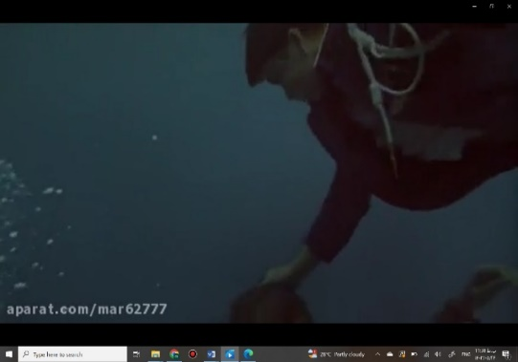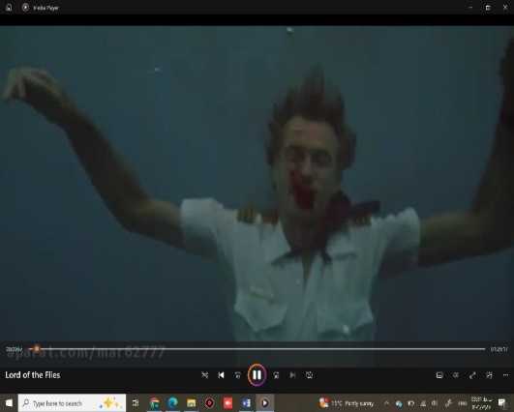

*(Hook, 1992, 00:00:57_00;01:10)*

*Figure 1. Film’s opening scene*

Cinematic techniques, like framing, continuity editing, and sound, enhance Benson’s role as the symbolic beast in the boys' minds. In the opening scene, the use of a static camera captures Benson in a detached way, aligning with Brown's (2022) concept of the "proscenium wall" (p. 67), which frames the action as if on a stage. This static framing makes the audience feel like third-person observers, maintaining psychological distance and emphasizing Benson’s isolation. As Ralph begins his rescue, however, the camera shifts to dynamic angles that actively track his movements underwater and to the surface, underscoring Ralph’s central role and sense of urgency. This contrast between static and dynamic shots deepens the viewer’s engagement in Ralph’s struggle while highlighting the symbolic separation between Benson and the other boys.

Building on the dynamic cinematography, the opening scene also employs continuity editing and match cuts to maintain a smooth narrative flow, creating a coherent and engaging cinematic experience. Continuity editing is a technique used to ensure that the sequence of events is presented in a logical and seamless manner, allowing the audience to follow the action without confusion. Bordwell et al. (2020) explain that these techniques create seamless transitions between shots, ensuring that each cut feels natural and purposeful. As Ralph rescues Captain Benson, the editing style becomes particularly evident. The camera shifts smoothly from the underwater struggle to the surface, effectively connecting different spatial and temporal elements of the scene. This technique allows the viewer to experience the urgency and intensity of the rescue without becoming disoriented by abrupt changes in perspective or location.

In addition, the use of match cuts is especially crucial in this sequence. By aligning Ralph’s movements between shots, the filmmakers create a fluid visual narrative that emphasizes the continuous action of the rescue. These editing choices not only enhance the scene's dramatic impact but also reinforce the themes of survival and rescue. The seamless transition from the chaotic underwater environment to the relative calm of the surface underscores Ralph's determination and heroism, highlighting the life-or-death stakes involved in saving Captain Benson. This careful attention to editing helps to immerse the audience in the unfolding drama, maintaining their engagement and emotional investment in the story.

In the later scenes, as Benson’s mental and physical state worsens, he begins muttering incoherently and wandering unpredictably around the island, unsettling the boys, especially the younger ones. His erratic behavior gradually transforms him into the embodiment of the beast they fear, culminating in Jack’s suggestion that they should "get rid of him" (Hook, 1990, 00:33:09). Overhearing this, Benson flees to a dark cave, where he ultimately meets his tragic end. The transition from this verbal symbol in the novel to its visual representation in the film is particularly significant. Captain Benson, unlike the dead parachutist in the novel, serves as a tangible embodiment of the boys' fear. Initially, Benson is cared for by the boys, but as his mental and physical state deteriorates, he becomes a more direct source of fear. This transformation is reinforced by the visual and symbolic elements that the film uses to create a cohesive narrative. Janney’s (2010) discussion of visual cohesion emphasizes how films use visual and auditory elements to create cohesive ties that enhance the narrative. In *Lord of the Flies* (1990), the film’s portrayal of Captain Benson’s deteriorating condition, erratic behavior, and eventual retreat to a dark cave serves as a powerful visual narrative that parallels the growing fear associated with the beast.

The film utilizes dark and foreboding imagery, such as Benson’s shadowy retreat into the cave, to visually link Benson to the concept of the beast. His erratic movements and incoherent speech further intensify this connection, as the unsettling sounds and visuals create a cohesive atmosphere of fear and tension. These elements ensure that the beast remains a constant presence in the film, reinforcing the boys' growing fear and anxiety. Using these visual and auditory techniques, the film maintains a continuous narrative where the beast is consistently reinforced through Benson’s portrayal. This approach allows the film to preserve the thematic depth of the novel while effectively adapting its symbols to a visual medium, demonstrating how cohesion can be achieved through imagery and symbolism in film.

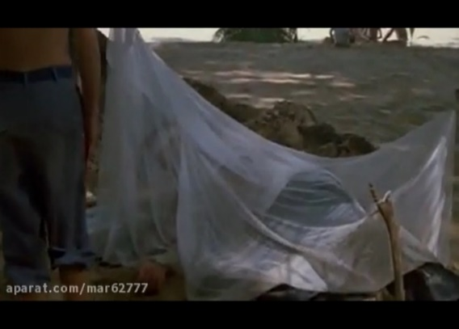

*(Hook, 1992, 00:24:31)*

*Figure 2. Captain Benson under a mosquito net*

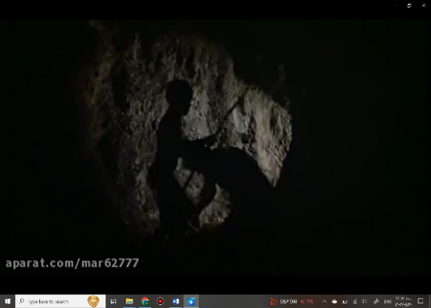

*(Hook, 1992, 00:48:58)*

*Figure 3. Captain Benson in the dark cave (moments before being struck by one of the boys)*

Kress and van Leeuwen (2006) and Liu and O'Halloran (2009) argue that visual symbols, through their associative meanings, can deepen thematic elements such as fear and isolation. In the film, symbols like the mosquito net and Benson’s retreat into a cave underscore these themes. The mosquito net initially appears as a protective barrier, but it gradually comes to symbolize Benson’s psychological isolation and the boys' growing fear of him. Likewise, his retreat into the cave visually mirrors the boys' descent into savagery, reinforcing their collective fear of the unknown. Through these visual cues, the film enhances the narrative's psychological complexity, revealing how physical symbols can represent emotional and social isolation.

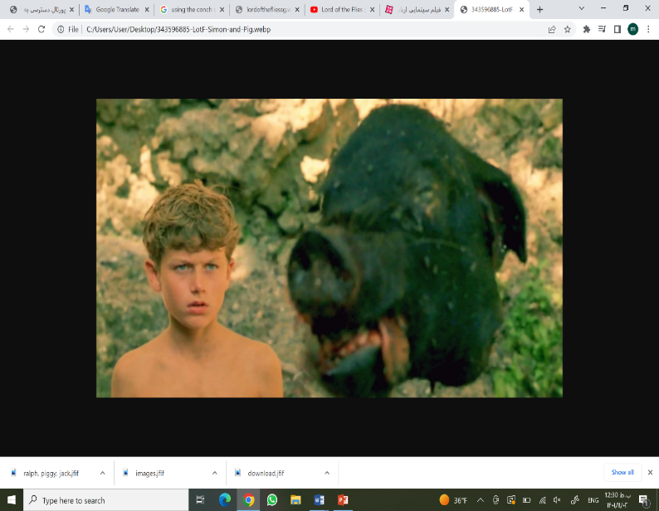

*(Hook, 1990, 00:59:54)*

*Figure 4. Simon’s gaze at the pig’s head in the afternoon*

Hook’s adaptation diverges significantly from Golding’s portrayal of the beast in Simon’s encounter with the pig’s head. In the novel, Simon’s confrontation with the Lord of the Flies is marked by explicit dialogue, in which the pig’s head introduces itself as the beast, confirming that the true source of evil lies within the boys. In contrast, the film adaptation relies on non-verbal cues in this scene. Simon approaches the pig’s head in silence, and a prolonged close-up captures his reaction as he stares at the head. This visual pause allows viewers to interpret the symbolism independently but may result in a more ambiguous representation of the theme of inner evil compared to the novel's explicit articulation.

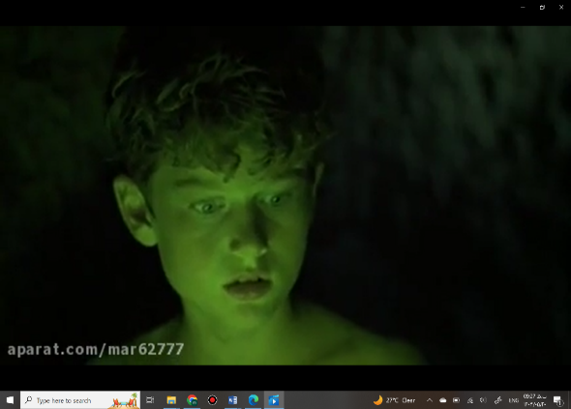

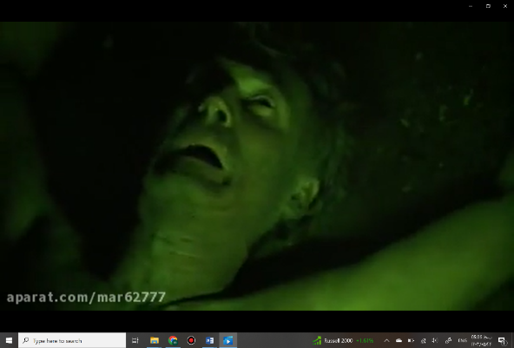

*(Hook, 1990, 01:03:45_01:03:46)*

*Figure 5. Simon’s encounter with Captain Benson’s corpse*

To compensate for the absence of dialogue and to clarify the theme of inner darkness, Hook adds an alternate scene where Simon discovers Captain Benson’s corpse. This additional scene functions as a climactic moment of realization, emphasizing that the boys’ fear is rooted not in an external monster, but in their own capacity for savagery. The dim lighting in the cave, with only the green glow stick illuminating Simon’s path, symbolizes his growing understanding of the true nature of the beast. Bordwell et al. (2020) note that "cool colors tend to recede" (p. 166), and here, the green glow creates depth and contrast, visually underscoring the moment’s significance.

The use of close-up shots in this scene intensifies Simon’s reaction to Benson’s decaying body, allowing viewers to experience his shock and understanding firsthand. Blain Brown (2022) emphasizes that close-ups are essential for capturing intense emotions, as they "make the audience more involved in the story" by focusing on a character’s facial expressions (p. 10). This technique, combined with the lighting and framing, encapsulates Simon’s realization and reinforces the film’s central theme of inner human evil without the need for explicit dialogue. Furthermore, the eerie sounds of bats and an ominous background score elevate the tension, aligning with Bordwell et al.'s (2020) insights on sound’s role in guiding audience interpretation by reinforcing visual cues. Together, these elements contribute to an unsettling atmosphere that mirrors the novel's psychological tension, capturing the tragic realization that the beast lies within.

This scene complements Simon's earlier confrontation with the Lord of the Flies. While the film’s depiction of Simon’s silent encounter with the pig’s head captures the atmosphere of fear, it doesn’t fully convey the novel’s complex theme of innate human evil. To maintain thematic cohesion and compensate for this depth, the film uses Simon’s encounter with Captain Benson’s corpse to visually communicate that the real source of fear is not an external beast but the darkness within the boys. This addition ensures that the central theme of inner human evil remains intact, relying on visual and auditory elements rather than verbal articulation to convey this profound realization.

1. **Conclusion**

This article has explored the symbolic representation of the beast in William Golding's Lord of the Flies (1954) and its cinematic adaptation by Harry Hook (1990). Using Halliday and Hasan's (1976) cohesion theory, the analysis demonstrated how Golding employs cohesive linguistic devices; such as reference, conjunction, and lexical cohesion, to maintain the beast's presence throughout the narrative, transforming it from a figment of the boys' imaginations to a powerful symbol of inner darkness and fear. The cohesive devices used by Golding effectively establish the beast as a central, terrifying force within the boys, subtly illustrating humanity's latent capacity for savagery.

In Hook's 1990 adaptation, the symbolic beast takes a tangible form through Captain Benson, who becomes a central figure for the boys’ fears. Drawing on the theories of Kress and van Leeuwen (2006) and Liu and O'Halloran (2009), which emphasize the power of visual symbols to convey complex themes, the film effectively uses imagery like the mosquito net and Benson’s retreat into a dark cave to reflect the boys’ descent into primal fear and isolation. This visual approach complements Golding's original themes by harnessing symbols and cinematic techniques to illustrate the narrative’s psychological depth and the growing sense of dread among the boys.

Moreover, the film’s pivotal scenes, such as Simon’s encounter with the pig’s head and his discovery of Benson’s body, reinforce the thematic focus on innate human evil. Hook’s reliance on non-verbal cues, intensified through close-ups and lighting, echoes the novel's atmosphere of dread while inviting the viewer to engage more deeply with the symbol of the beast. This layered representation emphasizes the beast not only as a source of external fear but as a reflection of the boys' internal descent into savagery. By integrating cinematic techniques and Golding’s thematic framework, the film adapts the abstract horror of the novel into an accessible yet profound visual experience, demonstrating the compatibility of verbal and visual storytelling in exploring the darker aspects of human nature.

1. **References**

Bordwell, D., Thompson, K., & Smith, J. (2020). *Film art: An introduction* (12th ed.). McGraw-Hill Education.

Brown, B. (2022). *Cinematography: Theory and practice: Image making for cinematographers and directors* (4th ed.). Routledge.

Cook, D. A. (2016). *A history of narrative film* (5th ed.). WW Norton & Company.

Fulton, H. (2005). Film narrative and visual cohesion. In H. Fulton, R.E.A Huisman, J. Murphet & A.K.M Dune (Eds.), *Narrative and media* (pp. 108-122). Cambridge University Press.

Golding, W. (1954/2006). *Lord of the flies*. Perigee.

Halliday, M. A. K., & Hasan, R. (1976). *Cohesion in English*. Routledge.

Hook, H. (Director). (1990). *Lord of the flies* [Film]. Castle Rock Entertainment.

Janney, R. W. (2010). Film discourse cohesion. In C. R. Hoffman [Ed.], *Narrative revisited* (pp. 245–256). Benjamins.

Kress, G. R., & Van Leeuwen, T. (2006). *Reading images: The grammar of visual design* (2nd ed.). Routledge.

Liu, Y., & O'Halloran, K. (2009). Intersemiotic texture: Analyzing cohesive devices between language and images. *Social Semiotics, 19(4)*, (pp. 367–388).

**Marijanović, B. (2018). *Staying human and humane within and without a civilizational frame: An analysis of adaptations of* *Things Fall Apart*, *Lord of the Flies*, and *The Road*. In *Željko Uvanvic* (Ed.),** Proceedings from the International Conference on Comparative Literature (p. 157).

McIntyre, D. (2008). Integrating multimodal analysis and the stylistics of drama: A multimodal perspective on Ian McKellen's *Richard III*. *Language and Literature*, *17*(4), (pp. 309–334).

Narimene, A., & Lamia, B. (2022). *William Golding’s Lord of the Flies (1954) and Harry Hook’s The Forgotten Island (1990): A dialogic study*. (Doctoral dissertation, Université Mouloud Mammeri). Shodhganga.

Olsen, K. (2000). *Understanding Lord of the Flies: A student casebook to issues, sources, and historical documents*. Bloomsbury.

Virvidaki, K. (2017). Testing coherence in narrative film. Palgrave Macmillan.