Bioactive Nanofibers from Gastrointestinal Nematode Antigens as a Next-Generation Strategy for Seafood Preservation
Soheil Sadr¹, Hassan Borji^{1*} Nooshinmehr Soleymani¹, Behrouz Ghorani², Ammar Algburi³
¹Department of Pathobiology, Faculty of Veterinary Medicine, Ferdowsi University of Mashhad, Mashhad, Iran.
²Department of Food Nanotechnology, Research Institute of Food Science & Technology (RIFST), Mashhad 91851-76933, Iran.
3Department of Microbiology, College of Veterinary Medicine, University of Diyala, Baqubah 32001, Iraq.

*Corresponding author: hborji@um.ac.ir

Abstract- In recent years, a growing demand for healthy, high-quality food products has prompted a significant focus on developing innovative methods to extend the shelf life and enhance food safety. This focus is particularly critical for perishable items, such as fish. Accordingly, the use of active edible coatings has been proposed as a promising solution. One of the most interesting and advanced materials investigated for this purpose is the combination of antigens extracted from digestive nematodes with electrospun nanofibers. The protein nature of nematode antigens and their unique biological properties, including immunomodulatory activities, antimicrobial and anti-inflammatory potential, can serve as powerful and active coating agents. Another angle to consider is nanofibers, which serve as an ideal substrate for the protection, stabilization, and controlled release of antigens, because of their high surface area-to-volume ratio, controlled porosity, and the ability to load and release active ingredients in a targeted manner. The incorporation of these antigens into a nanofibrous structure enhances both their stability and biological activity in response to environmental factors. Furthermore, the nanofibrous coating establishes a semi-permeable physical barrier around the fish fillet, effectively preventing moisture evaporation and oxygen penetration. Additionally, the gradual release of active antimicrobial compounds will effectively prevent bacterial growth and microbial spoilage. This mechanism, ultimately, leads to a significant prolongation in shelf life, preservation of sensory quality (such as texture, color, and aroma), and ensuring the safety of fish meat. In light of these parameters, the present project investigates the application of antigens extracted from nematodes engineered into nanofibrous structures to produce protective coatings for fish meat. The primary objective of this study is to assess the potential of nanofibers loaded with antigens, which may possess antimicrobial and antioxidant properties due to their specific protein structure.

- INTRODUCTION
In light of the increasing demand for safe and high-quality food, the development of efficient ways to preserve perishable commodities, such as fish meat, has become a significant concern today [1, 2]. Even when conventional methods are possible, they often pose challenges, including changes in taste, health problems, and reduced nutrient levels. To preserve food quality and extend its shelf life, scientists have been developing new technologies based on natural principles to circumvent these limitations [3, 4].
Nanotechnology has brought about a remarkable transformation in medicine, enabling the targeting and destruction of cancer cells with smart nanoparticles, enabling direct and controlled drug delivery to the infected tissues, and opening a new window for treating intractable diseases by developing precise diagnostic nanotools [5-9]. The food packaging industry has undergone a revolutionary transformation driven by nanotechnology, enabling the use of materials at the molecular level [10-12]. Nanofibers are the best option for developing protective coatings because they have an extremely high surface area-to-volume ratio, superior mechanical properties, and the ability to load active components (Figure 1).
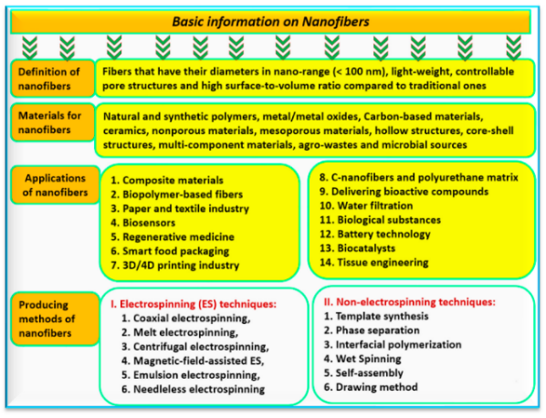
Figure 1. The main basic information on nanofibers, their definition, classification, and applications (MDPI Copyright, 2023) [13].

The nematode antigens, with their biological features, including immunomodulatory activities, antibacterial, and anti-inflammatory, will serve as effective active ingredients in the bio-coating process [14]. The objective of this review paper is to shed light on using nano-fibrous antigens, isolated from gastrointestinal nematodes, as an innovative method for preserving fish meat.
- NEMATODE-DERIVED ANTIMICROBIAL PEPTIDES
Gastrointestinal nematodes have evolved advanced strategies to control their hosts' immune systems and combat bacteria in their environments. These organisms can coexist with their hosts and prevent secondary bacterial infections because of their capability to produce large quantities of bioactive chemicals and antigens [15]. The scientific community shows that these chemical compounds effectively inhibit the growth of a wide range of Gram-positive and Gram-negative bacteria.
The primary antibacterial mechanism of these compounds is disrupting the bacterial cell membrane [16]. Antimicrobial peptides derived from nematodes bind to bacterial outer membranes, forming holes that lead to the leakage of the intracellular contents and, ultimately, kill the bacteria [17]. Furthermore, bacterial growth and proliferation may be prevented by these chemicals through inhibition of bacterial cell wall formation or disruption of internal metabolic processes [18].
- NANOFIBERS
The high surface-to-volume ratio of nanofibers with diameters in the nanoscale range (often between 1 and 100 nanometers) is associated with their extraordinary physical, mechanical, and chemical properties. Electrospinning is the primary method for manufacturing nanofiber structures. In this technique, a polymer solution is exposed to a strong electric field, then elongated, and deposited into very thin fibres. The shape, porosity, and chemical composition of nanofibers can be precisely controlled in this approach [19, 20]. Nanofibers have a wide variety of applications, including filtration, tissue engineering, batteries, and sophisticated sensors. Nanostructures are used in the food business for a variety of purposes, including the creation of active packaging, the enhancement of food texture, and the controlled release of active chemicals (such as antibacterial agents or antioxidants) by acting as smart carriers [21, 22] (Figure 2).
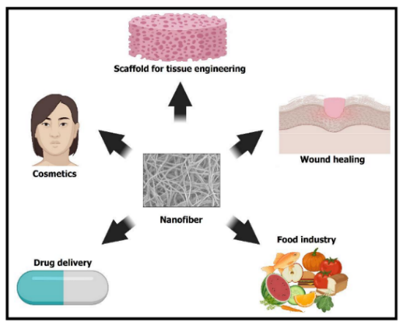
Figure 2. Different applications of fabricated nanofibers (MDPI Copyright, 2021) [23].
One of the most important advantages that nanofibers have in the food industry is their capability for "loading and releasing" active ingredients [24]. Nanofibers can absorb and retain substantial amounts of biomolecules, including enzymes, vitamins, antibacterial agents, and flavors. Their very large specific surface area, along with their outstanding porosity, enables them to achieve this [22, 25]. Nanofibers release these chemicals over time in response to stimuli in the food environment, such as changes in humidity, pH, or temperature. The shelf life of the product is significantly extended, and the effectiveness of its active ingredients is considerably enhanced. One example of this is the impracticality of using conventional coating methods to consistently safeguard fish meat against the proliferation of spoiled microorganisms. On the other hand, nanofibers loaded with natural antimicrobial substances can provide continuous protection against bacterial growth through the sustained release of the active agent over time.
Nematode antigens, also known as bioactive substances, are often complex, sensitive molecules that are rapidly degraded under environmental conditions. These antigens are found in gastrointestinal nematodes. These molecules are ensnared within the network of nanofibers, which not only prevents their destruction but also ensures they remain stable and ensures their availability and activity for a long period. In addition, nanofibers serve as an efficient physical barrier against the entry of oxygen and moisture, two of the most important contributors to food spoilage. This is achieved by forming a consistent, imperceptible network over the surface of the food. As a result, the application of nanofiber coatings offers a dual, highly effective approach to safeguarding fish meat through establishing a physical barrier coupled with controlled release of natural antimicrobial chemicals.
- CONCLUSION
In conclusion, and based on the recent findings, there is strong empirical evidence to suggest that active, natural coatings for fish meat preservation and extending its shelf life may be developed using nanofibrous antigens derived from gastrointestinal nematodes. However, in order to make this technology commercially viable, it is crucial that future research endeavours focus on the following: improving the extraction of antigen protocols, conducting precise toxicological and sensitization assessments of these coatings, and evaluating their impact on the sensory properties of fish meat.

ACKNOWLEDGMENT
We thank the Ferdowsi University of Mashhad Research Deputy for their support.
Conceptualization: Hassan Borji; Methodology: All Authors; Writing - original draft preparation: All Authors; Writing - review and editing: Soheil Sadr; Supervision: Hassan Borji.
REFERENCES
1. Yu D, Wu L, Regenstein JM, Jiang Q, Yang F, Xu Y, et al. Recent advances in quality retention of non-frozen fish and fishery products: A review. Critical Reviews in Food Science and Nutrition. 2020;60(10):1747-59.
2. Ali A, Wei S, Ali A, Khan I, Sun Q, Xia Q, et al. Research progress on nutritional value, preservation and processing of fish—A review. Foods. 2022;11(22):3669.
3. Sheng L, Wang L. The microbial safety of fish and fish products: Recent advances in understanding its significance, contamination sources, and control strategies. Comprehensive Reviews in Food Science and Food Safety. 2021;20(1):738-86.
4. Speranza B, Racioppo A, Bevilacqua A, Buzzo V, Marigliano P, Mocerino E, et al. Innovative preservation methods improving the quality and safety of fish products: Beneficial effects and limits. Foods. 2021;10(11):2854.
5. Contera S, Bernardino de la Serna J, Tetley TD. Biotechnology, nanotechnology and medicine. Portland Press Ltd.; 2020. p. 551-4.
6. Malik S, Muhammad K, Waheed Y. Emerging applications of nanotechnology in healthcare and medicine. Molecules. 2023;28(18):6624.
7. Haleem A, Javaid M, Singh RP, Rab S, Suman R. Applications of nanotechnology in medical field: a brief review. Global Health Journal. 2023;7(2):70-7.
8. Sadr S, Hajjafari A, Sazmand A, Santucciu C, Masala G, Soroushianfar M, et al. Nanobiosensors for revolutionizing parasitic infections diagnosis: a critical review to improve global health with an update on future challenges prospect. European Journal of Medical Research. 2025;30(1):484.
9. Sadr S, Nazemian S, Dianaty S, Hajjafari A, Fazel B, Rezaei A, et al. Advancing gut microbiome insights: Graphene quantum dot nanobiosensors for microbial metabolite detection. Chemical Engineering Journal. 2025:162954.
10. Tavakolizadeh M, Sadr S, Rahdar A, Pandey S, editors. Novel Applications of Nanoparticles in Food Packaging: Improving Food Safety, Stability, and Shelf Life. Symposium Proceeding; 2025.
11. Sharma C, Dhiman R, Rokana N, Panwar H. Nanotechnology: an untapped resource for food packaging. Frontiers in microbiology. 2017;8:1735.
12. de Sousa MS, Schlogl AE, Estanislau FR, Souza VGL, dos Reis Coimbra JS, Santos IJB. Nanotechnology in packaging for food industry: Past, present, and future. Coatings. 2023;13(8):1411.
13. Prokisch J, Sári D, Muthu A, Nagy A, El-Ramady H, Abdalla N, et al. Biotechnology of Nanofiber in Water, Energy, and Food Sectors. Agronomy. 2023;13(11):2734.
14. Cooper D, Eleftherianos I. Parasitic nematode immunomodulatory strategies: recent advances and perspectives. Pathogens. 2016;5(3):58.
15. Stear M, Maruszewska-Cheruiyot M, Donskow-Łysoniewska K. Modulation of the Immune Response by Nematode Derived Molecules. International Journal of Molecular Sciences. 2025;26(12):5600.
16. Cotton S, Donnelly S, Robinson MW, Dalton JP, Thivierge K. Defense peptides secreted by helminth pathogens: antimicrobial and/or immunomodulator molecules? Frontiers in immunology. 2012;3:269.
17. Yeshi K, Ruscher R, Loukas A, Wangchuk P. Immunomodulatory and biological properties of helminth-derived small molecules: Potential applications in diagnostics and therapeutics. Frontiers in Parasitology. 2022;1:984152.
18. Rausch S, Midha A, Kuhring M, Affinass N, Radonic A, Kühl AA, et al. Parasitic nematodes exert antimicrobial activity and benefit from microbiota-driven support for host immune regulation. Frontiers in immunology. 2018;9:2282.
19. Shen C, Yang Z, Wu D, Chen K. The preparation, resources, applications, and future trends of nanofibers in active food packaging: a review. Critical Reviews in Food Science and Nutrition. 2024;64(26):9656-71.
20. Min T, Zhou L, Sun X, Du H, Zhu Z, Wen Y. Electrospun functional polymeric nanofibers for active food packaging: A review. Food Chemistry. 2022;391:133239.
21. Zhang C, Li Y, Wang P, Zhang H. Electrospinning of nanofibers: Potentials and perspectives for active food packaging. Comprehensive Reviews in Food Science and Food Safety. 2020;19(2):479-502.
22. Wu J-h, Hu T-g, Wang H, Zong M-h, Wu H, Wen P. Electrospinning of PLA nanofibers: Recent advances and its potential application for food packaging. Journal of Agricultural and Food Chemistry. 2022;70(27):8207-21.
23. Rather AH, Wani TU, Khan RS, Pant B, Park M, Sheikh FA. Prospects of Polymeric Nanofibers Loaded with Essential Oils for Biomedical and Food-Packaging Applications. International Journal of Molecular Sciences. 2021;22(8):4017.
24. Zhang M, Xu L, Liu F. Batch preparation and characterization of zein-based beaded nanofiber membranes for active food packaging. International Journal of Biological Macromolecules. 2024;276:133966.
25. Rezaei A, Nasirpour A, Fathi M. Application of cellulosic nanofibers in food science using electrospinning and its potential risk. Comprehensive Reviews in Food Science and Food Safety. 2015;14(3):269-84.

